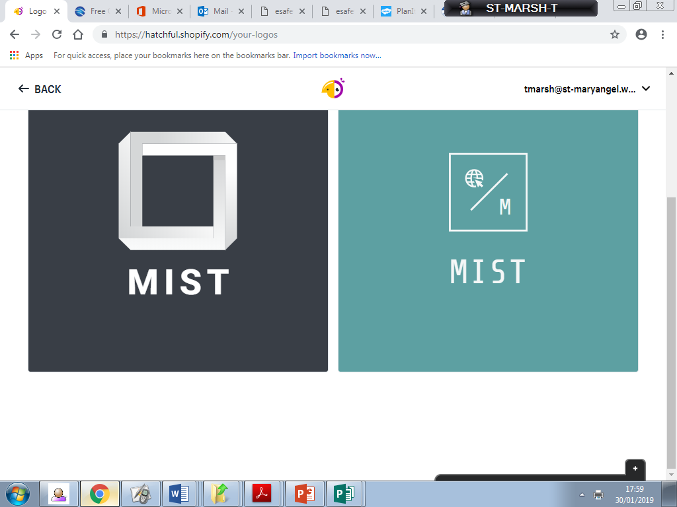

**Mary’s**

**Internet**

**Safety**

**Team**

**Keeping safe when playing online games**

Online gaming can be a fun and creative activity for all the family. However, it is essential that parents/carers help children to be aware of the possible risks and help build the skills and knowledge to enable them to enjoy gaming in a safe way. Childnet has published a free leaflet that has a wealth of advice to help parents/carers ensure children are accessing games in a positive and safe way. bit.ly/childnet_onlinegaming_introduction_for_parents

**Jessie & Friends KS1**

Jessie & Friends, a new online safety resource by CEOP for 4-7 year olds Jessie & Friends is series of three short animated films which aims to equip 4-7 year olds with the knowledge, skills and confidence they need to help them stay safe from sexual abuse and other risks they may encounter online. Jessie & Friends follows the adventures of Jessie, Tia and Mo as they begin to navigate the online world. They learn that while the internet can be an exciting place where they can learn and have fun, sometimes they may encounter things online which make them feel worried, scared or sad. Learning outcomes include identifying and responding safely to manipulative, pressurising and unhealthy behaviour online, and considering the safety and rights of themselves and other children when sharing content online. The films are accompanied by a comprehensive resource pack for professionals, with teaching plans for each episode and guidance on safe and effective delivery. Subtitled versions of the animations, storybooks, and posters for parents/carers and children are also available. The key message for children throughout Jessie & Friends is that if they ever feel worried about anything that happens to them online, they should seek help and talk to an adult they trust. To download this resource visit bit.ly/JessieAndFriendsEducation

Snapchat Streaks

Welcome!

It gives me great pleasure to introduce the third edition of the MIST newsletter. This half term, all children have been completing an E-Safety Questionnaire that the MIST team are currently analyzing. Results shall be with you shortly!

**Summer E-Safety Newsletter 2019**

Snapchat Streaks Is this harmless fun? Snapchat is one of the most popular social media apps used by young people to share photos and videos with friends. A Snapchat ‘streak’ is when you and a snapchat friend send and return a snap to each other within a 24 hour period. A number and an emoji appears beside a Snapchat friend’s name corresponding to the number of days in a row a new picture or video has been sent back and forth. You must Snapchat your friend within 24 hours of receiving the last Snap to keep the streak going. Young people can be pressured into keeping a streak going and when the streak does stop it can cause problems. The NSPCC told Newsround that they’ve received a number of calls from upset and worried young people because their snapchat streak has ended. One young person spoke with the NSPCC because she couldn’t get on to wifi that day she was worried that she would be bullied and that people would think she didn’t like them anymore. Whilst children can have great fun with friends using the streaks, parents/carers should remind children of the stress it could cause and help them question whether it is a true measure of friendship.