**Key Facts**

**Key Vocabulary**

* Resurrection
* Easter Vigil
* Easter Fire
* Paschal Candle
* Baptism
* Eucharist
* Eternal Life
* Easter is the most important season in the Church’s year.
* A Vigil is when we stay prayerfully awake through the night or part of a night in anticipation of a great event.
* The Easter Vigil takes place on the night before Easter Sunday. It has four main parts

**Liturgy of Baptism:**

* It is customary for people to be baptised during the Easter Vigil.
* Baptism is a celebration of new life. The person being baptised shares the life of Christ in a new and special way.
* In the first centuries of the Church’s existence, people were baptised by being fully immersed in the water three times. This was to symbolise that they were dying and rising to a new life with Christ.

**Service of Light:**

* The Easter Vigil opens with the blessing of a new fire, the lighting of the lamps & candles and the blessing and lighting of the Paschal Candle.
* We are reminded that Christ has risen and that in this moment of time, Christians can share his life.
* Everybody in church has candles lit from the Paschal Candle.

**Related Scripture**

***Genesis 1: 1-31* – Creation story**

***Genesis 2: 4-24 – Creation story***

***Exodus 14*: – The Festival of the Passover**

***Exodus 15*: – The Crossing of the Red Sea**

**The Appearances of the Risen Christ:**

***Mt. 28: 1-10***

***Mk. 16: 1-8***

***Lk. 24: 1-12***

***Jn. 20: 1-10***

***Jn.11: 17-27* – The Death of Lazarus**

***Lk. 24: 50-5*3 –The Ascension**

***Acts 1: 9 – The Ascension***

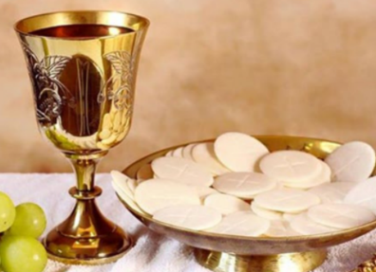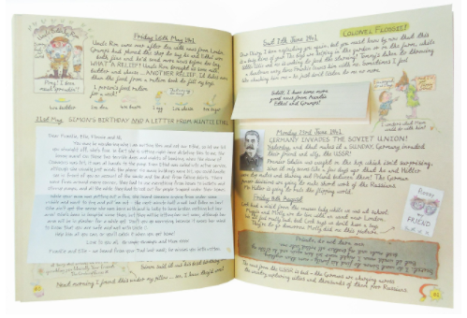

**Liturgy of the Eucharist:**

* In this part of the

Vigil, we do what

Jesus did at the

last supper.

**Liturgy of the Word:**

* During the Easter Vigil we listen to lots of readings from the Old Testament about what God our Father has done for his people and we listen to one of the Gospel accounts of the Resurrection.
* The readings reveal the powerful work of God the Father in the world and that the Resurrection of Jesus from the dead is God’s most powerful act.