Key Vocabulary
Object | A thing that can be used. For example a door, chair, car, table are all objects.
Material | Materials are what an object is made from.
Hard | Not easily broken or bent.
Soft | If soemthing is soft, it is easy to cut, fold or change the shape of.
Stretchy | Can be pulled to make it longer or wilder without breaking.
Shiny | Reflects light easily.
Dull | Doesn’t reflect light. Doesn’t look bright or shiny.
Rough | If something is rough, it feels and looks uneven or bumpy.
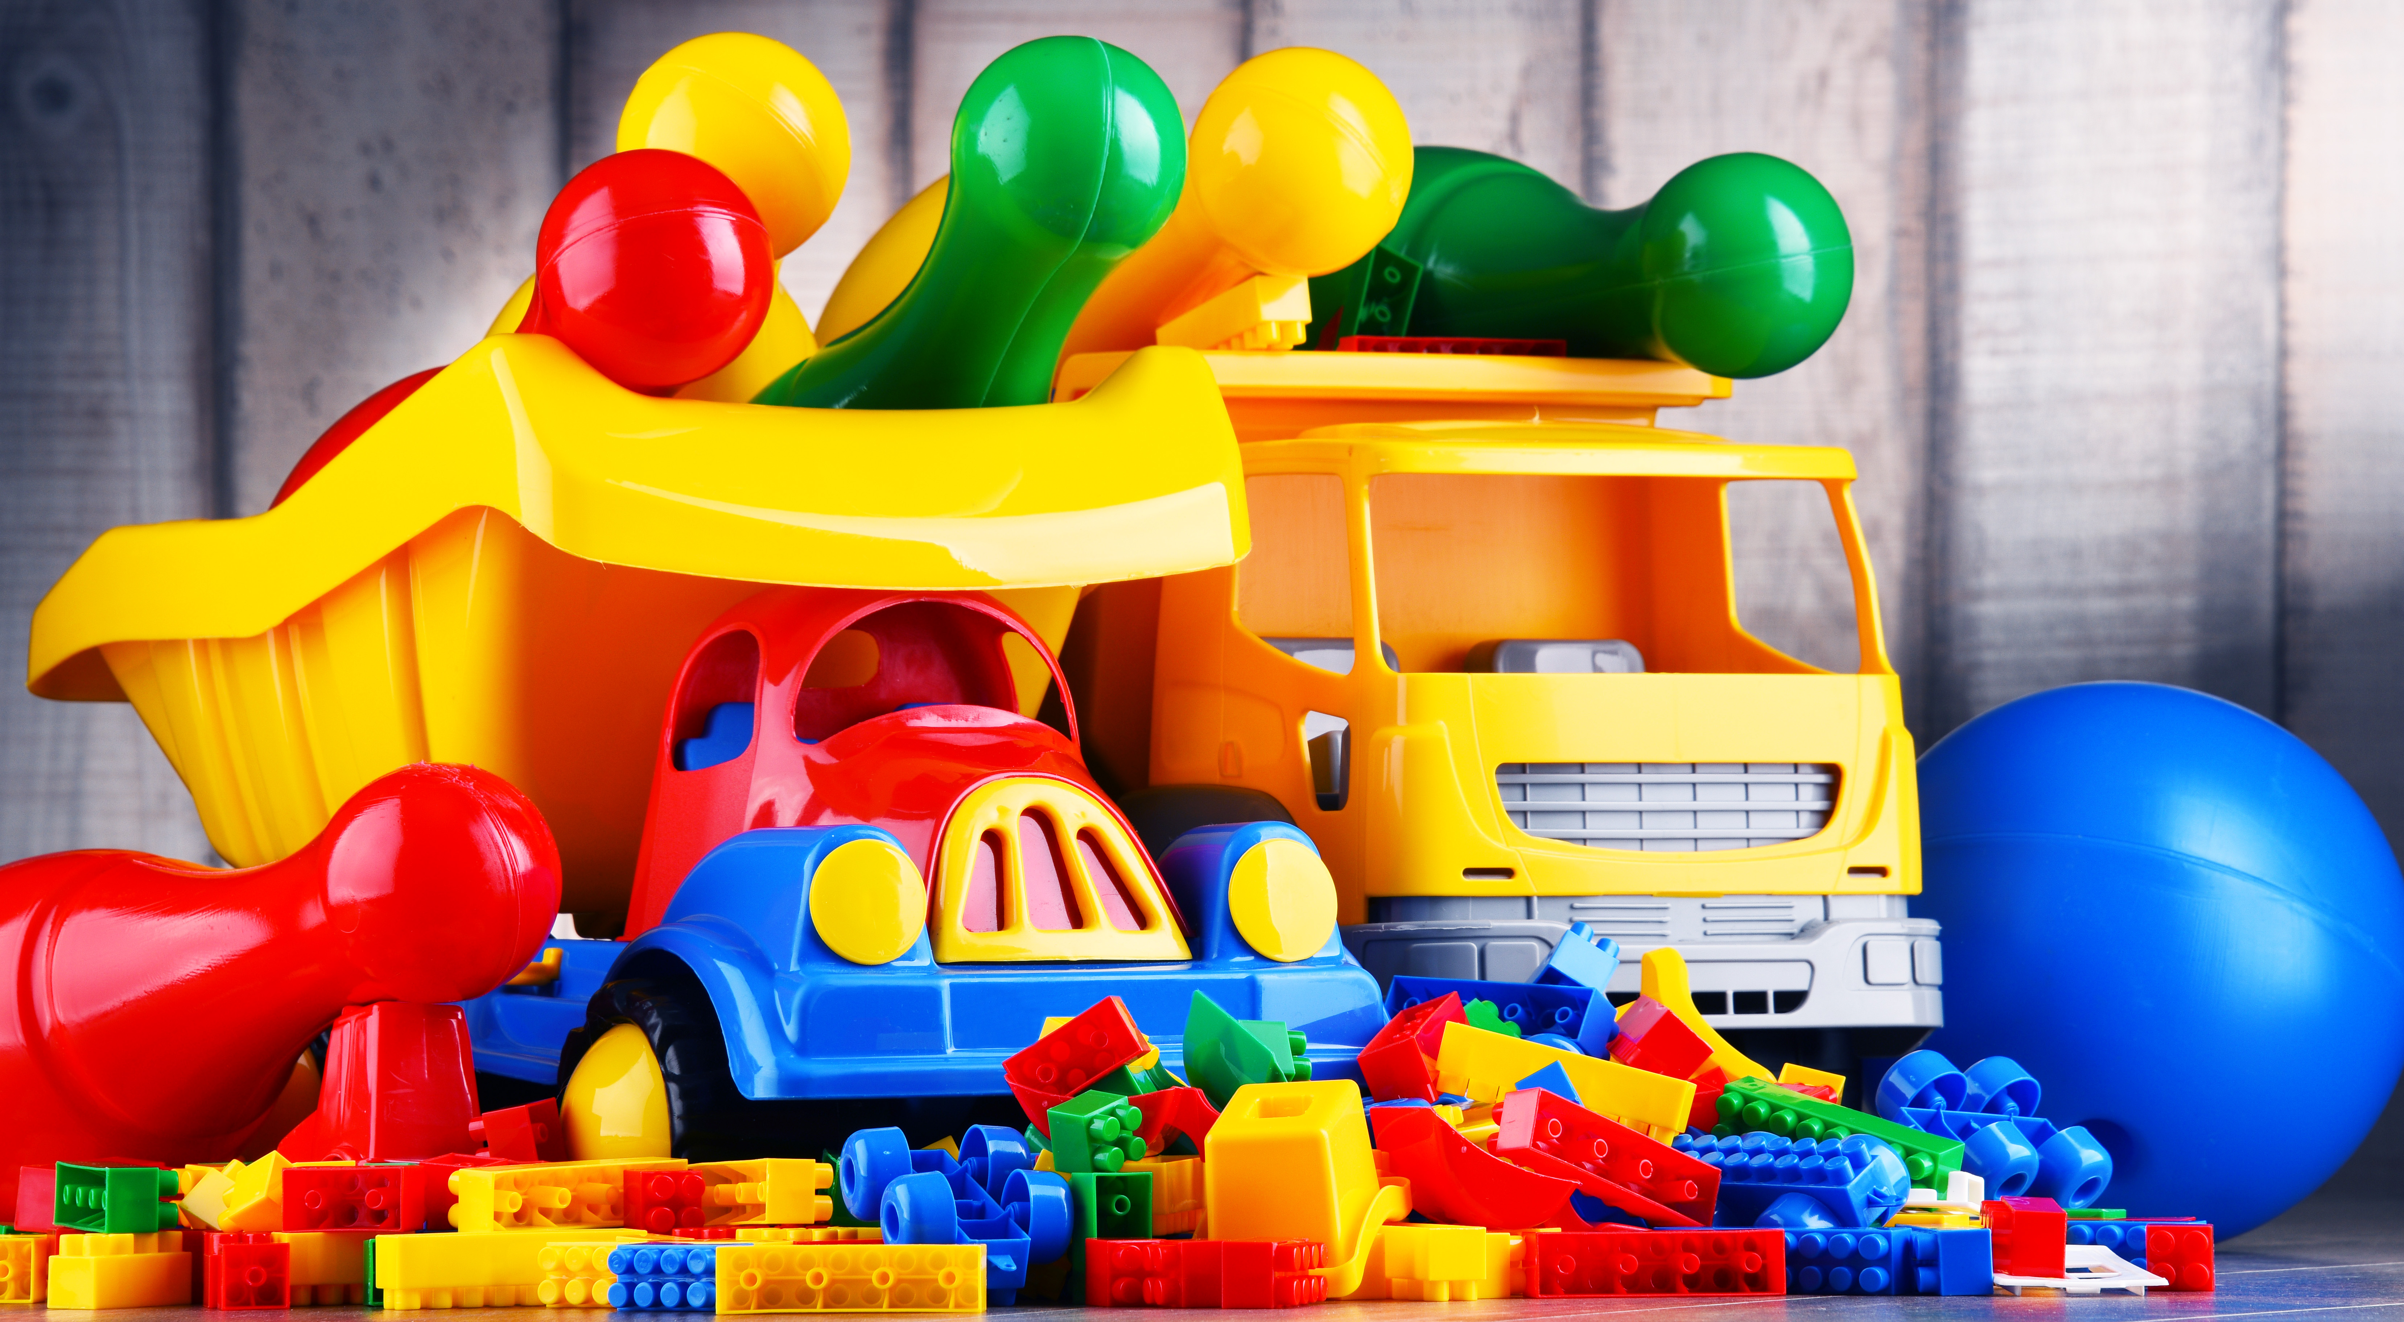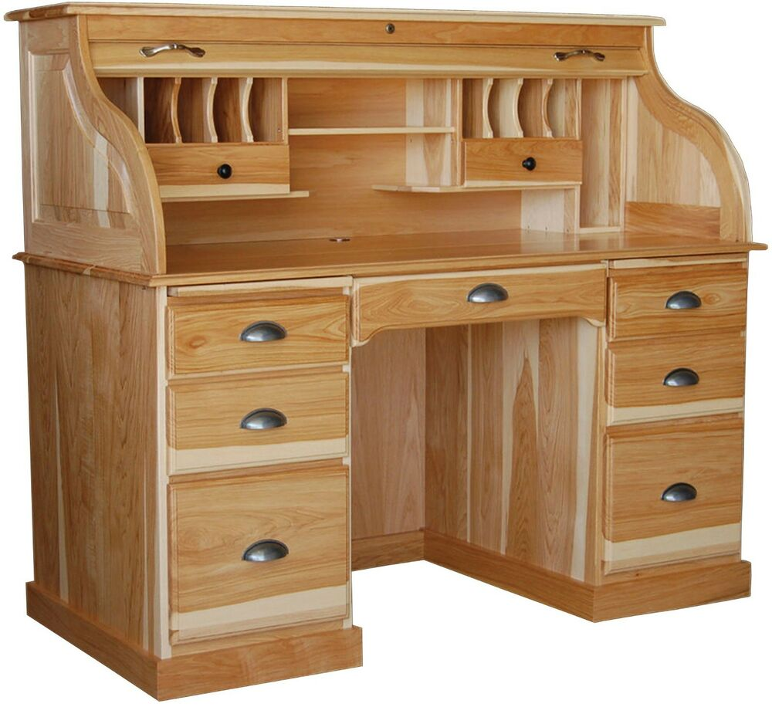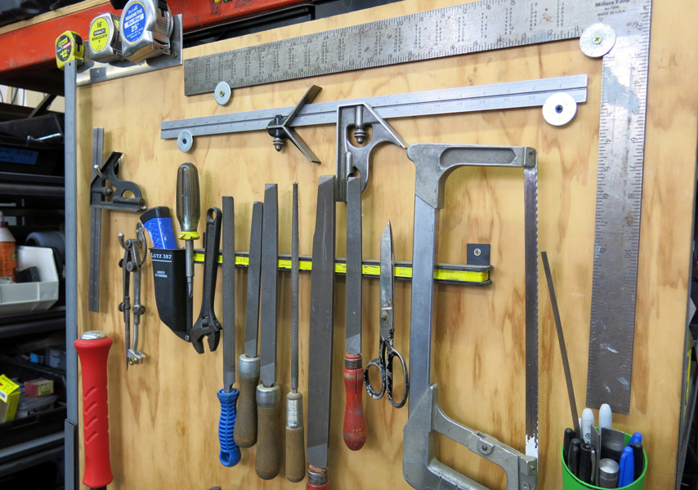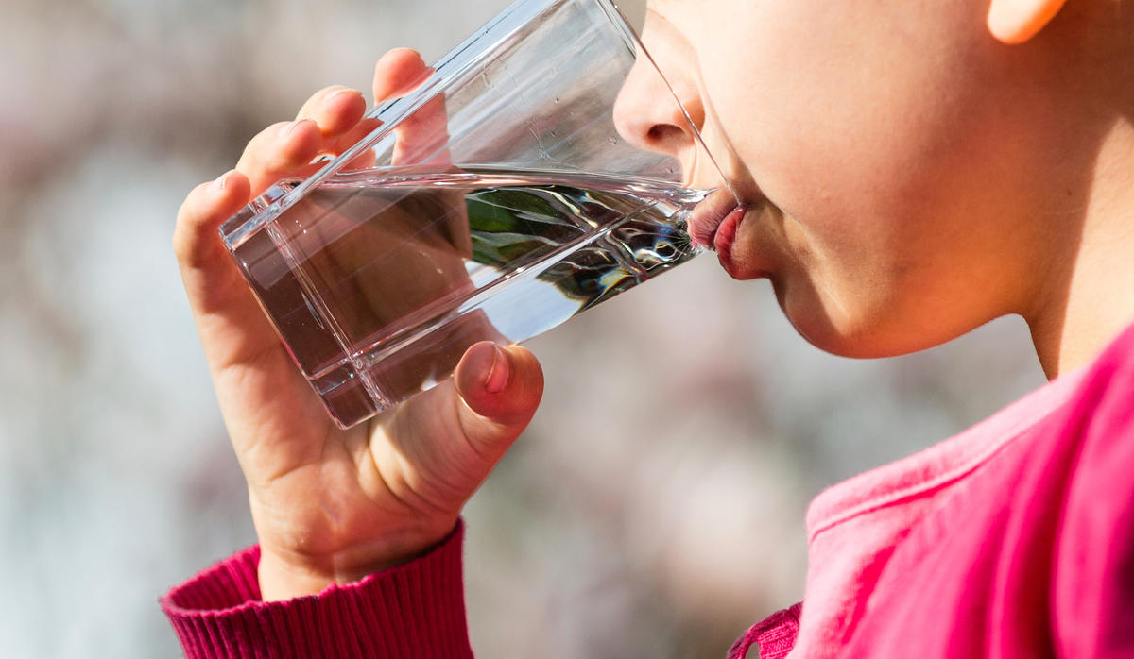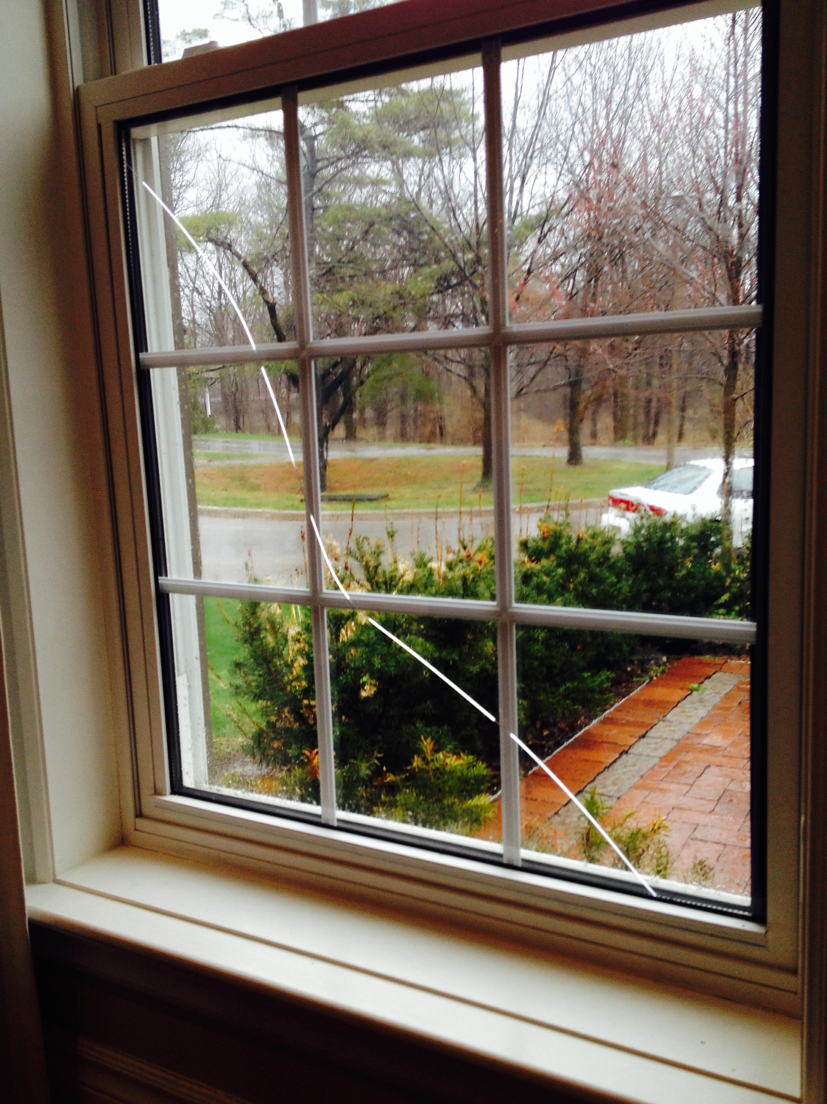
Plasic toys Wooden furniture Metal tools Drinking water Glass window
Key Knowledge:
Materials:
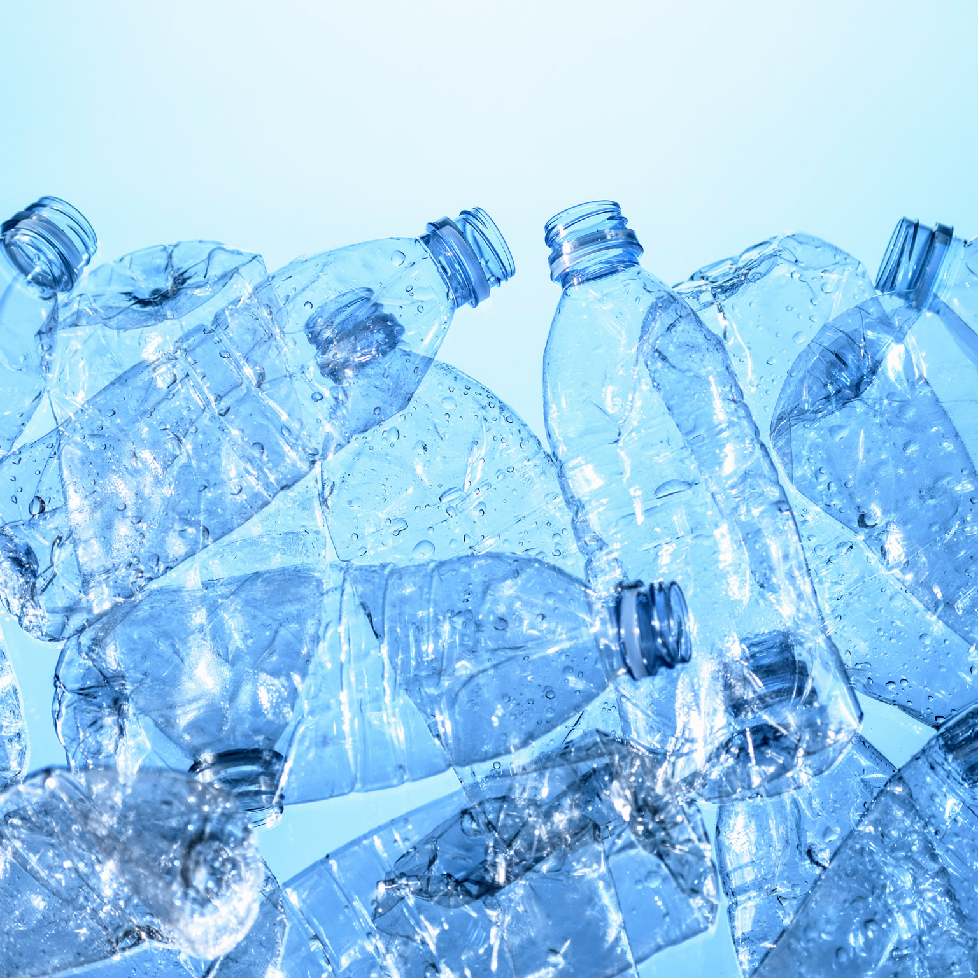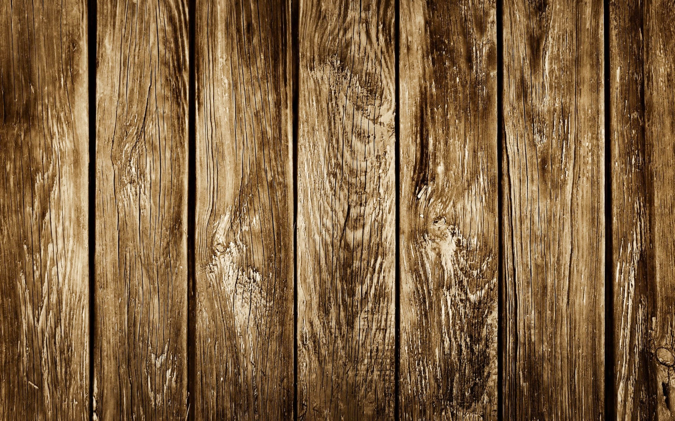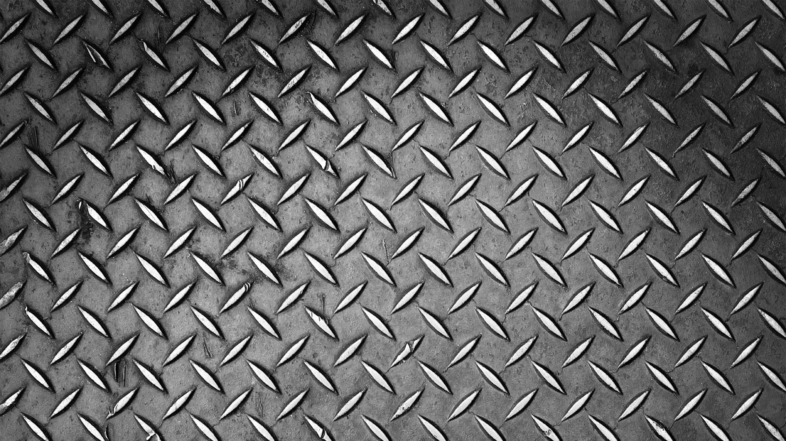
Plastic Wood Metal
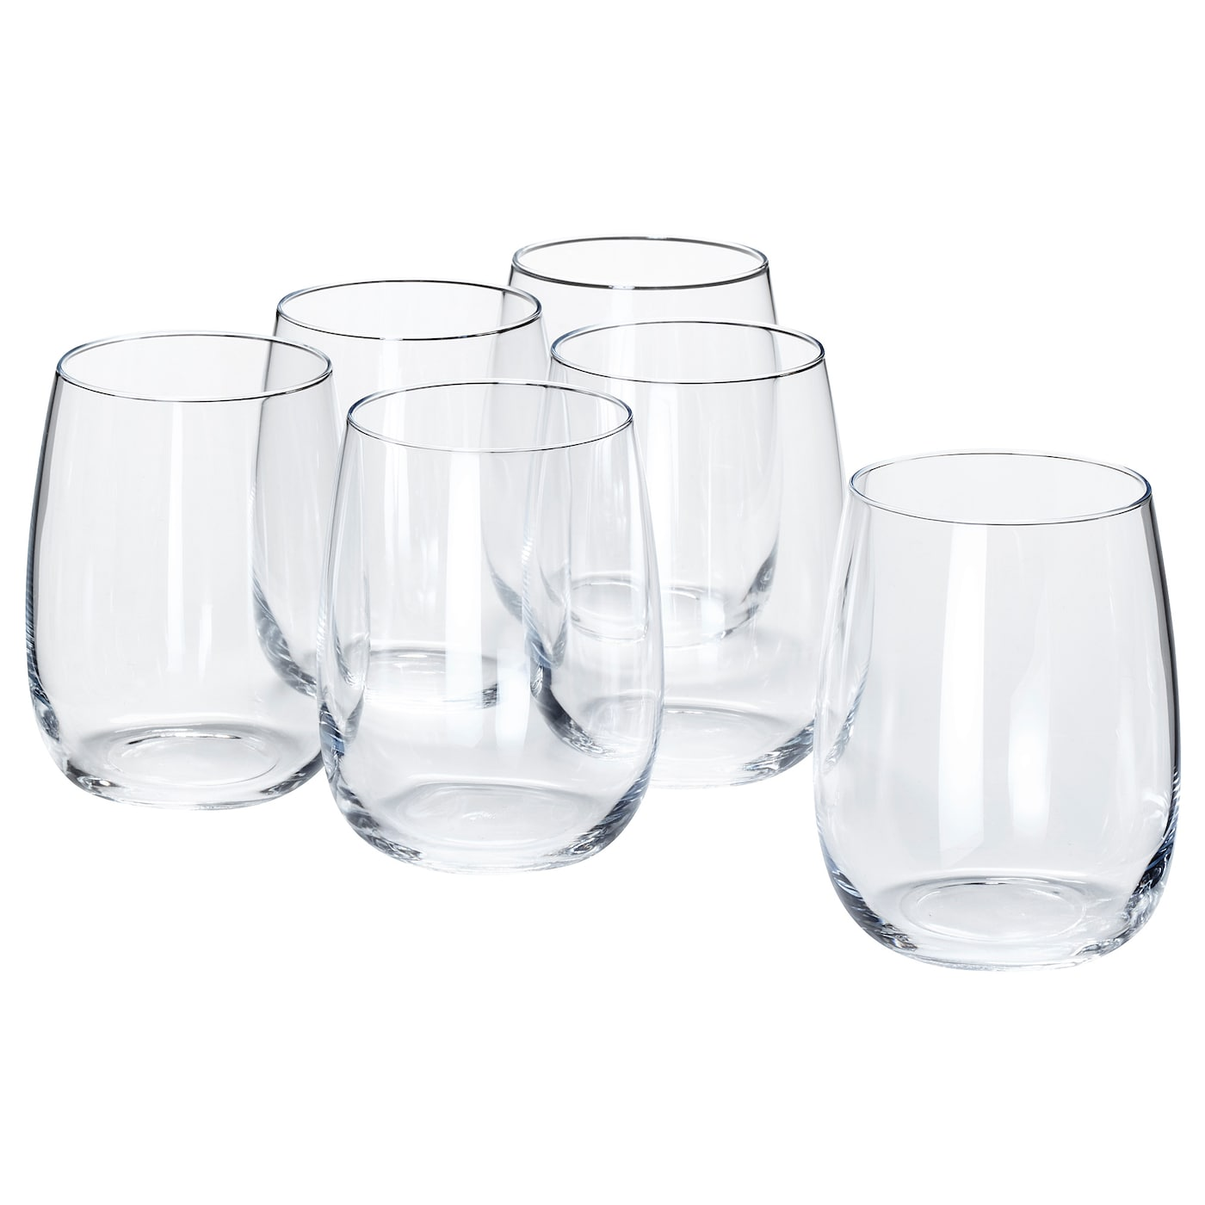
Water Glass
Key Knowledge
Materials:
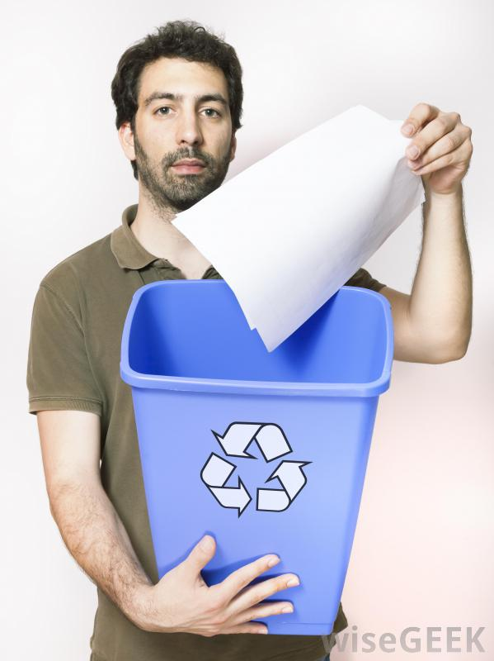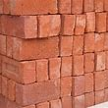
Paper Brick
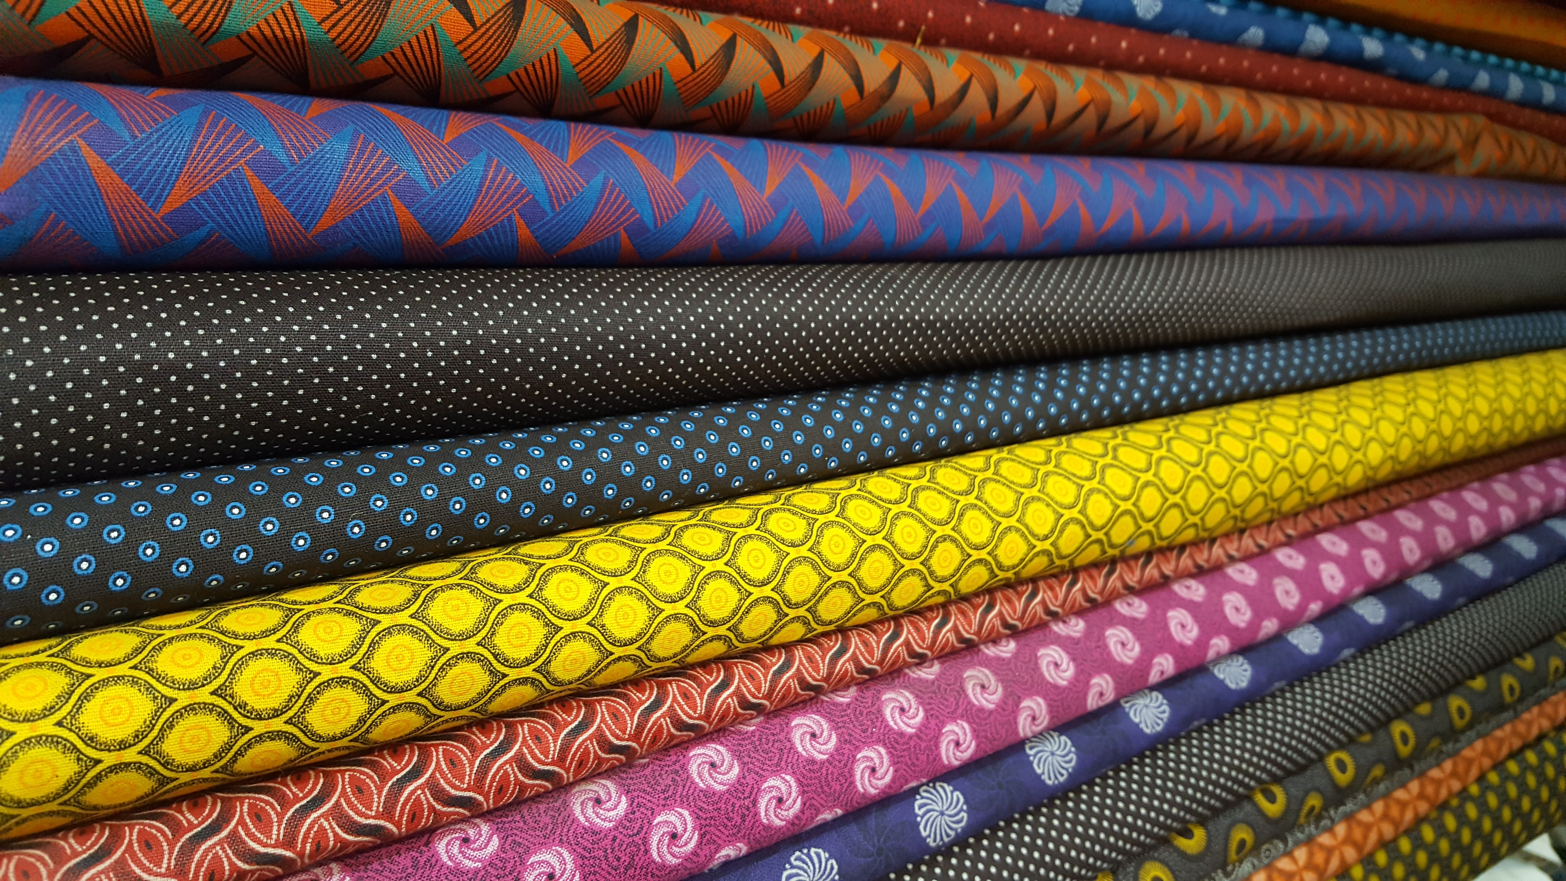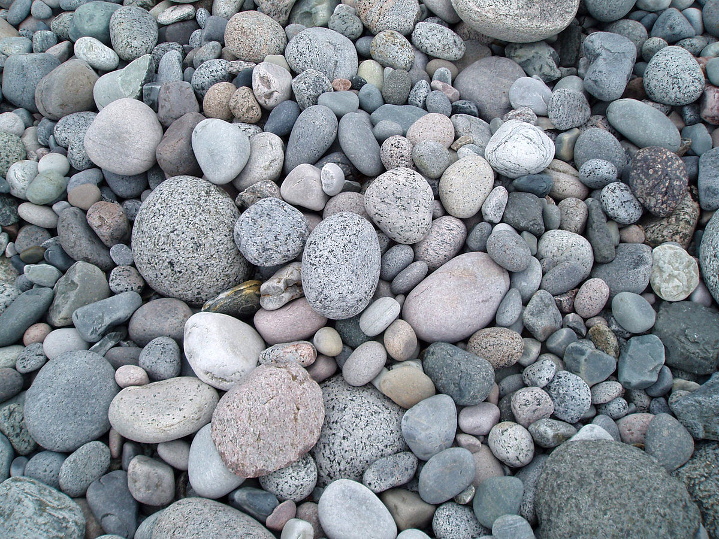
Fabric Stone

Key Vocabulary
Bendy | Bendy things can be folded easily
Not bendy | If something is not bendy, it can’t be folded easily.
Waterproof | If something is waterproof, it keeps water out. It keeps things dry.
Not waterproof | Not waterproof materials let water in.
Absorbent | If something is absorbent, it soaks water up.
Not absorbent | If something is not absorbent, it does not water.
Transarent | Transparent objects can be seen through.
Opaque | Opaque objects can be seen through.
Smooth | Smooth objects have no lumps or bumps

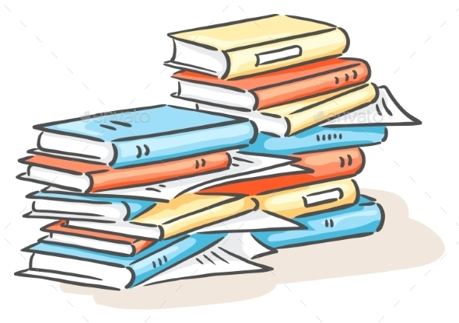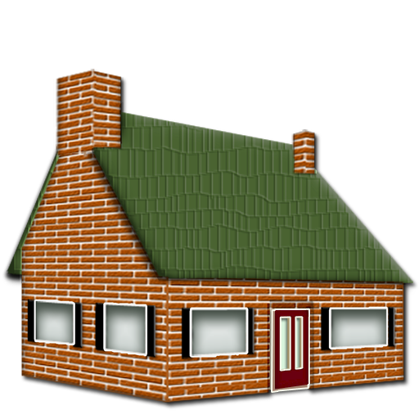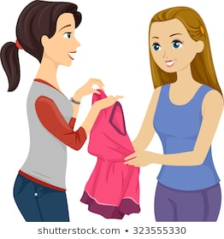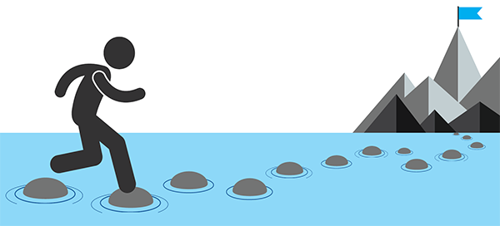
Ppaer Books Brick Houses Fabric clothing Stepping stones

