Key Vocabulary
Materials | Materials are what objects are made from.
Suitability | Suitability means having the properties which are right for a specific purpose.
Properties | This is what a material is like and how it behaves (soft, stretchy, waterproof).
Properties of Materials
Wood: hard, stiff, strong, opaque, can be carved into any shape.

Glass: waterproof, transparent, hard, smooth.

Plastic: waterproof, strong, can be made to be flexible or stiff, smooth or rough.

Metal: strong, hard, easy to wash.

Paper: lightweight, flexible.

Cardboard: strong, light, stiff.

Fabric: soft, flexible, hard-wearing, can be stretchy, warm, absorbent.

Rubber: hard-wearing, elastic, flexible, strong.
Bend an object by grabbing both ends of the object and bringing the ends inwards together.
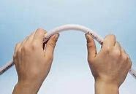
Stretch an object by pulling your hands slowly and gently apart.
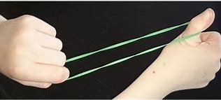
Squash an object by pushing both hands together.
Twist an object by turning your hands in opposite directions.
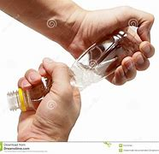
Key Vocabulary
John McAdam | John McAdam was a Scottish engineer who experimented with using new materials to build roads, inventing a new process called ‘macadamisation’.
John Dunlop | John Dunlop was a Scottish inventor who invented the air-filled rubber tyre. It was originally invented in 1887 to use with bicycles, and then became very useful when automobiles were developed.
Charles Macintosh | Charles Macintosh was a Scottish inventor and chemist who invented waterproof fabrics in 1818. The Macintosh raincoat was introduced in 1824.
Macadamisation | Macadamisation was the name given to John McAdam’s construction process of building roads. The name tarmac means a road made like this using tar.
Charles Macintosh invented the first waterproof fabric by painting a dissolved rubber solution onto cloth.
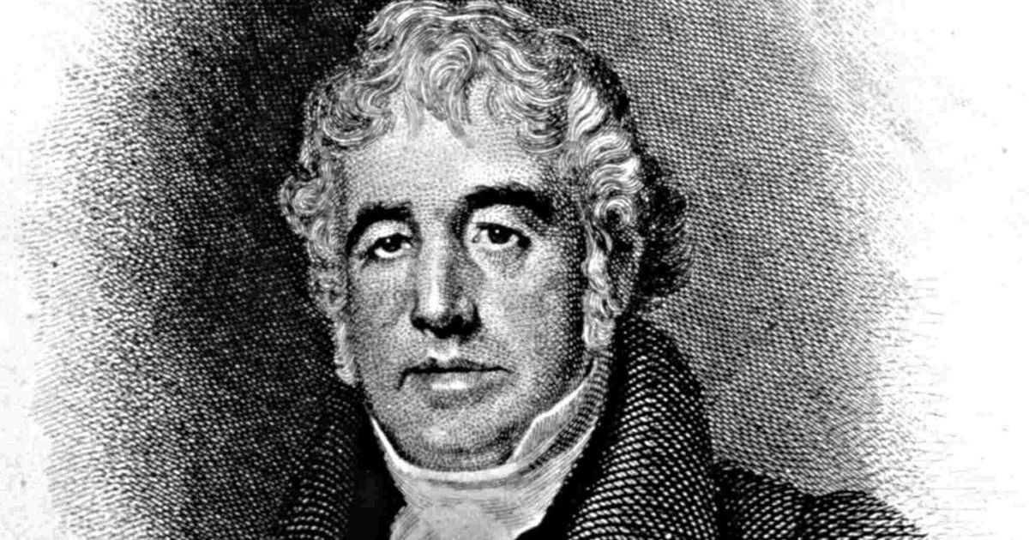
John Dunlop originally used rubber to make tyres for his son’s tricycle.
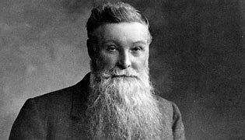
John McAdam’s process was so successful that roads were built in this way right across the world.
