Key Vocabulary
Digest | Break down food so it can be used by the body.
Oesophagus | A muscular tube which moves food from the mouth to the stomach.
Stomach | An organ in the digestive system where food is broken down with stomach acid and by being churned around.
Small Intestine | Part of the intestine where nutrients are absorbed by the body.
Large Intestine | Part of the intestine where water is absorbed from remaining waste food. Stools are formed in the large intestine.
Recum | Part of the digestive system where stools are stored before leaving the body through the anus.

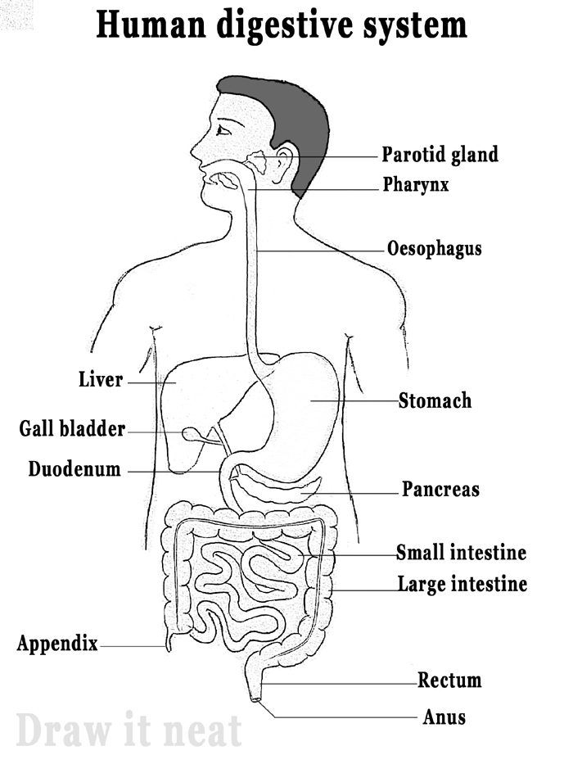

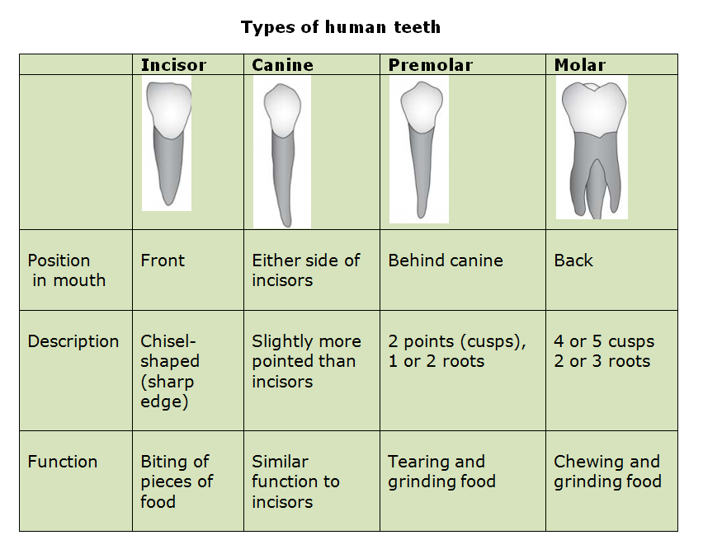
Key Vocabulary
Herbivore | An animal that eats plants.
Carnivore | An animal that feeds on other animals.
Omnivore | An animal that eats plants and animals.
Producer | A plant that produces its own food.
Predator | An animals that hunts and eats other animals.

To help prevent tooth decay:
Limit sugary food and drink
Bursh teeth twice daily using a fluoride toothpaste
Visit your dentist regularly
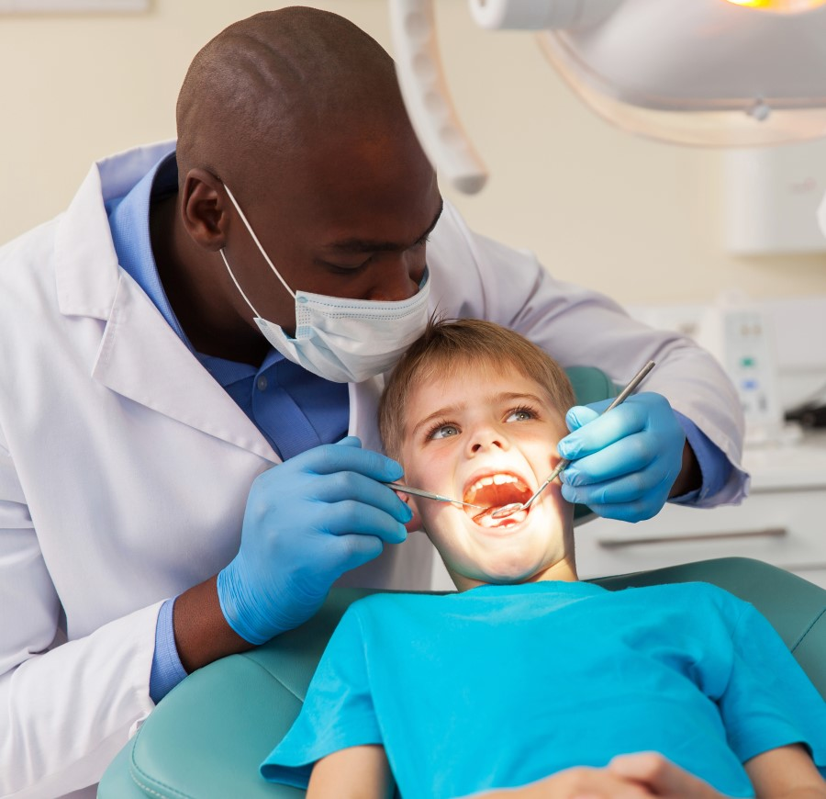
The teeth of an animal are designed to eat diffeent foods depending on the diet of the animal. Examples of a herbivore, a carnivore and an omnivore skull.
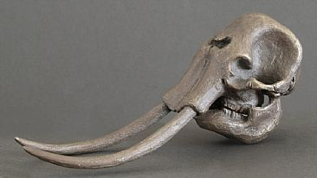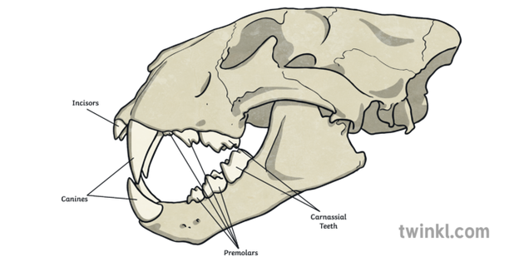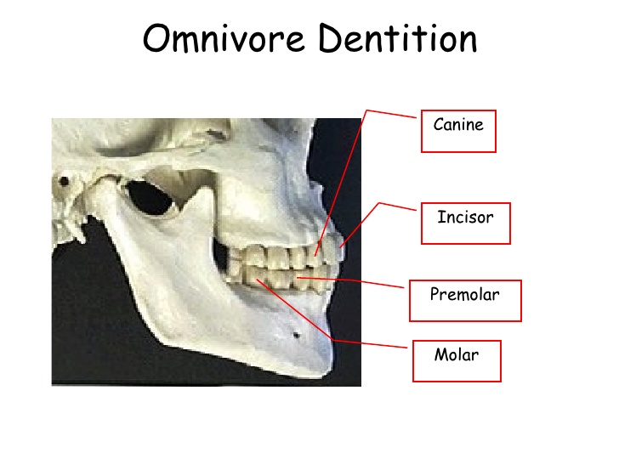
Elephant – Herbiivore Lion – Carnivore Human – Omnivore
