Key Vocabulary
Light | A form of energy that travels in a wave from a source.
Light source | An object that makes its own light.
Reflection | Reflection is when light bounces off a surface, changing the direction of a ray of light.
Incident ray | A ray of light that hits a surface.
Reflected ray | A rayof light that has bounced back after hitting a surface.
The law of reflection | The law states that the angle of the incident ray is equal to the angle of the reflected ray.
Light travels as a wave. But unlike waves of water or sound waves, it does not need a medium to travel through. This means light can travel through a vacuum – a completely airless space.
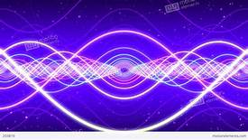
We need light to be able to see things. Light waves travel out from sources of light in straight lines. These lines are often called rays or beams of light.
Light from the sun travels in a straight line and hits the tree. The light ray is then reflected off the tree and travels in a straight line to the girl’s eye, enabling her to see the tree.
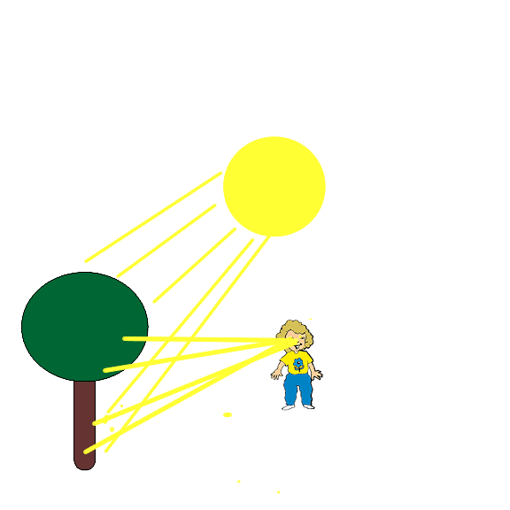
The law of reflection states that the angle of incidence is equal to the angle of reflection. Whenever light is reflected from a surface, it obeys this law.
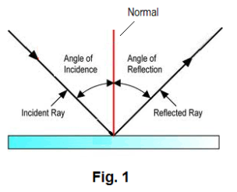
Key vocabulary
Refraction | This is when light bends as it passes from one medium to another e.g. light bends when it moves from air into water.
Visible Spectrum | Light that is visible to the human eye. It is made up of a colour spectrum.
Prism | A prism is a solid 3D shape with flat sides. The two ends are an equal shape and size. A transparent prism separates out visible light into all the colours of the spectrum.
Shadow | An area of darkness where light has been blocked.
Transparent | Describes objects that let light travel through them easily, meaning you can see through the object.
Translucent | Describes objects that let some light through, but scatters the light so we cannot see through them properly.
Opaque | Describes objects that do not let any light pass through them.
A shadow is always the same shape as the object that casts it. This is because when an opaque object is in the path of light travelling from a light source, it will block the light rays that hit it, while the rest of the light can continue travelling.
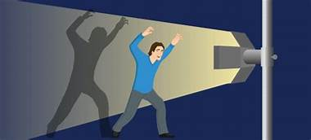
Shadows can also be elongated or shortened depending on the angle of the light source. A shadow is also larger when the object is closer to the light source. This is because it blocks more of the light.
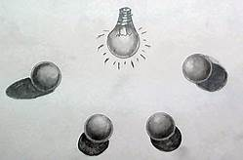
Isaac Newton shone a light through a transparent prism, separating out light into the colours of the rainbow (red, orange, yellow, green, blue, indigo and violet) – the colours of the spectrum. All the colours together merge and make visible light.
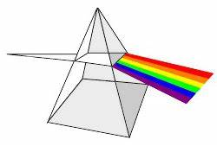
The spoon in this water looks as if it is bent. This is because light bends when it moves from air to water. When light bends in this way, it is called refraction.
