Key Knowledge

To Hear: Related Scripture and Texts

Key Vocabulary
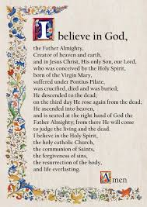
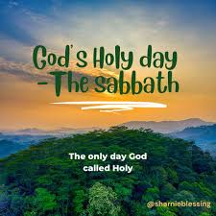
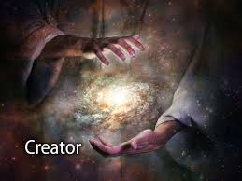
- The Creation story tells us God made the world in six days and on the seventh day, He rested.
- The Creed tells everyone what Catholics believe.
- The Creed says God made heaven and earth, and everything we can see and cannot see.
- The Church teaches us that God made everything.
- We cannot see God, but we can sense him in the world around us.
- We experience awe and wonder in Creation.
- God gave humans the responsibility for taking care of the world and everyone in it.
- We show love for God and each other by being stewards of His Creation.
- Pope Francis wrote a letter called Laudato Si’ which means ‘Praise be to you’
- We must take care of the earth; it is everyone’s home.
- We grow closer to God in prayer.
Genesis 1:1-4, 24-26 The creation of the world (aka the six days of Creation)

Laudato Si' 13 Present a brief introduction to the ideas Pope Francis writes about here.

Creator Sabbath

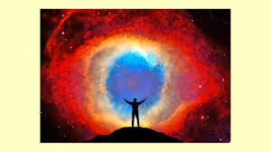
Creed

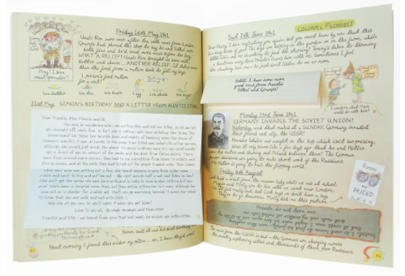

wisely
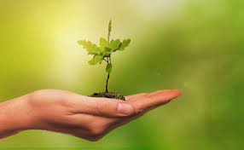
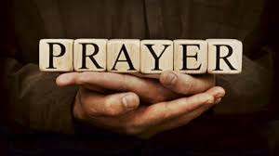
wonder
awe
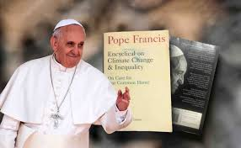

prayer
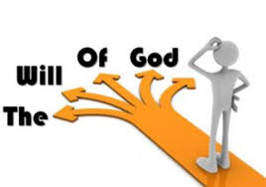
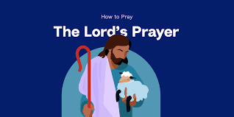

strength Laudato Si’

home Our Father thy will

