 |  | Autumn 1 | Autumn 2 | Spring 1 | Spring 2 | Summer 1 | Summer 2
Nursery | FiCTION | Theme: Marvellous Me  Owl Babies – Martin Wadell  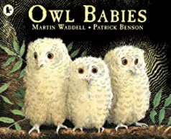  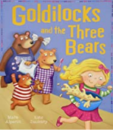  Goldilocks and the three bears | Theme: Celebrations  Kipper’s Birthday – Mick Inkpen  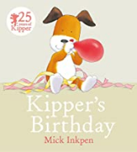 | Theme: Enchanted Worlds (Traditional Tales)  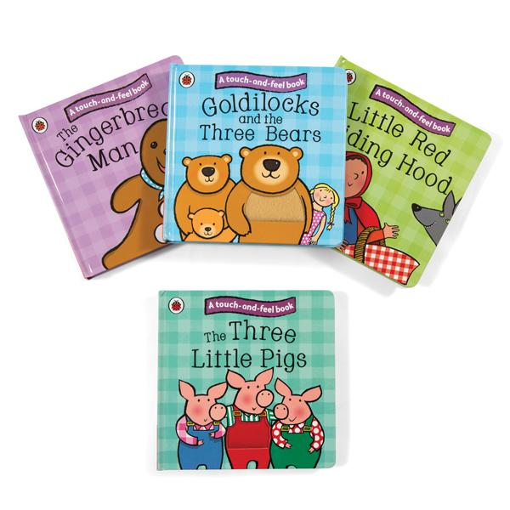  Three pigs/Rapunzel /Jack & the Beanstalk | Theme: Enchanted Worlds  Three billy goats gruff  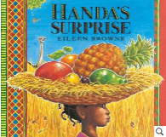  Handa’s Surprise – Eileen Browne | Theme: Where are we going, How shall we get there? (Travelling)  Little red riding Hood  We’re going on a bear Hunt –Michael Rosen  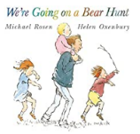  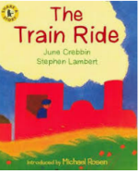  The train ride – June Crebbin | Theme: Where are we going, How shall we get there? (Places we can go to?)  Traditional tale – Wind & the Sun  The Very Hungry Caterpillar – Eric Carle  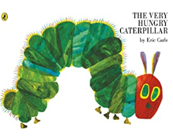
 | POETRY | Traditional Nursery Rhymes | “Happy Birthday” song | 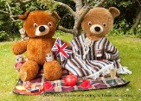  If you go down to the woods today |  | Nursey rhymes- wheels on the bus/ Daisy Daisy/Noah’s ark | Nursery rhyme – Mary Mary, Quite contrary
 | Non-Fiction | 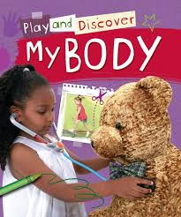  My body | 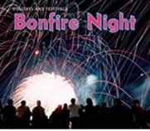  Bonfire night  Diwali |  | 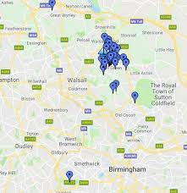  Maps/photographs of Aldridge |  | 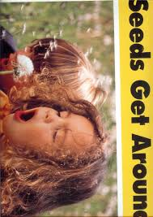  Seeds get around – a big book
 |  | Autumn 1 | Autumn 2 | Spring 1 | Spring 2 | Summer 1 | Summer 2
Reception | FICTION | Theme: Marvellous Me  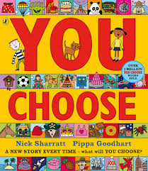  You choose – Nick Sharrat | Theme: Celebrations Significant Author: Julia Donaldson  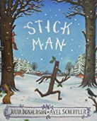  Stick Man – Julia Donaldson  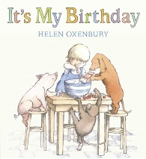 | Theme: Enchanted Worlds (The sea)  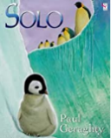  Solo the Penguin– Paul Gerraghty  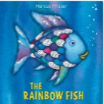  The Rainbow fish – Marcus Pfister  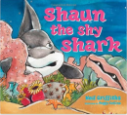  Shaun the Shy Shark –Neil Griffiths | Theme: Enchanted Worlds (Space)  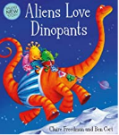  Aliens Love Underpants – Claire Freedman  Baboon on the moon  (literacy shed)  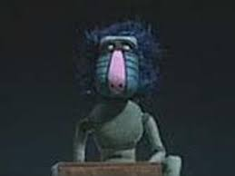 | Theme: Where are we going, How shall we get there? (Rainforest)  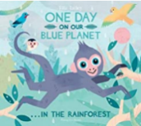  One Day on Our Blue Planet: In the Rainforest –Ella Bailey  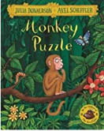  Monkey Puzzle – Julia Donaldson | Theme: Where are we going, How shall we get there? (Seaside)  Share the shell - Julia Donaldson  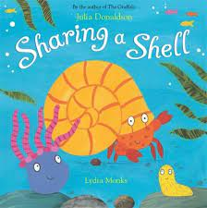  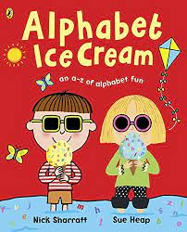  Alphabet Ice-cream -Nick  Sharrat & Sue Heap
 | Poetry | Rhymes linked with people who help us – Five fireman standing in a row…/ Miss Polly had a dolly… |  | 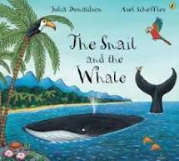  The snail and the whale – Julia Donaldson |  | The animal boogie  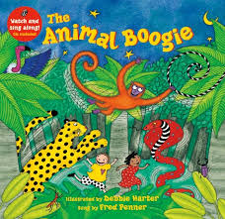 | We’re all going on a summer holiday - song
 | Non-Fiction | My body – flip book  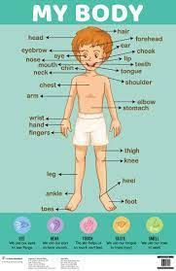 |  | Non fiction – One day on our blue planet  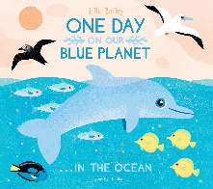 | Astronauts – Non fiction text | 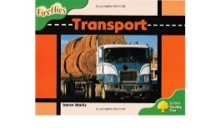  Transport – guided reading book
 |  | Autumn 1 | Autumn 2 | Spring 1 | Spring 2 | Summer 1 | Summer 2
Year 1 | FICTION | Theme – Animal Books  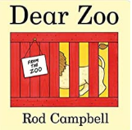  Dear Zoo – Rod Campbell  Walking through the Jungle – Julie Lacome  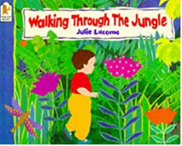 | Theme: Significant Author Jill Murphy  Whatever Next 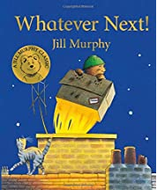  Peace at last  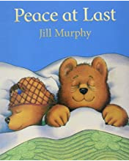  Five minutes Peace  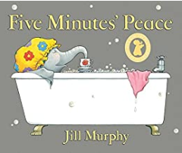 | Theme: Traditional Tales  The Marvellous Pumpkin  The gigantic Potato  Enormous Turnip  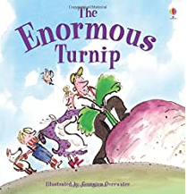  The Gigantic Turnip 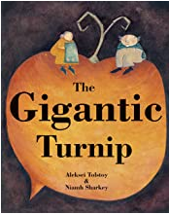 | Theme: Growing  Jack and the Beanstalk  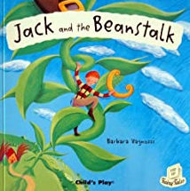  Jim and the Beanstalk  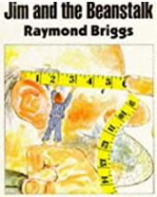  Shhhh – Sally Grindley  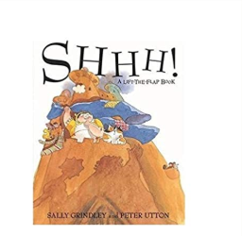 | Theme – familiar settings Judith Kerr focus  Handa’s Surprise  The Tiger that came to tea  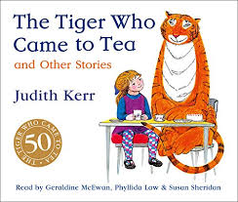  Mog and the VET  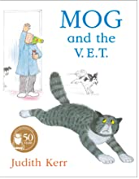 | Theme - Super heroes  Traction Man – Mini Grey  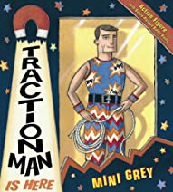  Books based on Super Heroes
 | Poetry | Poetry based on Animals  https://www.teachprimary.com/resource_uploads/Animal_poems.pdf | Poetry based on space  https://www.teachprimary.com/resource_uploads/swing-on-a-star1.pdf | Poetry based on growing  A seedy story - judith Nicholls |  | Riddles  I see a tiger :  http://poetryforkidsjoy.blogspot.com/2011/06/tiger-poem.html  The Dancing Tiger  By Malachy Doyle  Poetry learned and recited based on Victorians – “Stand up tall”
 | Non-Fiction | ORT - On Safari, Wild animals, The Equator -  Tusks,Giant animals  Wild homes, Bear spotting, A little book of reptiles, Creepy Crawlies  Reading short passages to find information | Making a sandwich  Blackcurrant jam  What is for lunch  Grow a pumpkin | Information Books based on plants, Winter,  Fact files of Monet, Florence Nightingale  Reading scheme –  Terrific Trees  Grow a Pumpkin |  | Information Books based on materials, tigers Victorians and changes in seasons.  Mr Scoops School  A day in the life of a Victorian ,Around the world in 80 days | Information fact files about Super heroes  Around the world in 80 days
 |  | Autumn 1 | Autumn 2 | Spring 1 | Spring 2 | Summer 1 | Summer 2
Year 2 | FICTION | Theme – Food  Oliver’s Vegetables - Alison Bartlett and Vivian French 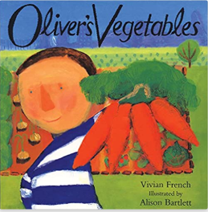 | Theme – Significant Author: Allan Ahlberg  Funnybones  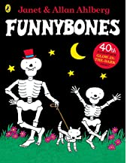 | Theme - Wellbeing  The Day The Crayons Quit - Drew Daywalt  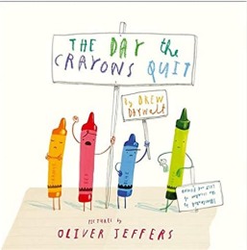 | Theme - Wellbeing  Not Now Bernard – David Mckee  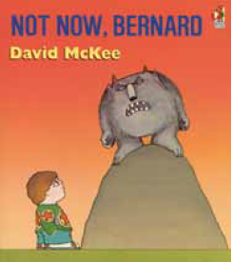  Who’s afraid of the Big Bad Book? – Lauren Child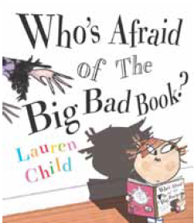 | Theme – The Seaside  Katie Morag - Mairi Hedderwick  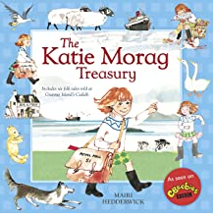  Lighthouse Keeper’s Lunch - Ronda Armitage and David Armitage  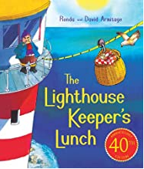 | Theme – The Seaside  The Pirate Cruncher - Jonny Duddle 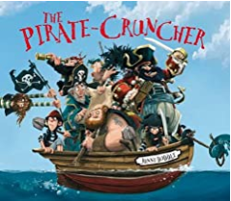
 | Poetry | "Chocolate for breakfast" - Kenn Nesbitt | "I heard it in the playground" a selection of poems by Ahlberg | The Crow’s Tale (poetry) | "The boy with the similar name" by Roger McGough | "The seagulls" by Michel Rosen | "Treasures on the beach" by Brenda Williams
 | Non-Fiction | Non-fiction – recipes, instructions, food from around the world | Non fiction – human body, growing up, important places and people (link to Aldridge WLP) | Self-help posters/books  BV related books and links to significant people e.g. MLK |  | Non-fiction –geographical texts (seaside), holiday leaflets, maps, seaside abroad

 |  | Autumn 1 | Autumn 2 | Spring 1 | Spring 2 | Summer 1 | Summer 2
Year 3 | FICTION | Theme – Alternative Traditional Tales  The True Story of The 3 Little Pigs! - Jon Scieszka  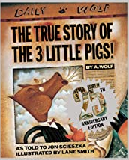 | Theme – Science-Fiction  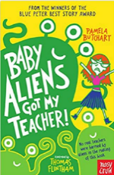  Baby Aliens Got My Teacher- Pamela Butchart | Theme – Significant author: Dick King-Smith  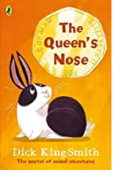  The Queen’s Nose – Dick King-Smith | Theme – Historical  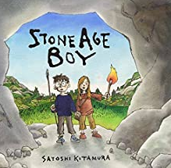  Stone Age Boy - Satoshi Kitamura | 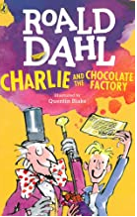  Theme - Chocolate  Charlie and the Chocolate Factory – Roald Dahl
 | POETRY | 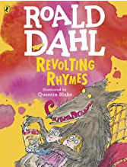  Humorous Poetry - Revolting Rhymes – Roald Dahl | Shape Poetry – Volcanoes | Poems from Around the World – Chinese Festival  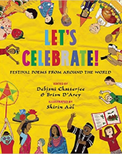  Let’s Celebrate! edited by Debjani Chatterjee and Brian D’arcy - The Chinese Dragon by Catherine Benson | Wordplay and humour – I was Born in the Stone Age by Michael Rosen | Performance Poetry  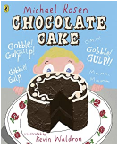 | Classic Poems: Spoken Verse  George by Hilaire Belloc
 | NON-FICTION | 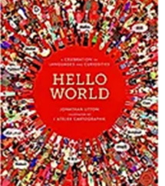  Information texts focusing on different parts of the world l | Persuasion - Advert  Egypt Magnified by  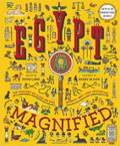  David Long  (Create an interactive  advert for a holiday to  an exotic place) | 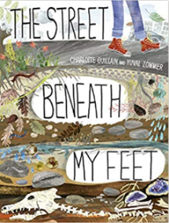  Information texts based on the Aldridge topic using this book | (Historical links that can inspire a day in the life of a Stone Age Hunter Diary)  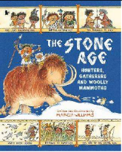  The Stone Age Hunters,  Gatherers and Woolly  Mammoths by Marcia  Williams | 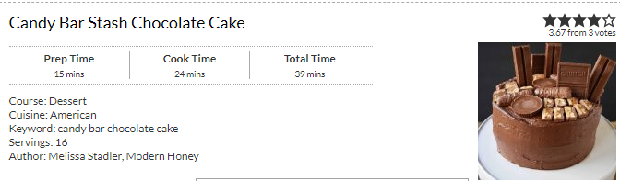  Instructions and recipes – linked with WLP Chocolate

 |  | Autumn 1 | Autumn 2 | Spring 1 | Spring 2 | Summer 1 |  | Summer 2
Year 4 | FICTION | Theme – I Am Warrior- Roman Legends  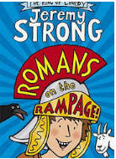  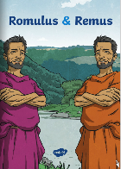  Romans on the Rampage by Jeremy Strong  Romulus and Remus  (Twinkl) | Theme - Picture Book –  Historical  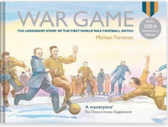  War Game by Michael Foreman  https://www.literacyshed.com/the-christmas-truce.html | Theme – Fantasy – Vikings  How to Train Your Dragon by Cressida Cowell 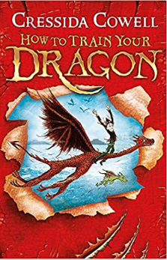 |  | Theme – Significant Author: David Walliams  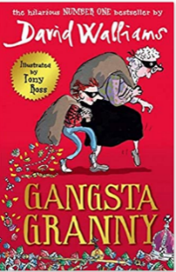  Gangsta Granny
 | POETRY | Image poetry  The Wolf and The Woodpecker (Linked to Romulus and Remus) | WW1 Poetry –  Where the poppies now grow by Hilary Robinson & Martin Impey,  Carol Ann Duffy: The Christmas Truce, In Flanders Field | List Poetry – Metaphors and similes  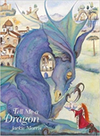  The Dragons inside of me- Pie Corbett.  Tell Me A Dragon Poem by Jackie Morris |  | 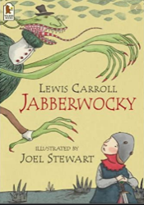  Classical Nonsense Poetry  The Jabberwocky  BY LEWIS CARROLL
 | NON-FICTION | Recount (Diary)  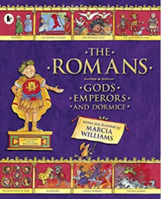  The Romans: Gods, Emperors and Dormice by Marcia Williams | Recount (Letter)  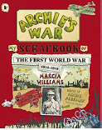  Archie’s War by Marcia  Williams  (letter writing  exemplars, formal and  informal writing- World War 1 theme)  Biographies  Rosa Parks (National Geographic Readers: Level 2) | Inform/instruct  Dare to Care: Pet Dragon  by Mark Robertson  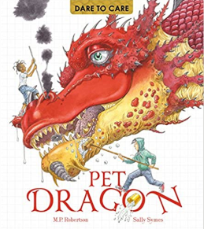 |  | Persuasive (Link with WLP Blue Planet)  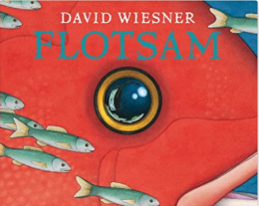  Flotsam by David Wieesner | Inform/Instruct  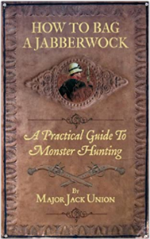  How to Bag a Jabberwock: A Practical Guide to Monster Hunting
 |  | Autumn 1 | Autumn 2 | Spring 1 | Spring 2 | Summer 1 |  | Summer 2
Year 5 | FICTION | Theme: Fantasy - Significant Author: C. S. Lewis  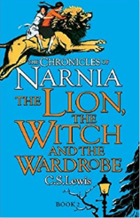  The Lion, The Witch and The Wardrobe by C.S. Lewis |  | Theme: Modern Classic - Crime and Punishment  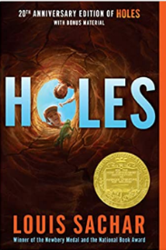  Holes by Louis Sachar  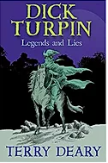  Theme: Legends - Crime and Punishment  Dick Turpin (Used during WLP lessons) |  | Theme: Myths and Legends – Ancient Greeks  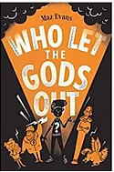  Who Let the Gods Out by Maz Evans
 | POETRY | Portal Theme poetry  Only A wardrobe by Brian Moses  Kit Wright’s poem ‘The Magic Box’  Miroslav Holub’ s poem ‘The Door’ |  | 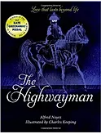  Classic Narrative Poetry  The Highway Man Poem |  | Theme Poetry: Mythical Beasts  The Museum of Mythical Beasts by Brian Moses  A Plea From the Rescue Centre for Mythical Beasts by Brian Moses
 | NON-FICTION | Rainforest non-fiction  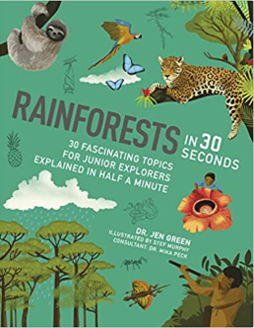 | 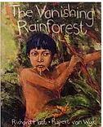 | 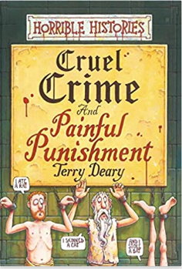 | 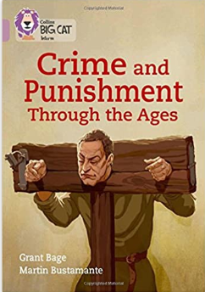 | 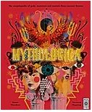  Mythologica: An Encyclopedia of Gods, Monsters and Mortals from Ancient Greece by Dr Stephen Kershaw & Victoria Topping  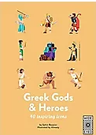  Greek Gods & Heroes by  Sylvie Baussier & Almasty

 |  | Autumn 1 | Autumn 2 | Spring 1 | Spring 2 | Summer 1 | Summer 2
Year 6 (set 2) | FICTION | Theme: Historical Mystery – WW2  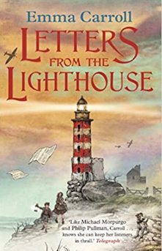  Letters From the Lighthouse by Emma Carroll |  | Theme: Historical Adventure - Significant Author: Michael Murpurgo  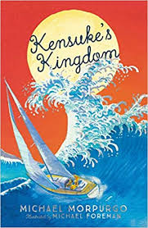  Kensuke’s Kingdom by Michael Morpurgo |  | Theme: Inspirational Class Read  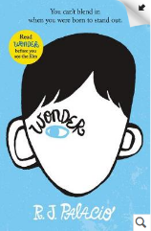  Wonder  R. J. Palacio  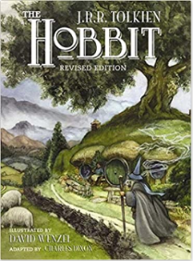  Theme: Modern Classic Fiction - Graphic Novel Epic Fantasy  The Hobbit by J.R.R Tolkien
 | POETRY | Palindromic Poetry  Refugees by Brian Bilston https://brianbilston.com/2016/03/23/refugees/  https://www.youtube.com/watch?time_continue=98&v=eaMXn6Fkx2c |  | Repetitive pattern poetry  Pie Corbett The Cave of Curiosity. https://soundcloud.com/talkforwriting/ city  or  ‘The Convergence of the Twain’ by Thomas Hardy |  | Choral and Performance Poetry: Personal Narrative  'Russian doll' by Rachel Rooney  'Mirror' by Rachel Rooney  'Man… I Had it Made' by Joseph Coelho
 | NON-FICTION | 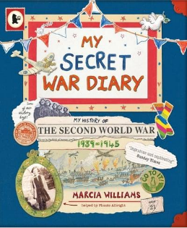  Recount (Diary and Letters)  My Secret War Diary by Marcia Williams, Information leaflets about evacuation and air raids |  | 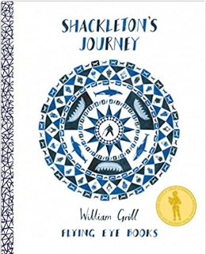  Persuasion Information/explanation (WLP link to polar regions)  Shackleton's Journey  by William Grill |  | Encyclopaedias and ology series  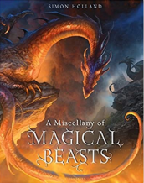  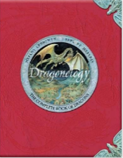  A Miscellany of Magical Beasts by Simon Holland  Dragonology: The Complete Book of Dragons (Ology Series)  by Dugald Steer

 | Autumn 1 | Autumn 2 | Spring 1 | Spring 2 | Summer 1 | Summer 2
 | Theme: Historical – WW2  Goodnight Mr Tom by Michelle Magorian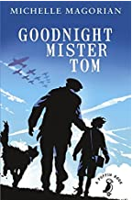 |  | Theme: Classic Fiction  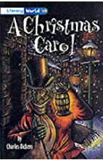  A Christmas carol by Charles Dickens | Theme: Modern Classic  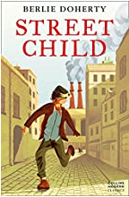  Street Child by Berlie Doherty (playscript) | Theme: Inspirational Class Read  Wonder  R. J. Palacio  Theme: Graphic Novel Epic Fantasy  The Hobbit by J.R.R Tolkien
 | War poetry? |  | Macbeth by William Shakespeare ( retold)? |  | Choral and Performance Poetry: Personal Narrative  'Russian doll' by Rachel Rooney  'Mirror' by Rachel Rooney  'Man… I Had it Made' by Joseph Coelho
 | 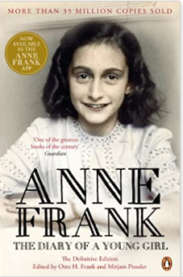  Anne Frank's Diary. |  | Persuasion Information/explanation (WLP link to polar regions)  Shackleton's Journey  by William Grill |  | Encyclopaedias and ology series  A Miscellany of Magical Beasts by Simon Holland  Dragonology: The Complete Book of Dragons (Ology Series)  by Dugald Steer

