Term and WLP/ | Book  Selected book to engage and extend vocabulary linking to the WLP. | Key Knowledge | Links to Next Stage of Learning in Year 1 | Link to COEL | Enrichment
Autumn Term
Autumn 1  Marvellous Me  (SMATT 4) | 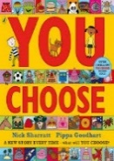  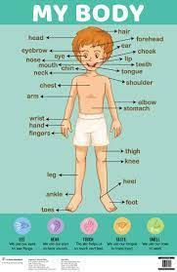  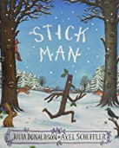 | Prime Areas  Listen stories; developing comprehension. Listen and learn new rhymes and songs, looking to extend vocabulary. Encourage use of longer sentences and begin to express a point of view, using words as well as actions.  Develop a good posture when sitting at a table or sitting on the floor. Discuss healthy choices about food, drink, activity and tooth brushing  Develop the skills to manage the school day; lining up and queuing, mealtimes and personal hygiene. Use a chosen hand to hold their pencil. Make friends and develop the skills to play with one another and begin to find solutions to conflicts. Extend language to express their feelings and consider the feelings of others. Begin to understand how others might be feeling. Learn how to identify and moderate their own feelings. Show more confidence in new social situations. Recognise the importance of following rues and understand why they are important. Describe feelings.  Specific Areas  Use print and letter knowledge in writing; and write names. Write some letters accurately; correct letter formation will be encouraged. Develop skills in rhyming. Continue to count or clap syllables in a word. Identify words with the same initial sound. Read the sounds in words to blend. Introduce digraphs. Encourage engagement in extended conversations about stories, using new vocabulary.  Recognise up to 6 objects, without having to count them individually (‘subitising’). Develop an understanding of the ‘cardinal principal’ – knowing that the amount counted represents the set. Show ‘finger numbers’ up to 10 and begin to make marks as well as numerals. Begin to solve real world mathematical problems with numbers up to 10. Compare quantities using language: ‘more than’, ‘fewer than’. Talk about and explore 2D shapes using informal and mathematical language. Continue to understand position. | Science Biology- identify, name, draw and label the basic parts of the human body that relate to the senses.  Art - Observe anatomy (faces, limbs)  History Recognise the difference between past and present in their own and others’ lives  DT - Healthy sandwich/skewer – Healthy picnic | Active Learning: Participate in routines  Finding out and exploring  Being willing to ‘have a go’  Being involved and concentrating  Keep on trying  Enjoying achieving what they set out to do  Having their own ideas  Making links  Choosing ways to do things  Active Learning: Participate in routines  Finding out and exploring  Being willing to ‘have a go’  Being involved and concentrating  Keep on trying  Enjoying achieving what they set out to do  Having their own ideas  Making links  Choosing ways to do things | Settling in to routines, expectations and establishing behaviour – rewards and sanctions. Reception Baseline Assessments  Disney day
Autumn 2  Celebrations  (SMATT 5) | 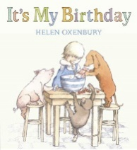 | Prime Areas  Continue to listen to stories; developing comprehension, recognise setting and characters. Continue to extend vocabulary. Encourage use of longer sentences and begin to express a point of view, using words as well as actions. ⎫ Develop a good posture when sitting at a table and encourage a correct pencil grip. Discuss healthy choices about food, drink, activity and tooth brushing. ⎫ Develop the skills to manage personal hygiene. Make friends and develop the skills to play with one another and begin to find solutions to conflicts including negotiation. Extend language to express their feelings and consider the feelings of others. Learn how to identify and moderate their own feelings. Recognise the importance of following rues and understand why they are important.  Specific Areas  Links to specific areas- Literacy & Maths. Use print and letter knowledge in writing; and write names. Write some letters accurately and write for a purpose. Continue to develop correct letter formation. Develop skills in rhyming and begin to add more rhyming words to the string. Identify words with the same initial sound - alliteration. Read the sounds in simple and longer words to blend. Introduce digraphs. Encourage engagement in extended conversations about stories, using new vocabulary. Encourage children to hold conversations with adults and peers; asking questions ⎫ Recognise up to 6 objects, without having to count them individually (‘subitising’). Make marks as well as numerals. Begin to solve real world mathematical problems with numbers up to 10. Talk about and explore 3D shapes using informal and mathematical language. Copy, continue and create patterns. | History - Describe historical events  Art - name all the colours.  Mixing of colours  Find collections of colour.  Applying colour with a range of tools  Geography- Use picture maps and globes.  DT - Select from and use a range of tools and equipment to perform practical tasks [for example, cutting, shaping, joining and finishing]
Spring Term
Spring 1  Enchanted Worlds  The Sea  (SMATT 3) | 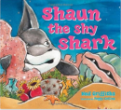  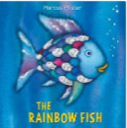  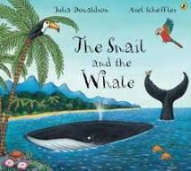  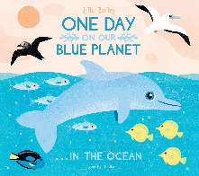 | Prime areas  Express feelings and that of others. Build constructive and respectful relationships. Think about the perspectives of others. Identify and moderate their own feelings socially and emotionally. Begin to regulate behaviour. Show independence, resilience and perseverance in the face of challenge. Explain the reasons for rules, ⎫ Connect and share ideas to another using a range of connectives responding to what they hear with relevant questions, comments and actions. Use new vocabulary through the day. Ask questions to find out more. Engage in story times Listen to and talk about stories to build familiarity and understanding. Retell the story, some as exact repetition and some in their own words. ⎫ Combine different movements with ease and fluency. Confidently and safely use a range of large and small apparatus indoors and outside, alone and in a group. Develop overall body-strength, balance, co-ordination and agility. Develop a range of ball skills. Become more aware of different factors that support health and wellbeing. Develop small motor skills so that they can use a range of tools competently, safely and confidently. Develop the foundations of a handwriting style which is fast, accurate and efficient.  Specific areas-  Read individual letters by saying the sounds for them. Read some letter groups that each represent one sound and say sounds for them. Read a few common exception words. Re-read books to build confidence in word reading. Anticipate and recall key events in stories. Use and understand recently introduced vocabulary during discussions about stories, non-fiction, rhymes and poems and during role-play. Form lowercase and capital letters correctly. Spell words by identifying the sounds and then writing the sound with letter/s. Write short sentences with words with known sound-letter correspondences ⎫ Count objects, actions and sounds. Count beyond ten. Compare numbers. Understand the ‘one more than/one less than’ relationship between consecutive numbers. Explore the composition of numbers to 10. Subitise (recognise quantities without counting) up to 5. Compose and decompose shapes so that children recognise a shape can have other shapes within it, just as numbers can. Continue copy and create repeating patterns. Compare length, weight and capacity. | Geography - skills to study the geography of the school and the key human and physical features of its surrounding environment  Art - Observe and draw landscapes  History - Select from and use a range of tools and equipment to perform practical tasks [for example, cutting, shaping, joining and finishing]  DT - Design purposeful, functional, appealing products for themselves and other users based on design criteria. | Active Learning: Participate in routines  Finding out and exploring  Being willing to ‘have a go’  Being involved and concentrating  Keep on trying  Enjoying achieving what they set out to do  Having their own ideas  Making links  Choosing ways to do things | Sea life  Centre trip
Spring 2  Enchanted worlds  Space  (SMATT 2) | 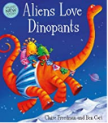 | Prime Areas  Continue to build respectful relationships. Think about the perspectives of others. Set and work towards simple goals, being able to wait for what they want and control their immediate impulses when appropriate. Give focused attention to what the teacher says, responding appropriately even when engaged in activity, and show an ability to follow instructions involving several ideas or actions. ⎫ Listen attentively, respond, and ask relevant questions, comments and actions when being read to and during whole class discussions and small group interactions. Offer explanations for why things might happen, making use of recently introduced vocabulary from stories, non-fiction, rhymes and poems when appropriate. ⎫ Use their core muscle strength to achieve a good posture when sitting at a table or sitting on the floor. Combine different movements with ease and fluency. Confidently and safely use a range of large and small apparatus indoors and outside, alone and in a group. Develop overall body-strength, balance, co-ordination and agility. Further develop and refine a range of ball skills including: throwing, catching, kicking, passing, batting, and aiming. Develop confidence, competence, precision and accuracy when engaging in activities that involve a ball. Know and talk about the different factors that support their overall health and wellbeing: Develop the foundations of a handwriting style which is fast, accurate and efficient. Begin to show accuracy and care when drawing.  Specific areas-  Form lower-case and capital letters correctly. Spell words by identifying the sounds and then writing the sound with letter/s. Write short sentences with words with known sound-letters. Begin to use a capital letter and full stop. Blend sounds into words, so that they can read short words. Read some digraphs that represent one sound and say sounds for them. Read simple phrases and sentences with some exception words. Re-read these books to build up their confidence in word reading, their fluency and their understanding and enjoyment. Re-read what they have written to check that it makes sense. ⎫ Understand the ‘one more than/one less than’ relationship between consecutive numbers. Explore the composition of numbers to 10. Automatically recall number bonds for numbers 0–10. Select, rotate and manipulate shapes in order to develop spatial reasoning skills. Explore and represent patterns within numbers up to 10, including evens and odds, double facts | History - Use stories to encourage children to distinguish between fact and fiction. Describe significant people from the past  Geography - Draw picture maps of imaginary places and from stories  Art - Develop impressed images  DT - Select from and use a range of tools and equipment to perform practical tasks [for example, cutting, shaping, joining and finishing. | Active Learning: Participate in routines  Finding out and exploring  Being willing to ‘have a go’  Being involved and concentrating  Keep on trying  Enjoying achieving what they set out to do  Having their own ideas  Making links  Choosing ways to do things
SuSumm
Summer Term
Summer 1  Where are we going ow shall we get there?  The Rainforest  (SMATT 3) | 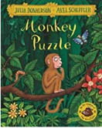  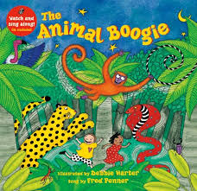  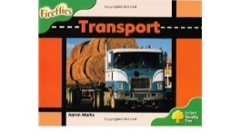 | Prime areas  Extend vocabulary show an ability to follow instructions involving several ideas or actions, understanding the importance of healthy food choices. Make comments about what they have heard and ask questions to clarify their understanding; Offer explanations for why things might happen, making use of recently introduced vocabulary from stories, nonfiction, rhymes and poems when appropriate. Begin to show accuracy and care when drawing.  Specific areas  Write simple phrases and sentences that can be read by others. Read aloud simple sentences and books that are consistent with their phonic knowledge, including some common exception words. Anticipate – where appropriate, Recall key events in stories, Compose and decompose shapes so that children recognise a shape can have other shapes within it, just as numbers can. How quantities can be distributed equally. Automatically recall number bonds, including subtraction facts and some number bonds to 10, including double facts. | Geography - Ask and answer geographical questions. Learn names of some places within/around the UK.  Art - Observe and draw landscapes. Find collections of colour. Create patterns − Develop impressed images.  DT - Build structures, exploring how they can be made stronger, stiffer and more stable  History - Ask questions such as: What was it like for people? What happened? How long ago? | Active Learning: Participate in routines  Finding out and exploring  Being willing to ‘have a go’  Being involved and concentrating  Keep on trying  Enjoying achieving what they set out to do  Having their own ideas  Making links  Choosing ways to do things
Summer 2  Holidays – The seaside  (SMATT 4) | 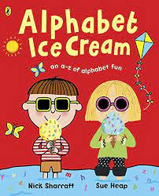  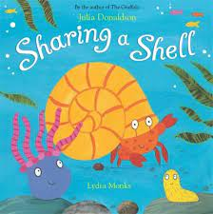 | Prime areas  Express their feelings and consider the feelings of others. Build constructive and respectful relationships. Think about the perspectives of others. Be confident to try new activities and show independence, resilience and perseverance in the face of challenge. Make comments about what they have heard and ask questions to clarify their understanding. Hold conversation when engaged in back-and-forth exchanges with their teacher and peers. Offer explanations for why things might happen, making use of recently introduced vocabulary from stories, non-fiction, rhymes and poems when appropriate. Express their ideas and feelings about their experiences using full sentences, including use of past, present and future tenses and making use of conjunctions, with modelling and support from their teacher. Demonstrate strength, balance and coordination when playing. Move energetically, such as running, jumping, dancing, hopping, skipping and climbing. Hold a pencil effectively Begin to show accuracy and care when drawing.  Specific areas  Write simple phrases and sentences that can be read by others. Say a sound for each letter in the alphabet and at least 10 digraphs. Read aloud simple sentences and books that are consistent with their phonic knowledge, including some common exception words. Anticipate – where appropriate, Recall key events in stories. Use and understand recently introduced vocabulary during discussions about stories, nonfiction, rhymes and poems and during role-play. Automatically recall (without reference to rhymes, counting or other aids) number bonds up to 5 (including subtraction facts) and some number bonds to 10, including double facts. Verbally count beyond 20, recognising the pattern of the counting system. Compare quantities up to 10 in different contexts, recognising when one quantity is greater than, less than or the same as the other quantity. Compare length, weight and capacity | History - Sequence and match artefacts from distinctly different periods of time. Label time lines with words or phrases such as: past, present, older and newer  Geography - Identify the key features of a location in order to say whether it is a city, town, village, coastal or rural area.  Name and locate the world’s continents and oceans. Draw picture maps of imaginary places and from stories  Art - Extend the variety of drawings tools  DT - Design purposeful, functional, appealing products for themselves and other users based on design criteria | Active Learning: Participate in routines  Finding out and exploring  Being willing to ‘have a go’  Being involved and concentrating  Keep on trying  Enjoying achieving what they set out to do  Having their own ideas  Making links  Choosing ways to do things

