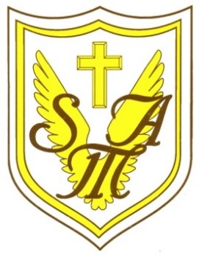
Recognising and celebrating the presence of Christ in one another.
St Mary of the Angels Catholic Primary School
Weston Crescent, Aldridge, WS9 0HA
E: postbox@st-maryangel.walsall.sch.uk
T: 01922 743 411
W: www.st-maryangel.walsall.sch.uk
@SMAAldridge
Headteacher: Mrs N. Hill

Friday 29th September 2023.

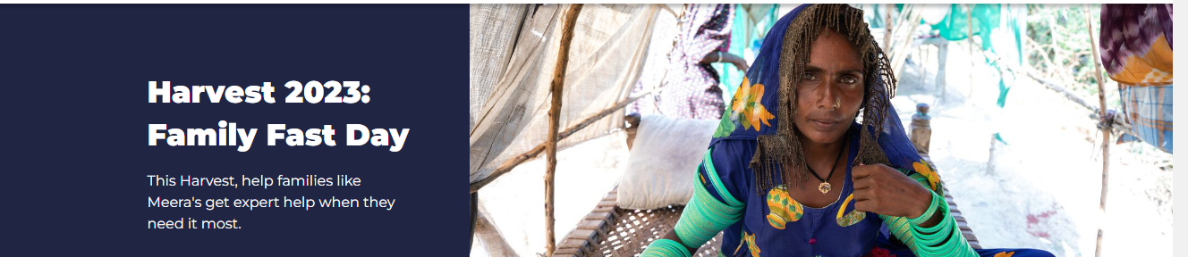
Dear Parents,
Hello, we are the Mini Vinnies and our role is to help lead the school to live simply and in solidarity with others.
For this reason, we are asking all classes, on Family Fast Day, Friday October 6th, to consider swapping their school dinner or packed lunch, with all the nice things we have to choose, for soup and a roll and a pudding.
By doing this we will be showing compassion and love to our global family who often do not have enough to eat and will also help raise money for CAFOD who help our global family with their needs. You can find out how this money will help here:
https://cafod.org.uk/fundraise/family-fast-day
If your child would like to participate and support this, please book in the usual way on the School Gateway.
Many thanks for your continued support as we work together in solidarity for the common good.
Yours Sincerely
The Mini Vinnies

E. J. Hayes (Assistant Head and RE Lead)

