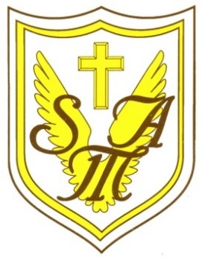
Recognising and celebrating the presence of Christ in one another.
St Mary of the Angels Catholic Primary School
Weston Crescent, Aldridge, WS9 0HA
E: postbox@st-maryangel.walsall.sch.uk
T: 01922 743 411
W: www.st-maryangel.walsall.sch.uk
@SMAAldridge
Headteacher: Mrs N. Hill

Friday 23rd September 2022

Dear Parents,

As a school we have signed up to the CAFOD’s Live Simply award. This is an opportunity for our school community to respond to the Church’s call to live simply, sustainably and in solidarity with the world’s poorest. It is an invitation to follow in the footsteps of Jesus who lived and preached a simple life, and to take meaningful action on the ecological crisis we face today.
Over the year, your children will take part in various projects to help live simply, sustainably and in solidarity with others. There will be opportunities for parents to also support and be involved, which we will share these with you as they arise.
The first of these projects is to link with the Season of Creation which is celebrated in the month of September and early October. During this time the pupils are learning to appreciate God’s creation and to think of ways that they can take care of the world. The children, through bible stories and the “Laudato Si” letter and video, from Pope Francis, will write pledges on how they can take small actions to look after the world and reduce the climate warming.
As part of the school community, we would like to encourage you, as a family, to take some time to watch the video and agree a family pledge that can help towards taking care of the world. Examples for this may be:
- switching lights off when leave rooms,
- switching off the TV instead of leaving it on standby,
- recycling plastics and paper,
- using reusable bottles and cups
- walking to school one day a week:
The list is endless, but as St Teresa says:
“I cannot change the world, but I can cast a stone across the waters to create many ripples”
The link for the video can be found on class pages and is here below:
https://www.youtube.com/watch?v=KOgF2Kgel6k
Once you have agreed a family pledge we would love you to share this with us using the Class Pledge Book on your child’s class page.

The Live Simply Award is a lovely way to involve everyone in our community to play a part in taking care of our world. I thank you all, in advance, for taking the time to get involved.
I look forward to reading your family pledges.
Thank you for your continued support.
Yours sincerely

Emma Hayes
Assistant Head / Pastoral Lead.

