Veins carry deoxygenated blood toward the heart.

Arteries carry deoxygenated blood away from the heart.
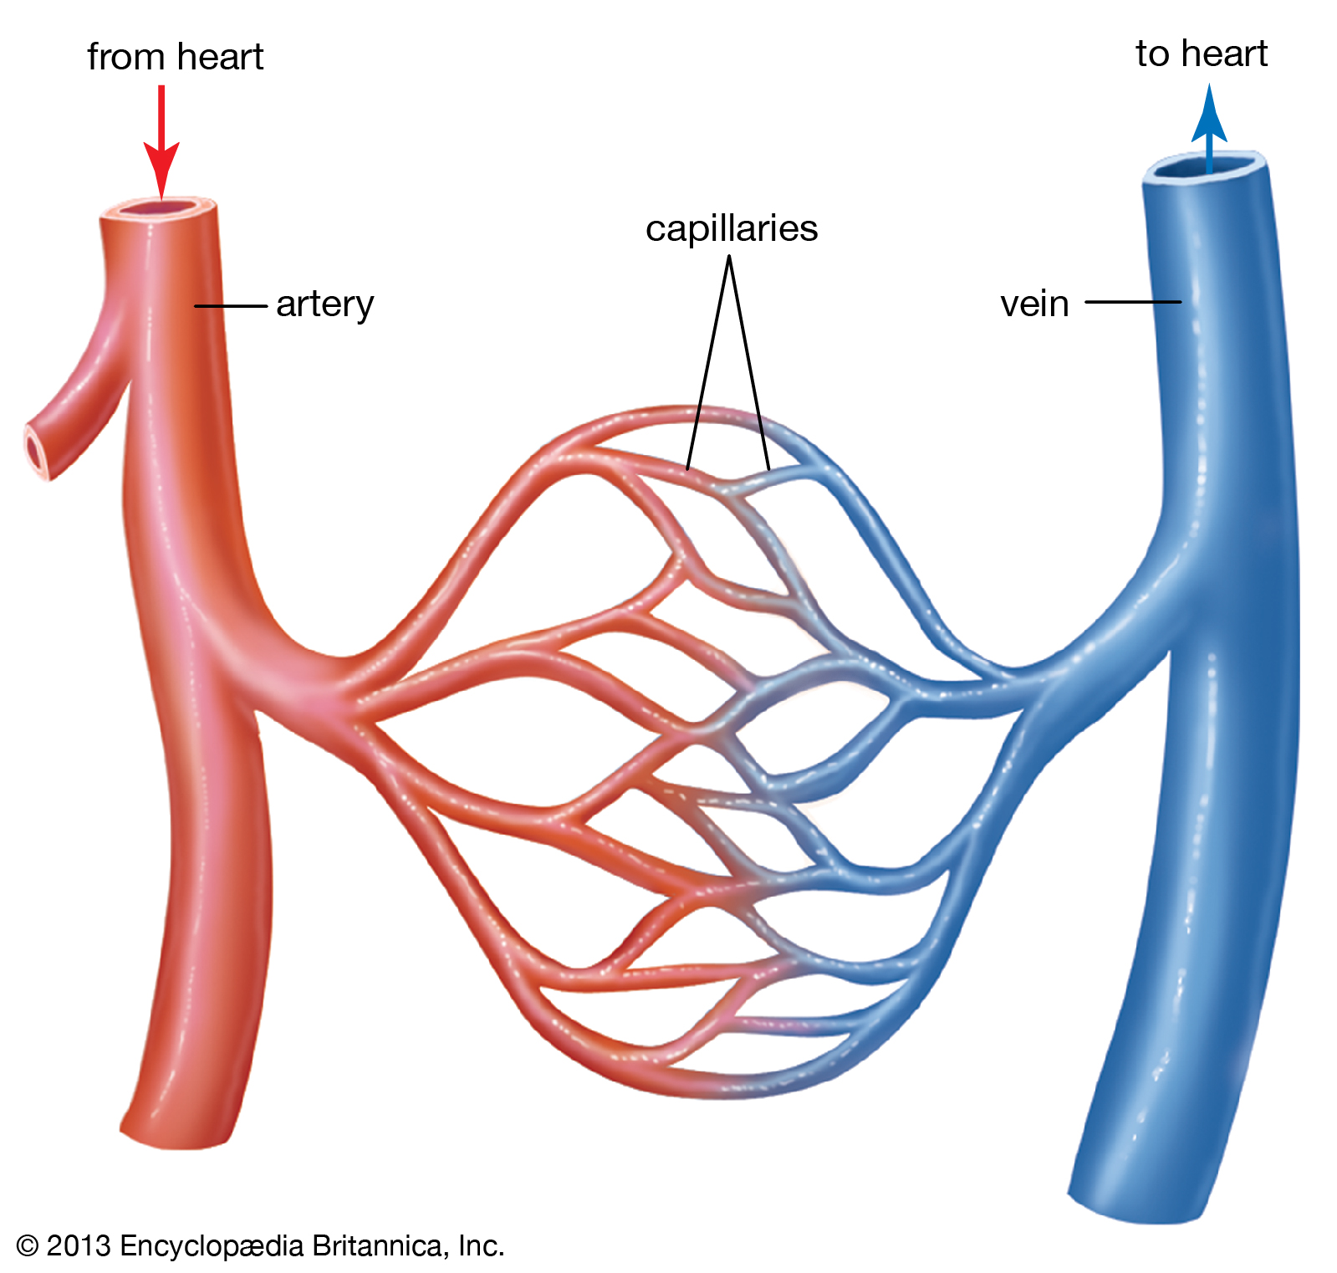
Capillaries are the smallest blood vessels in the body and it is here that the exchange of water, nutrients, oxygen and carbon dioxide takes place.
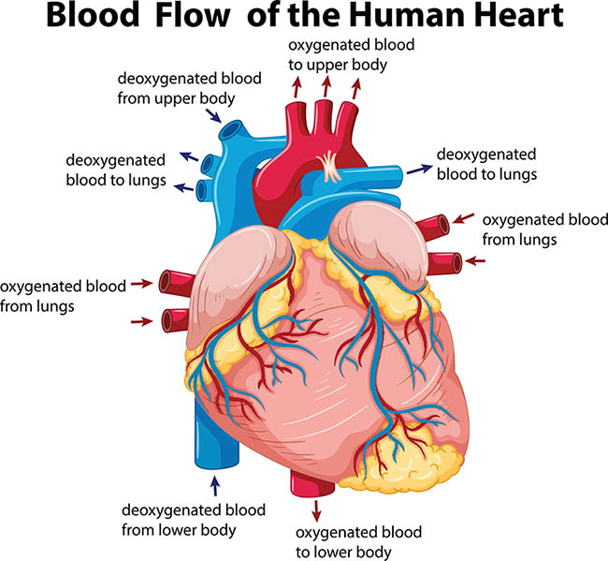

Mammals have hearts with four chambers. Notice how the blood that has come from the body is deoxygenated, and the blood that has come from the lungs is oxygenated again. The blood isn’t actually red and blue: we just like to show it like that on the diagram.
Key Vocabulary
Circulatory System | A system which includes the heart, veins, arteries and blood transporting substances around the body.
Heart | An organ which constantly pumps blood around the circulatory system.
Blood Vessels | The tube-like112 structures that carry blood through the tissues and organs. Veins, arteries and capillaries are the three types of blood vessels.
Oxygenated Blood | Oxygenated blood has more oxygen. It is pumped from the heart to the rest of the body.
Deoxygenated Blood | Deoxygenated blood is blood where most of the oxygen has already been transferred to the rest of the body.
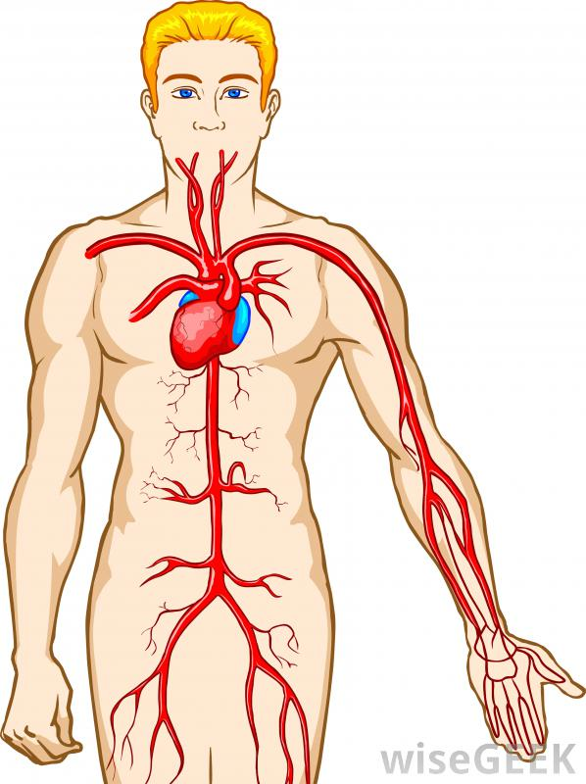
If you linked up all of the body’s blood vessels, including arteries, capillaries, and veins, they would measure over 60,000 miles.

The heart pumps blood to the lungs to get oxygen.
It then pumps this oxygenated blood around the body.

Key Vocabulary
Drug | A substance containing natural or man-made chemicals that has an effect on your body when it enters your system.
Alcohol | A drug produced from grains, fruits or vegetables when they are put through a process called fermentation.
Nutrients | Substances that animals need to stay alive and healthy.
Blood transports:
- Gases (mostly oxygen and carbon dioxide)
- Nutrients (including water)
- Waste products.
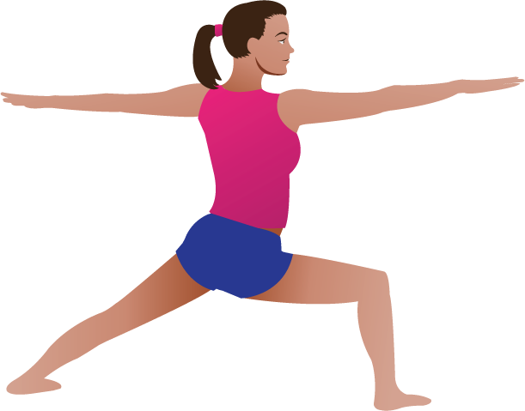
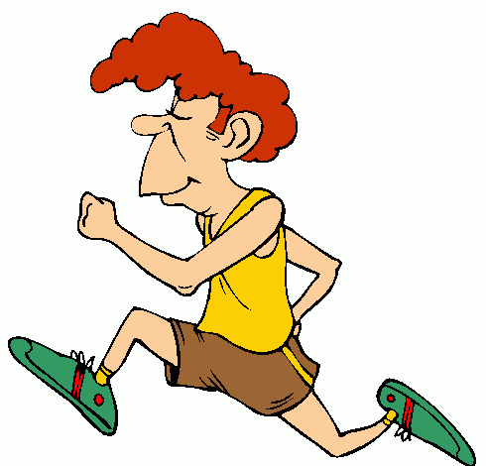

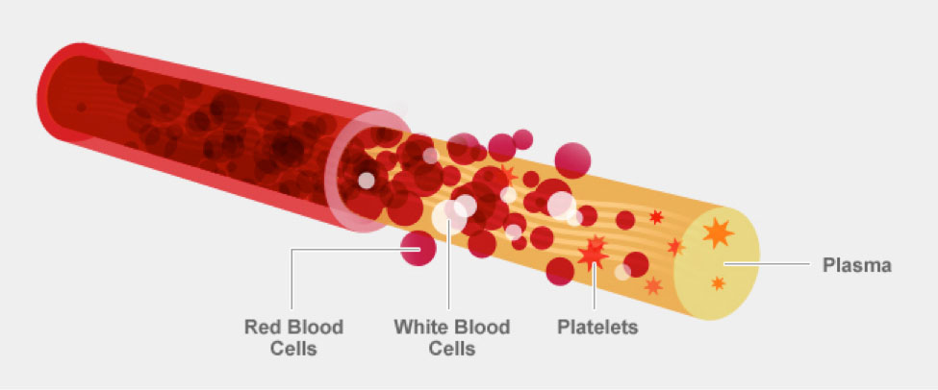
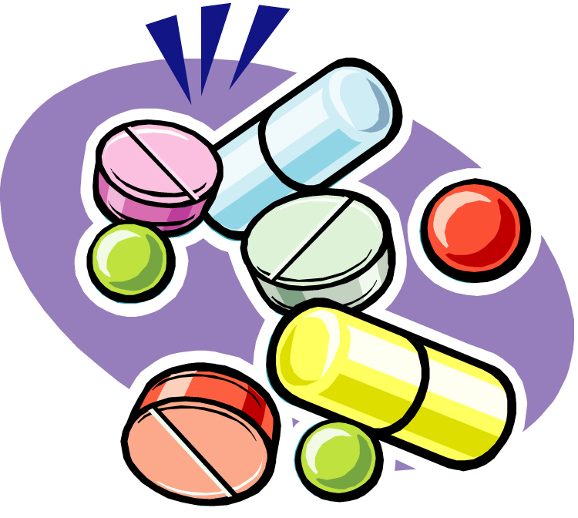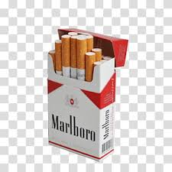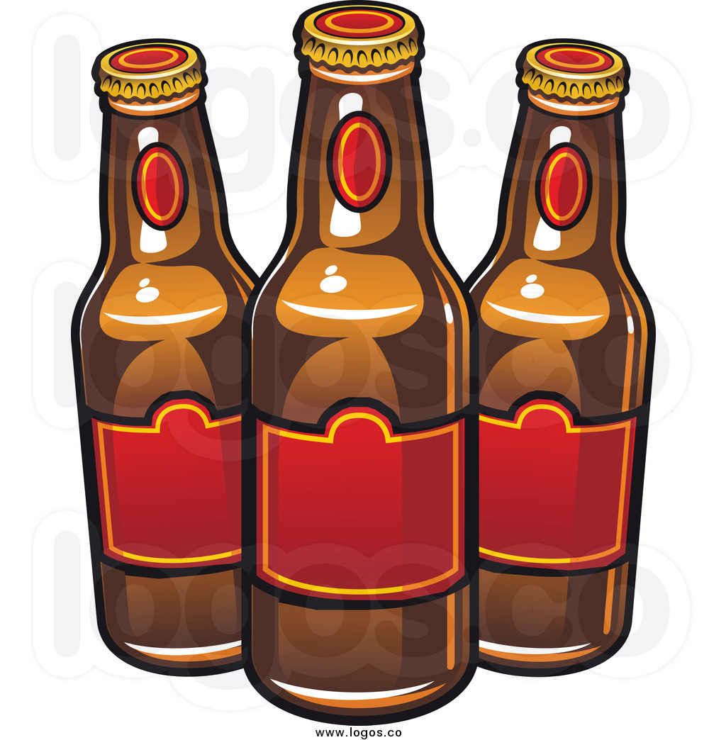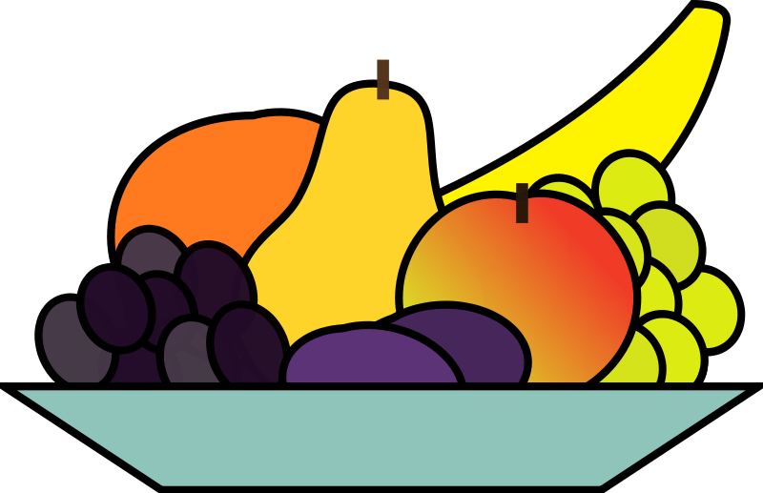
Drugs, alcohol and smoking have negative effects on the body.
A healthy diet involves eating the right types of nutrients in the right amounts.
The liquid part of blood contains water and protein. This is called plasma.
Plasma is liquid. The other parts of your blood are solid.
Regular exercise:
- Strengthens the muscles including the heart muscle
- Improves circulation
- Increases the amount of oxygen around the body
- Releases brain chemicals which help you feel calm and relaxed
- Helps you sleep more easily
- Strengthens bones.
- It can even help to stop us from getting ill.
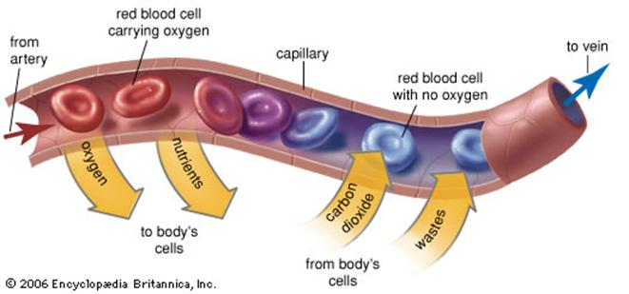
Red blood cells carry oxygen through your body.

Platelets help you stop bleeding when you get hurt.
White blood cells fight infection when you’re sick.
