|  |  |
| --- | --- |
| Key Vocabulary |  |
| Sun | A huge star that Earth and the other planets in our solar system orbit system. |
| Star | A giant ball of gas held together by its own gravity. |
| Moon | A natural satellite which orbits Earth or other planets. |
| Planet | A large object, round or nearly round, that orbits a star. |
| Sphere | A round 3D shape in the shape of a ball. |
| Spherical Bodies | Astronomical objects shaped like spheres. |
| Satellite | Any object or body in space that orbits something else, for example: the Moon is a satellite of Earth. |

Our Solar System (not to scale)

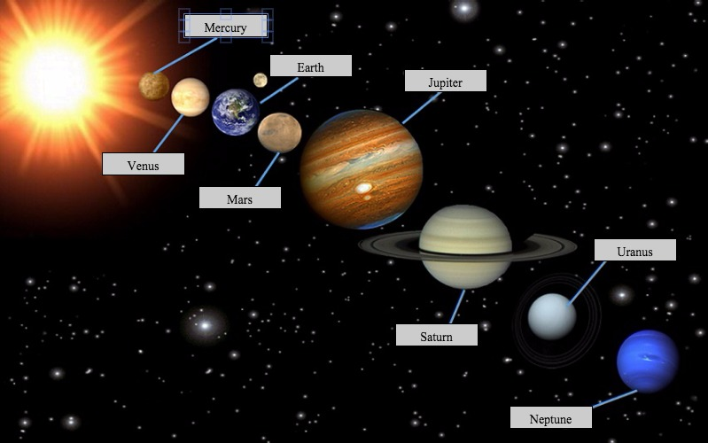

**Key Knowledge:** Mercury, Venus, Earth and Mars are rocky **planets**. They are mostly made up of metal and rock. Jupiter, Saturn, Uranus and neptune are mostly made up of gases (helium and hydrogen) although they do have cores made up of rock and metal.

Pluto used to be considered a planet but was reclassified as a dwarf planet in 2006.

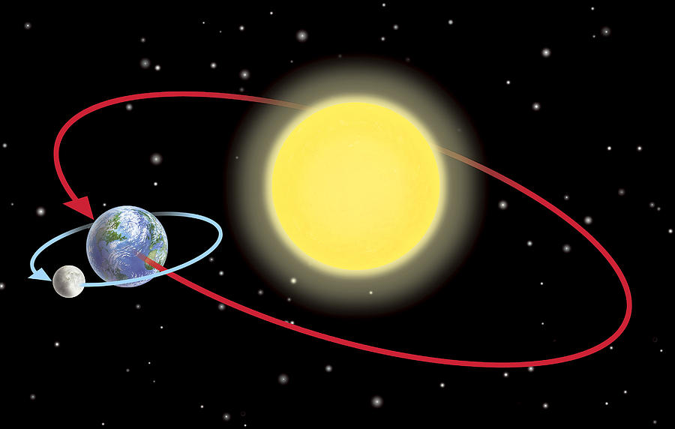

The **Moon** orbits Earth in an oval-shaped path while spinning on its axis. At various times in a month, the **Moon** appears to be different shapes. The is because the **Moon** rotates round Earth, the Sun lights up different parts of it.

|  |  |
| --- | --- |
| Key Vocabulary |  |
| Orbit | To move in a regular, repeating curved path around another object. |
| Rotate | To spin e.g. Earth rotates on its own axis. |
| Axis | An imaginary line that a body rotates around e.g. Earth’s axis (imaginary line) runs from the North Pole to the South Pole. |
| Geocentric Model | A belief people used to have that other planets and the Sun orbited around Earth. |
| Heliocentric Model | The structure of the Solar system where the planets orbit around the sun. |
| Astronomer | Someone who studies or is an expert in astronomy (space science). |

The work and ideas of many astronomers (such as Copernicus and Kepler) combined over many years before the idea of the heliocentric model was developed. Galileo’s work on gravity allowed astronomers to understand how planets stayed in orbit.

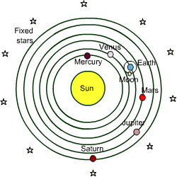

It appears to us that the Sun moves across the sky during the day but the Sun does not move at all. It seems to us that the Sun moves because of the movements of the Earth.



**Geocentric Model**

Years ago, people believed that **planets** moved around the Earth.

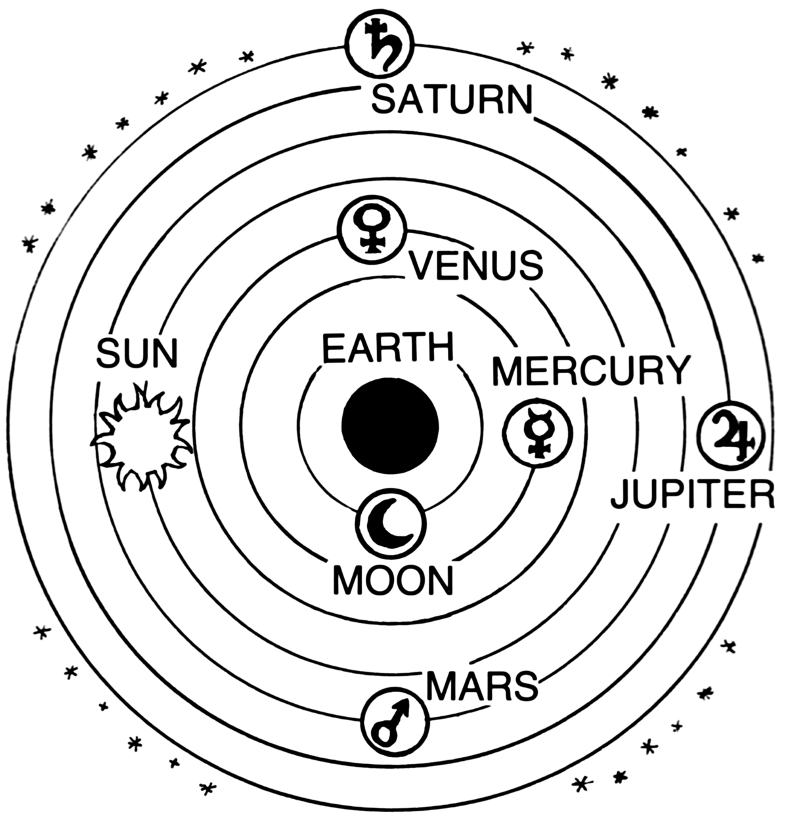

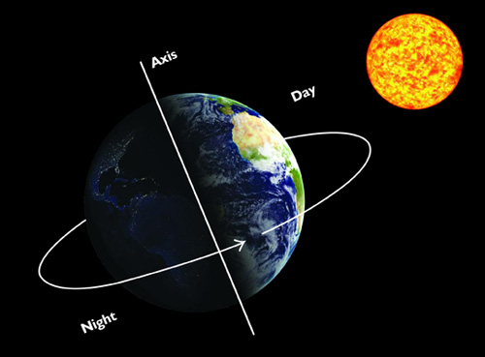

Earth rotates (spins) on its axis. It does a full rotation once in every 24 hours. At the same time that Earth is rotating, it is also orbiting (revolving) around the Sun. It takes a little more than 365 days to orbit the Sun. Daytime occurs when the side of Earth is facing towards the Sun. Night occurs when the side of the Earth is facing away from the Sun.