In the Mass what prayers are said to ask God for help ?
____________________________________________________________________________________________________________________________________________________________________________________________________________________________________________________________________________________________________________________________________

What different ways can we pray?
____________________________________________________________________________________________________________________________________________________________________________________________________________________________________________________________________________________________________________________________________

Key Vocabulary
Prayer,
Cross, Candles, Church building, Blessed Sacrament, holy water, confession, statues, genuflection, sign of peace, sukkot, Psalm.
Prayer Key Reflection
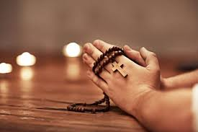
Why was prayer so important for Jesus? How does this help us to understand the importance of prayer?
___________________________________________________________________________________________________________________________________________________________________________________________________________________________________________________________________________________________________________________________________________________________________________________________________________________________________________________

What symbols help us to pray?
______________________________________________________________________________________________________________________________________________________________________________________________________________________________________________________________________________________________________________________________________________________________

What gestures and actions are associated with prayer.?
____________________________________________________________________________________________________________________________________________________________________________________________________________________________________________________________________________________________________________________________________

