Key Vocabulary
Sight | Your eyes let you see all the things around you.
Hearing | Your ears let you listen to all the things around you. Your brain is able to tell you what different sounds are.
Touch | Your skin gives you the sense of touch. You can tell if something is warm, cold, smooth or rough without even looking at it!
Taste | Your sense of taste comes from your tongue. You can tell if something tastes bitter or sweet. You might have some tastes you like and some you don’t.
Smell | You smell using your nose. Your nose can tell if things smell nice or not nice.
Senses
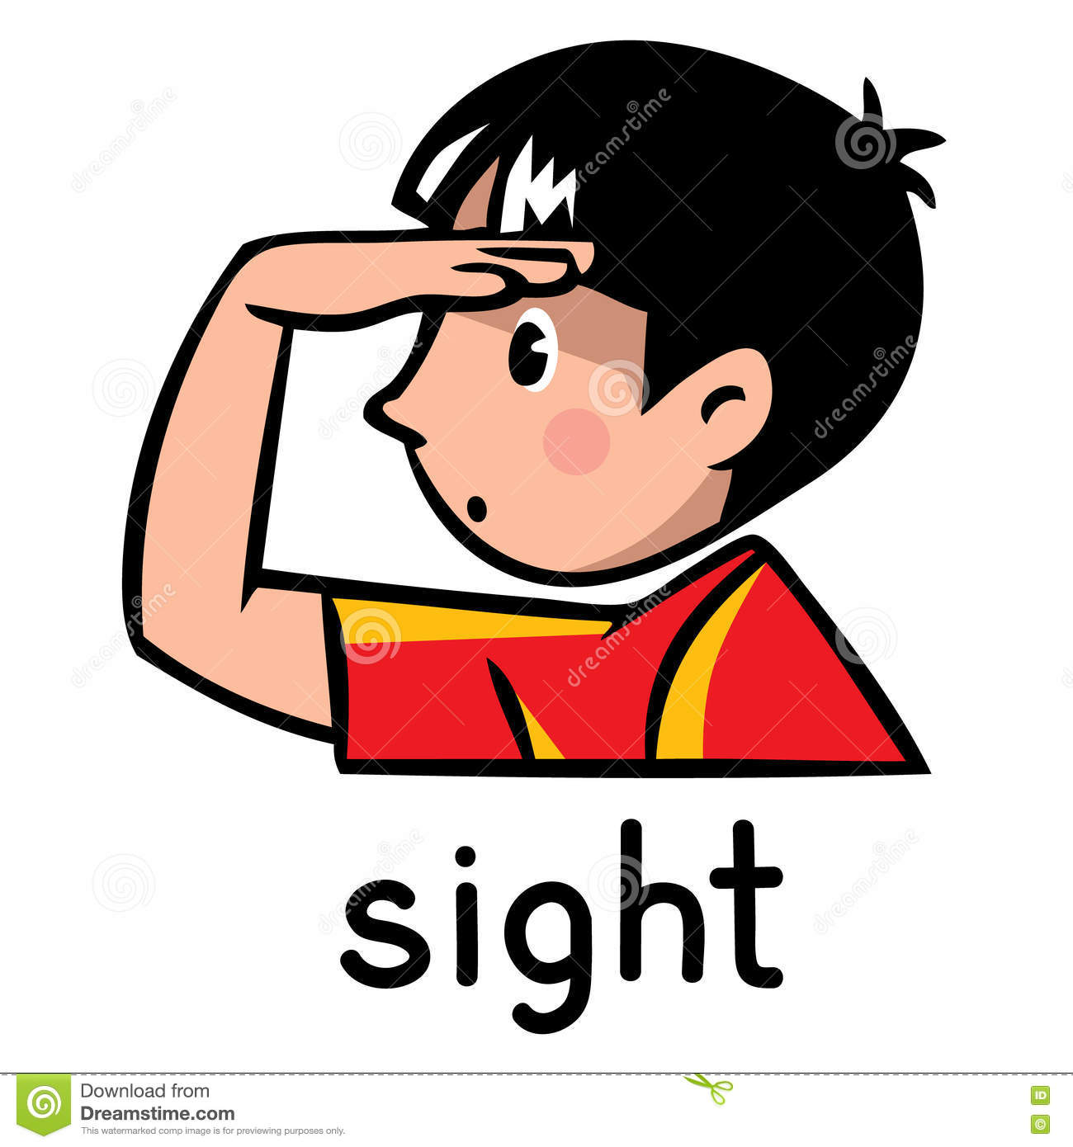
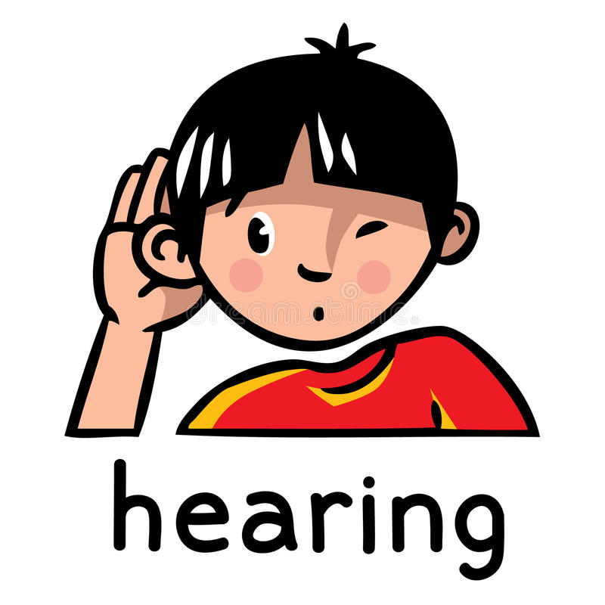
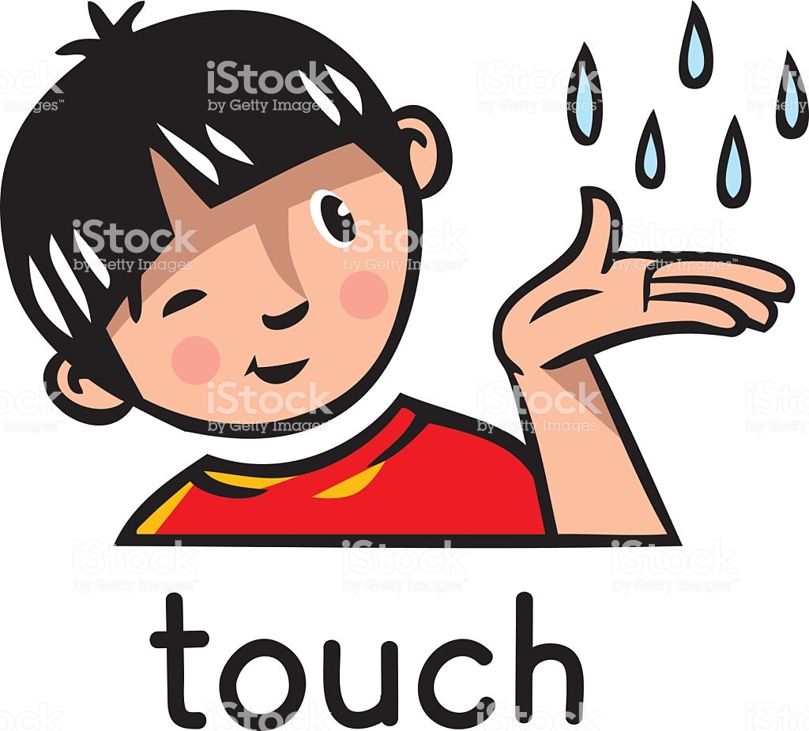
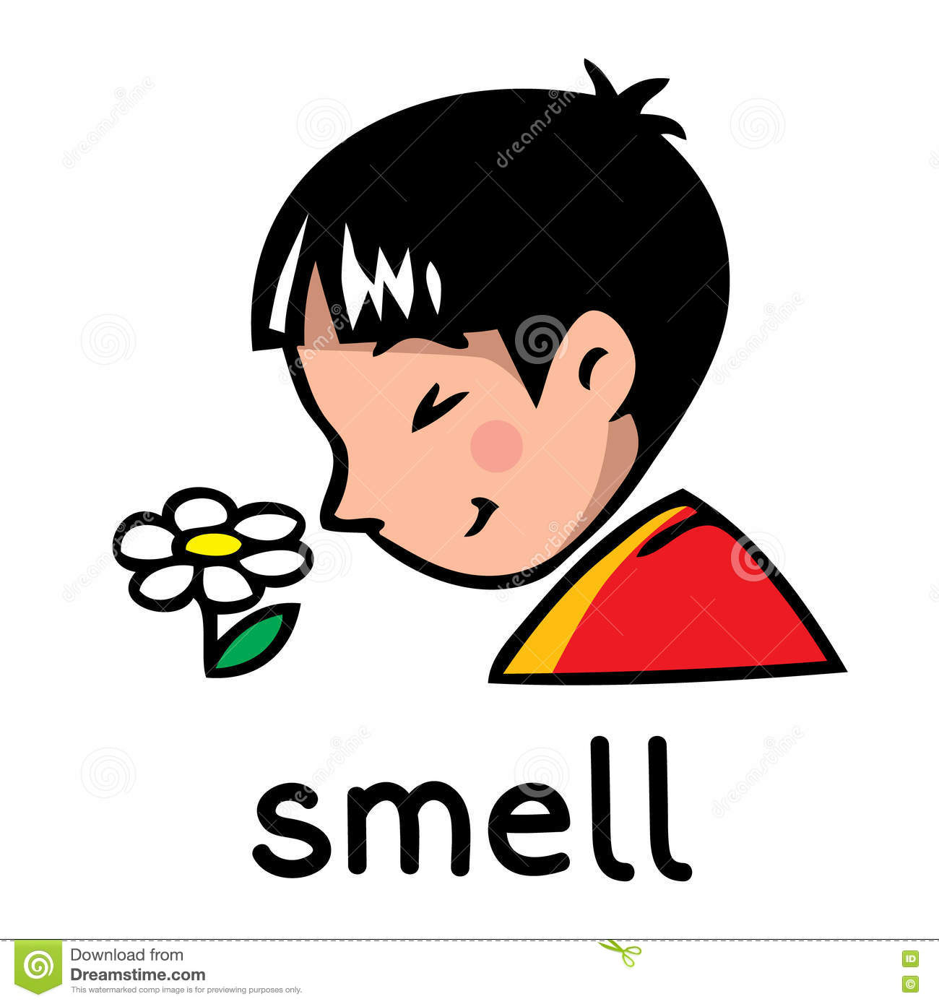

Parts of the Body
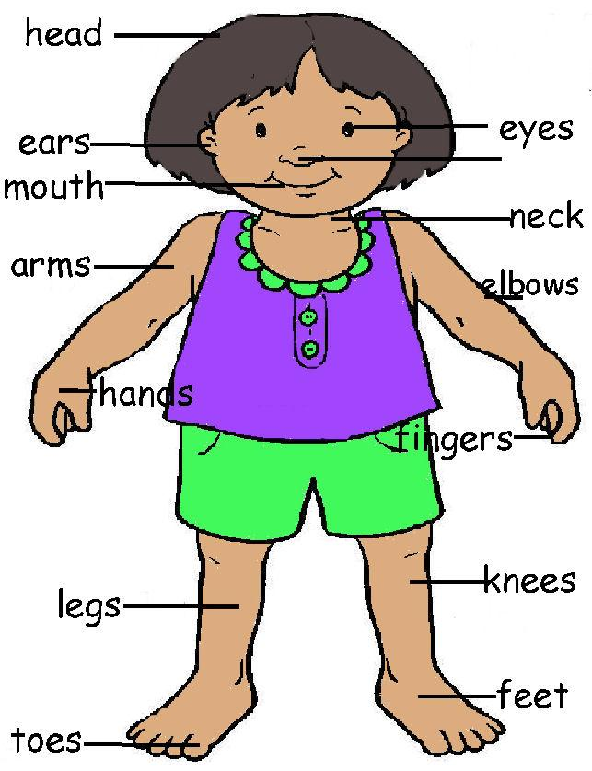

Key Vocabulary
Amphibians | Amphibians live in the water as babies and on land as they grow older. They have smooth, slimy skin.
Birds | All birds have a beak, two legs, feathers and wings.
Fish | Fish live and breathe under water. They have scaly skin, fins to help them swim and they breathe through gills.
Mammals | Mammals are animals that breathe air, grow hair or fur and feed on their mother’s milk as a baby.
Reptiles | All reptiles breathe air. They have scales on their skin.
Carnivore | Animals that mostly eat other animals (meat) are carnivores.
Herbivore | Animals that only eat plants are herbivores.
Omnivore | Aniamls that eat both plants and other animals are omnivores.
Amphibians
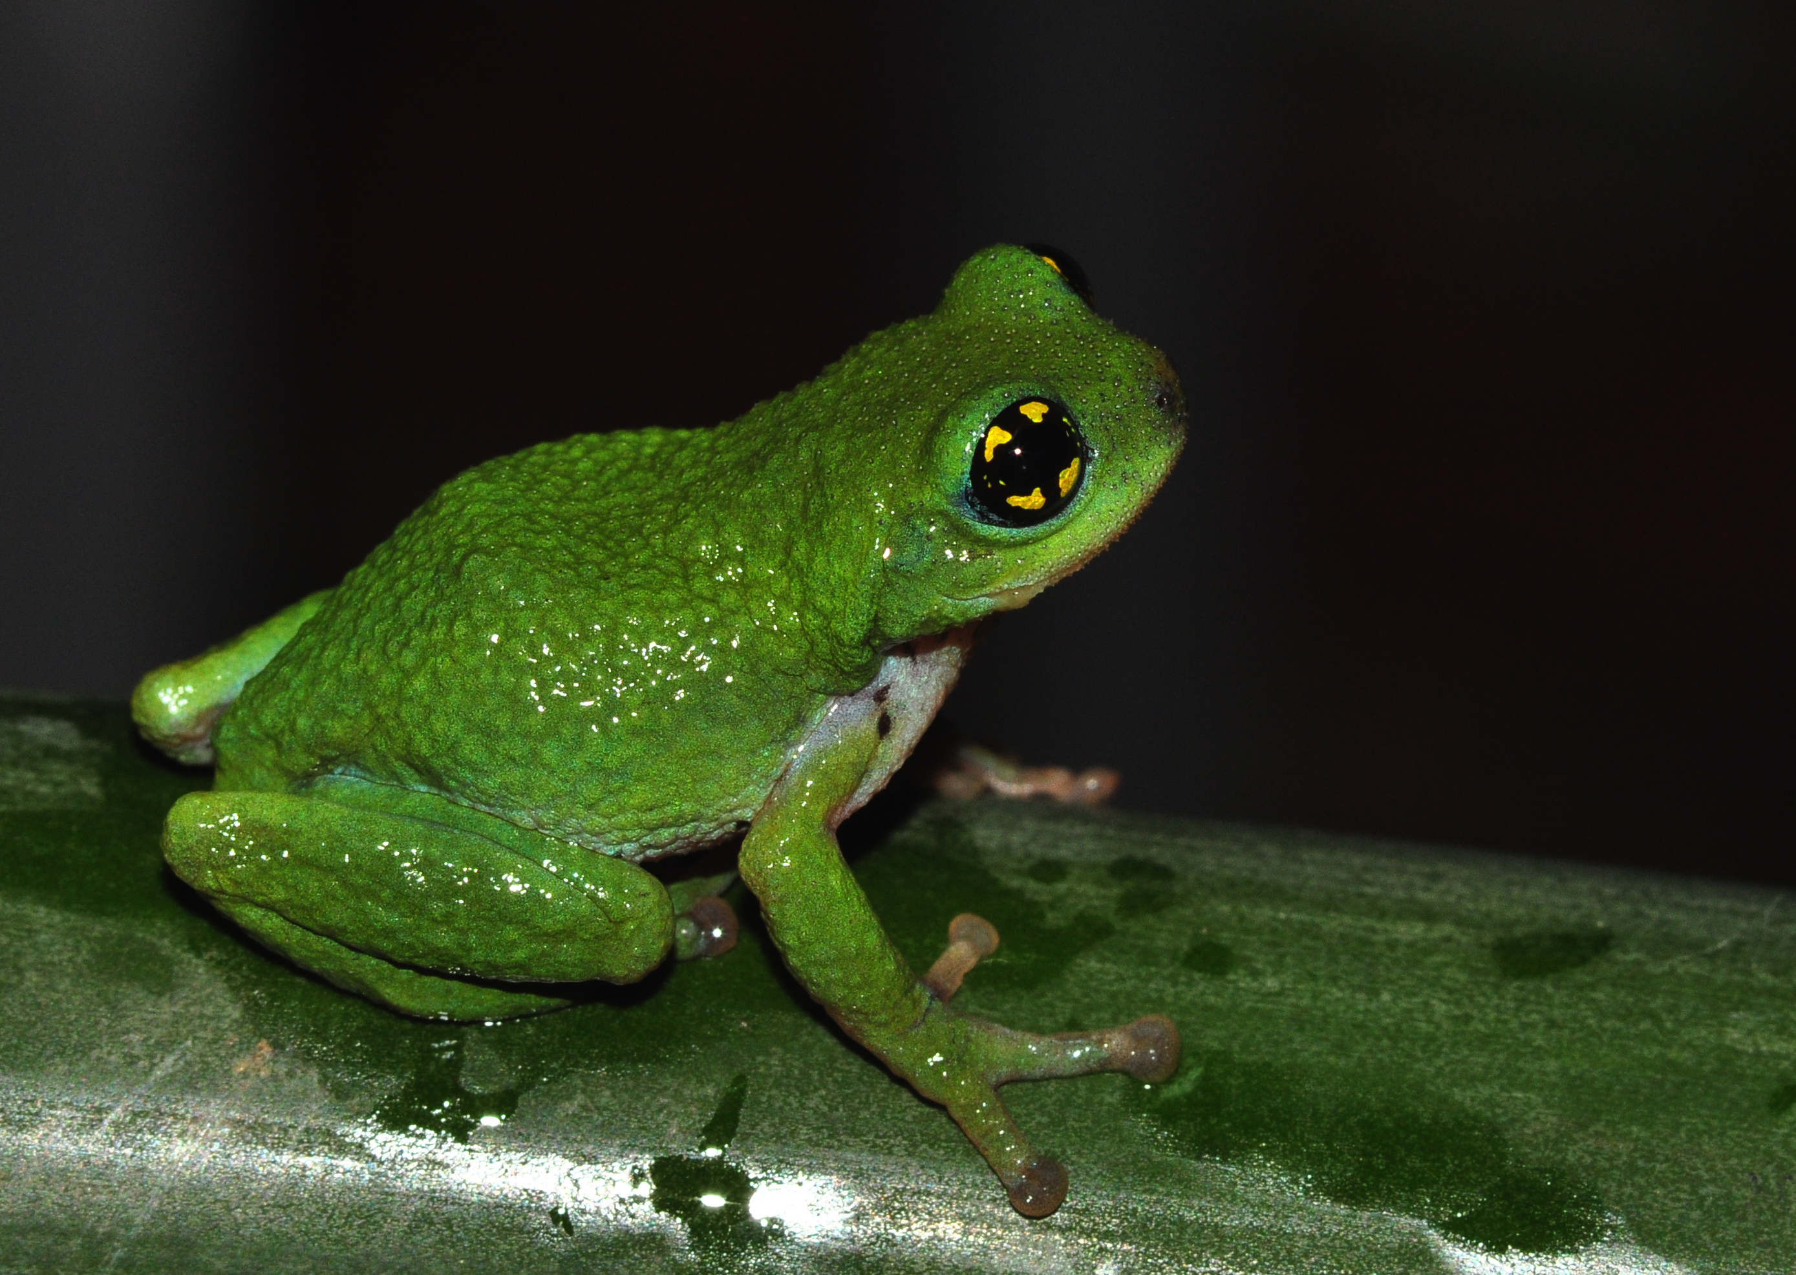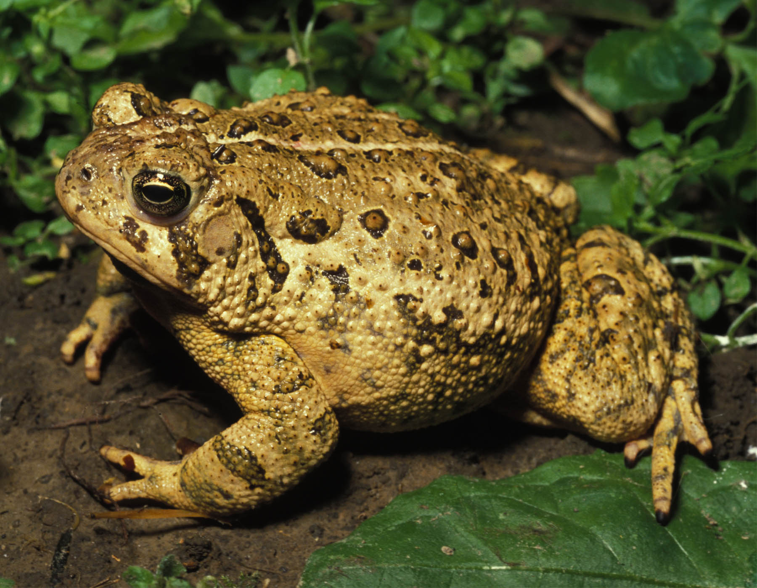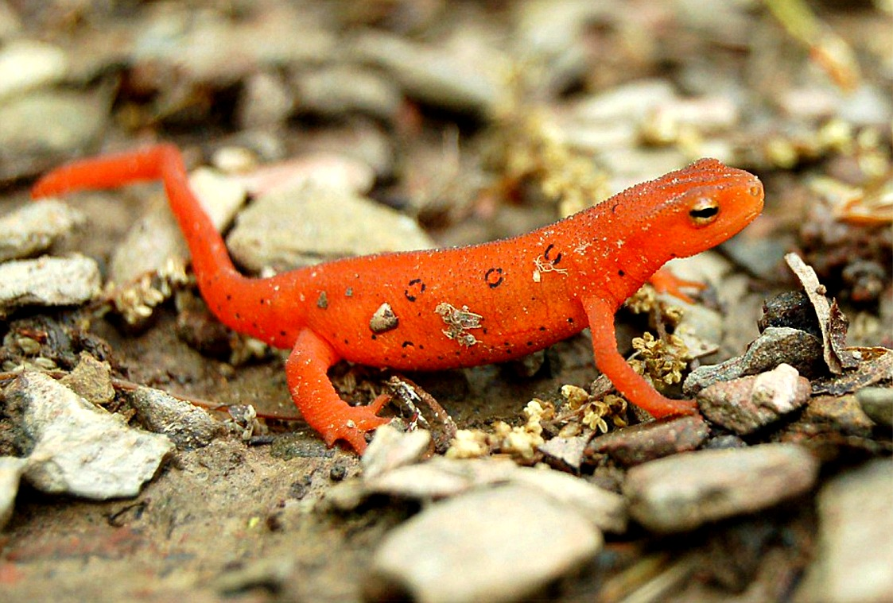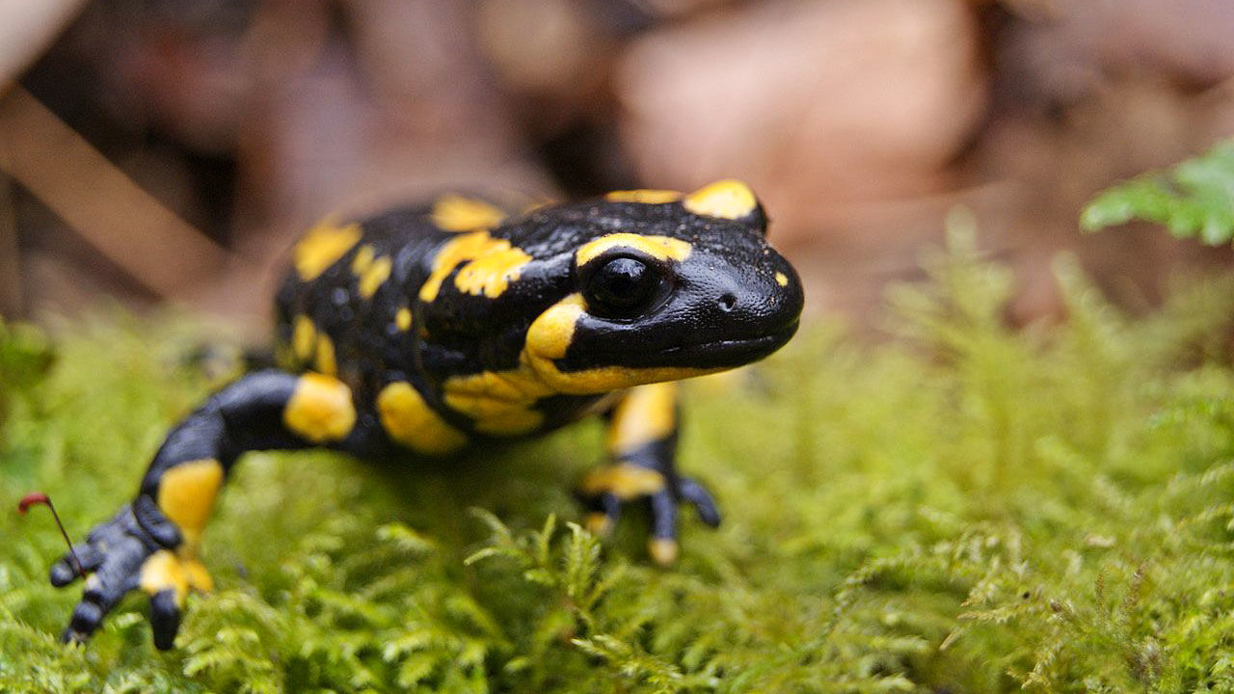
Frog Toad Newt Salamander

Reptiles
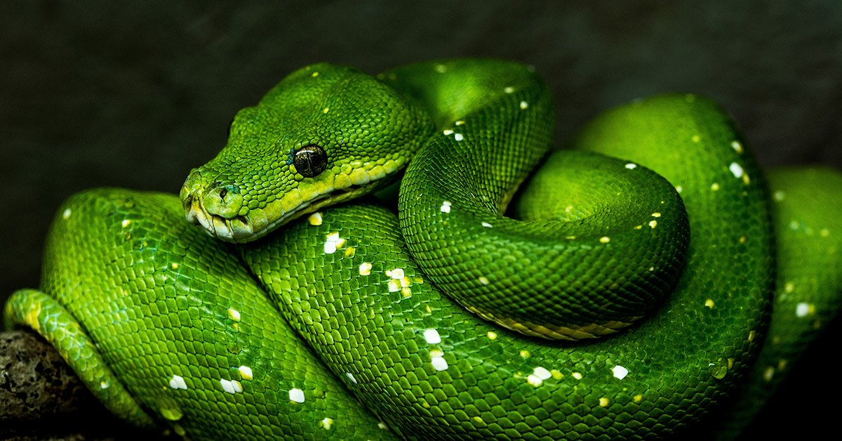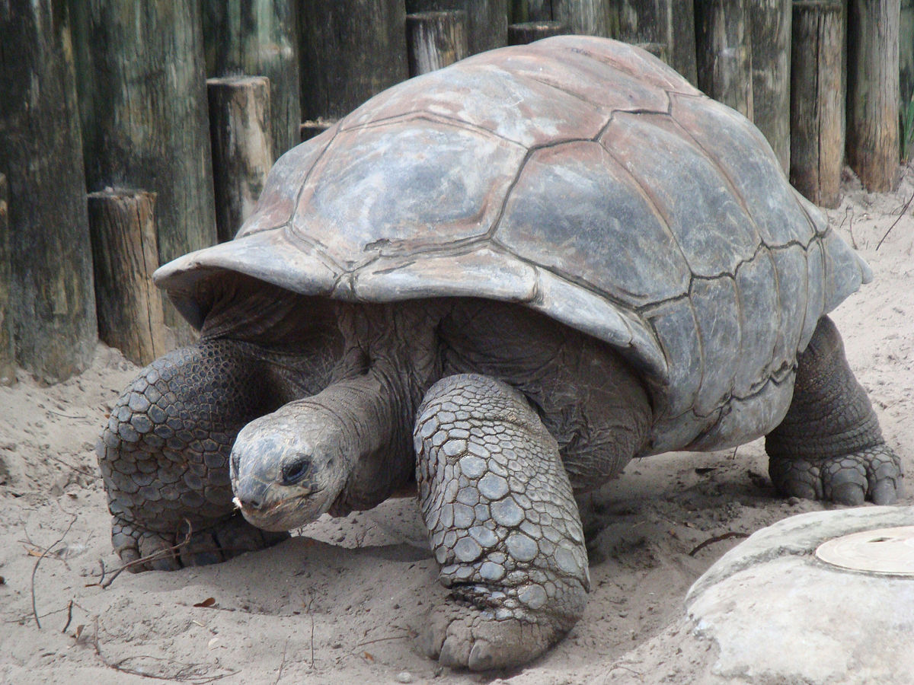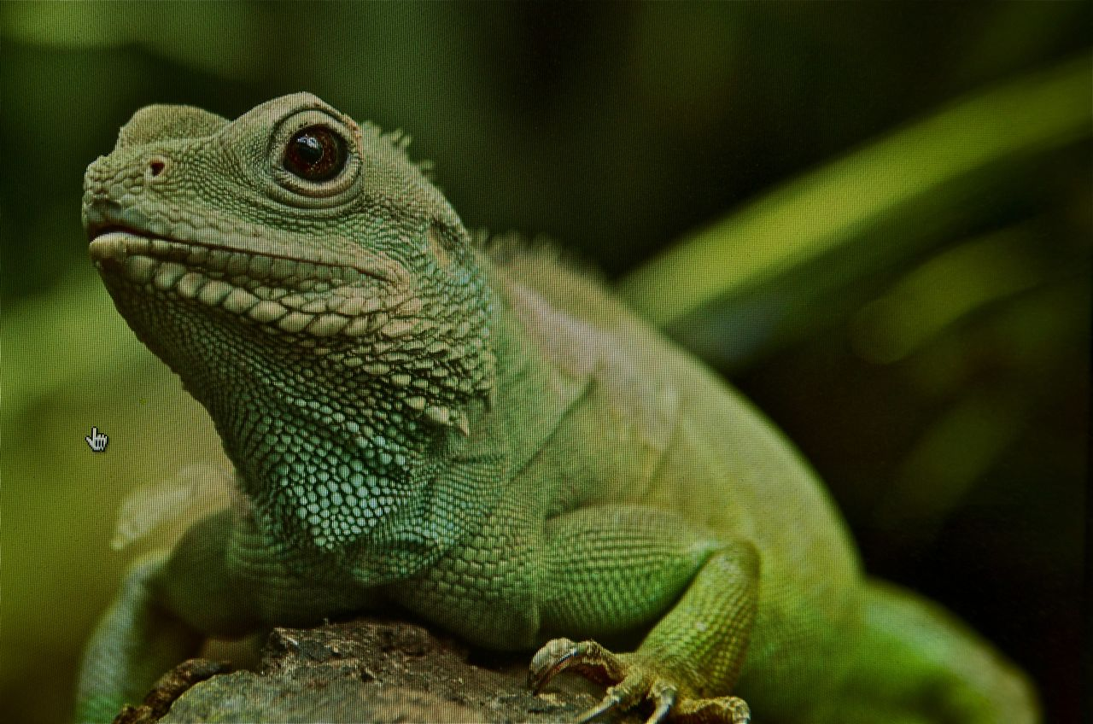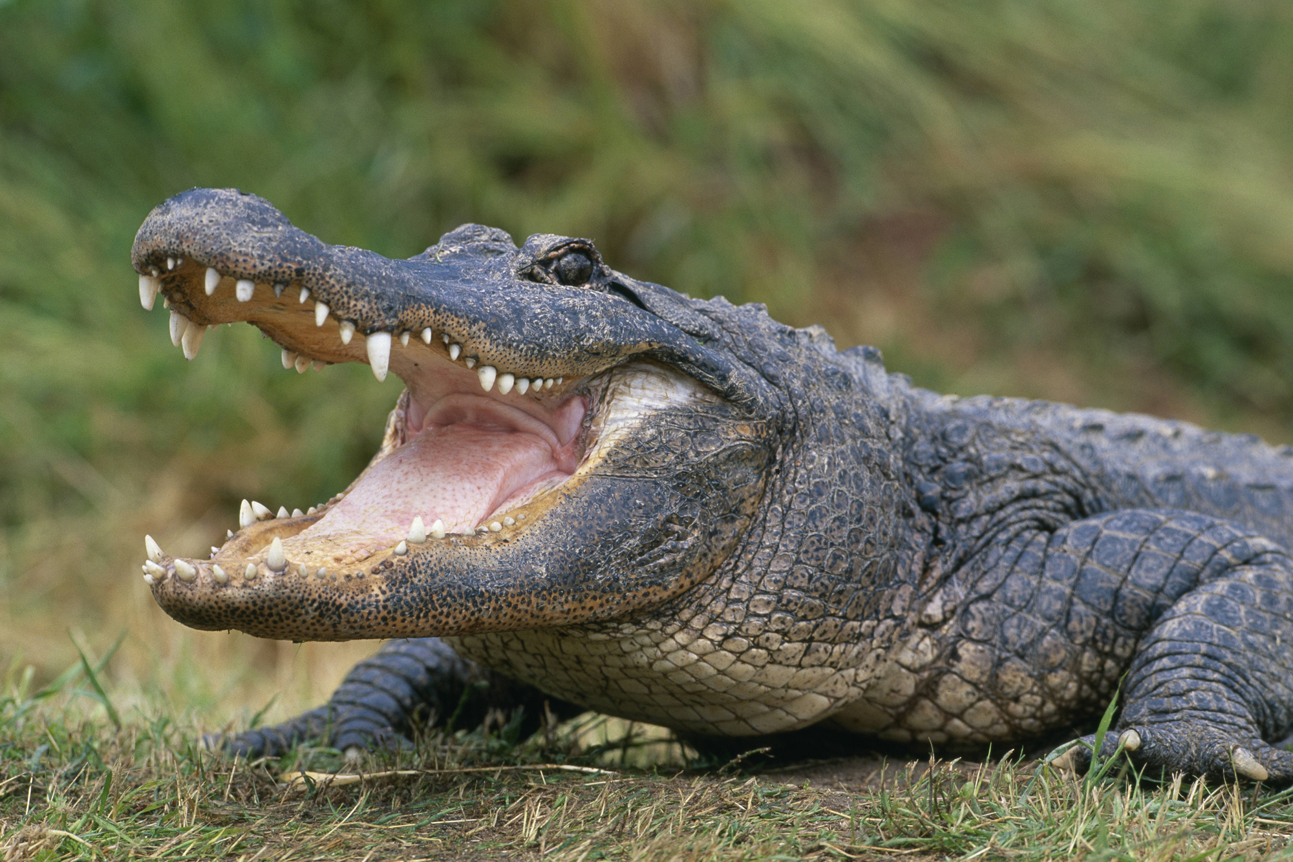
Snake Tortoise Lizard Alligator
Fish
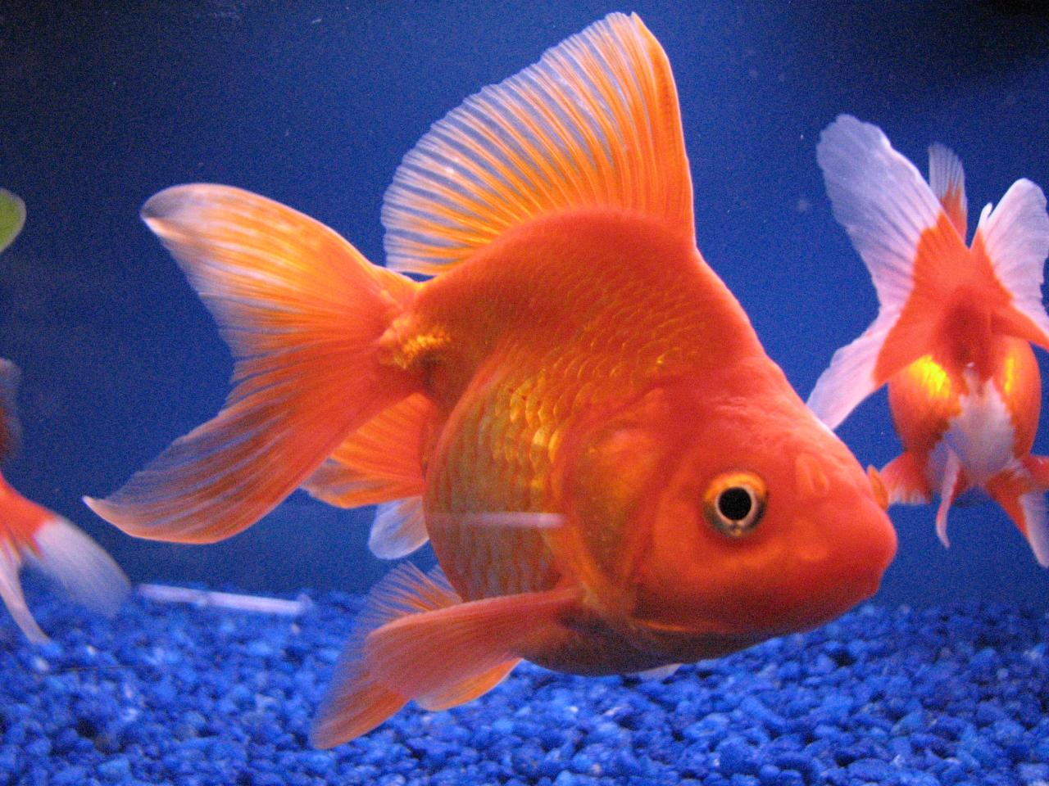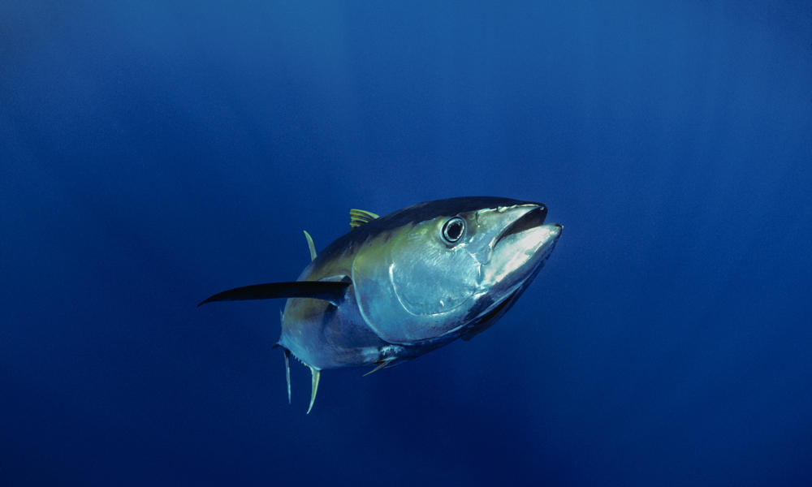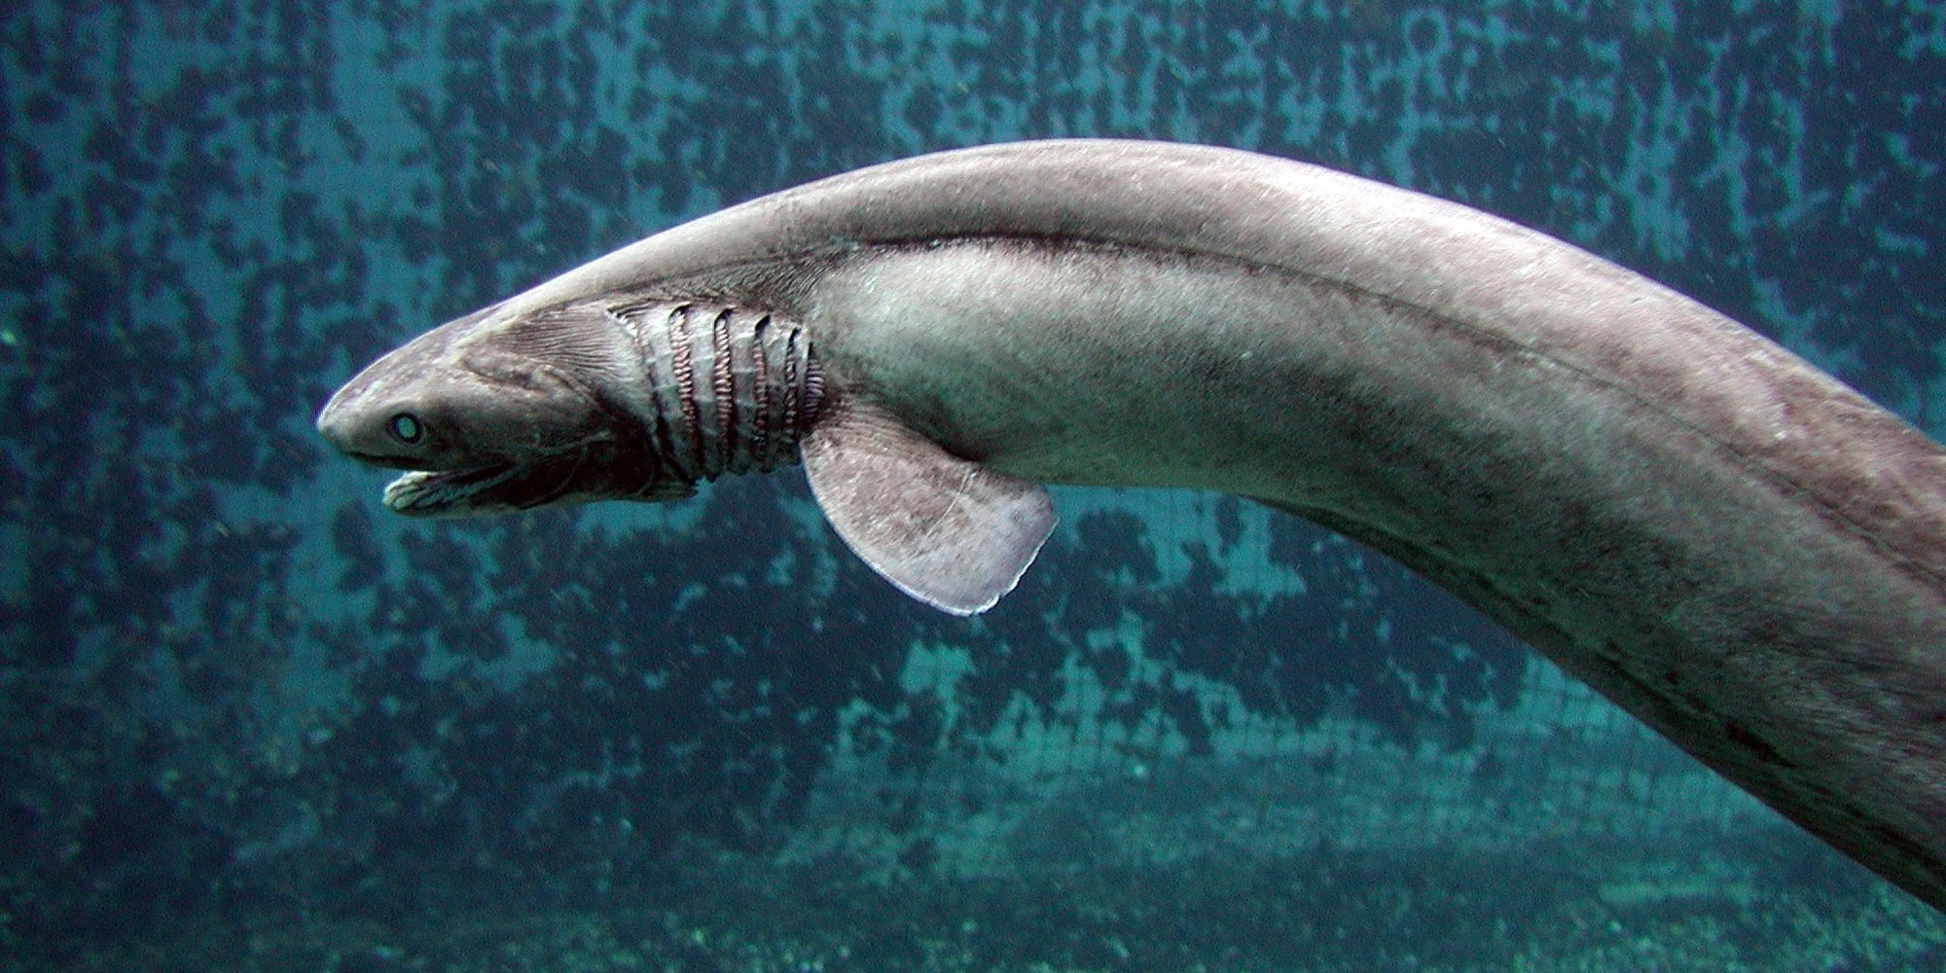
Goldfish Tuna Shark Eel
Birds
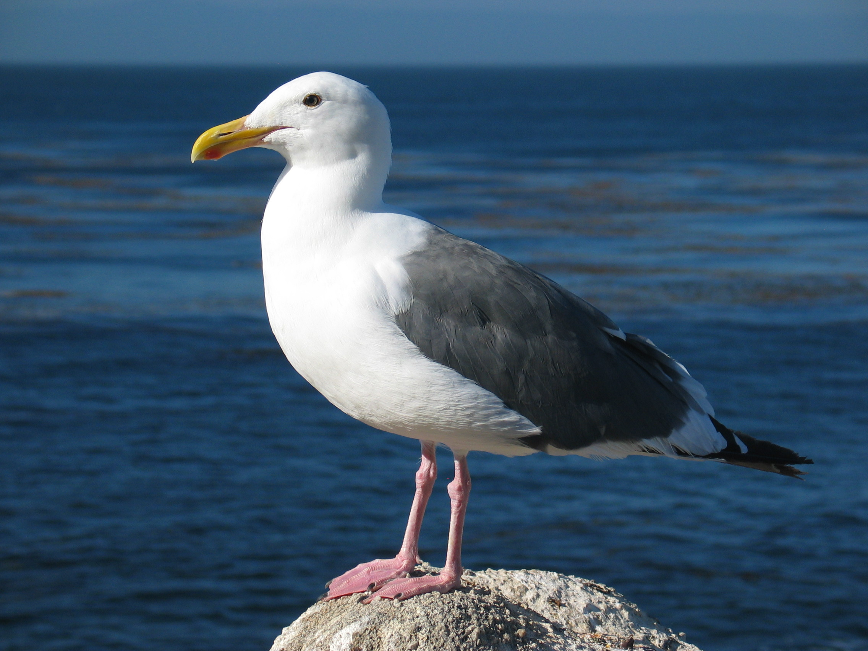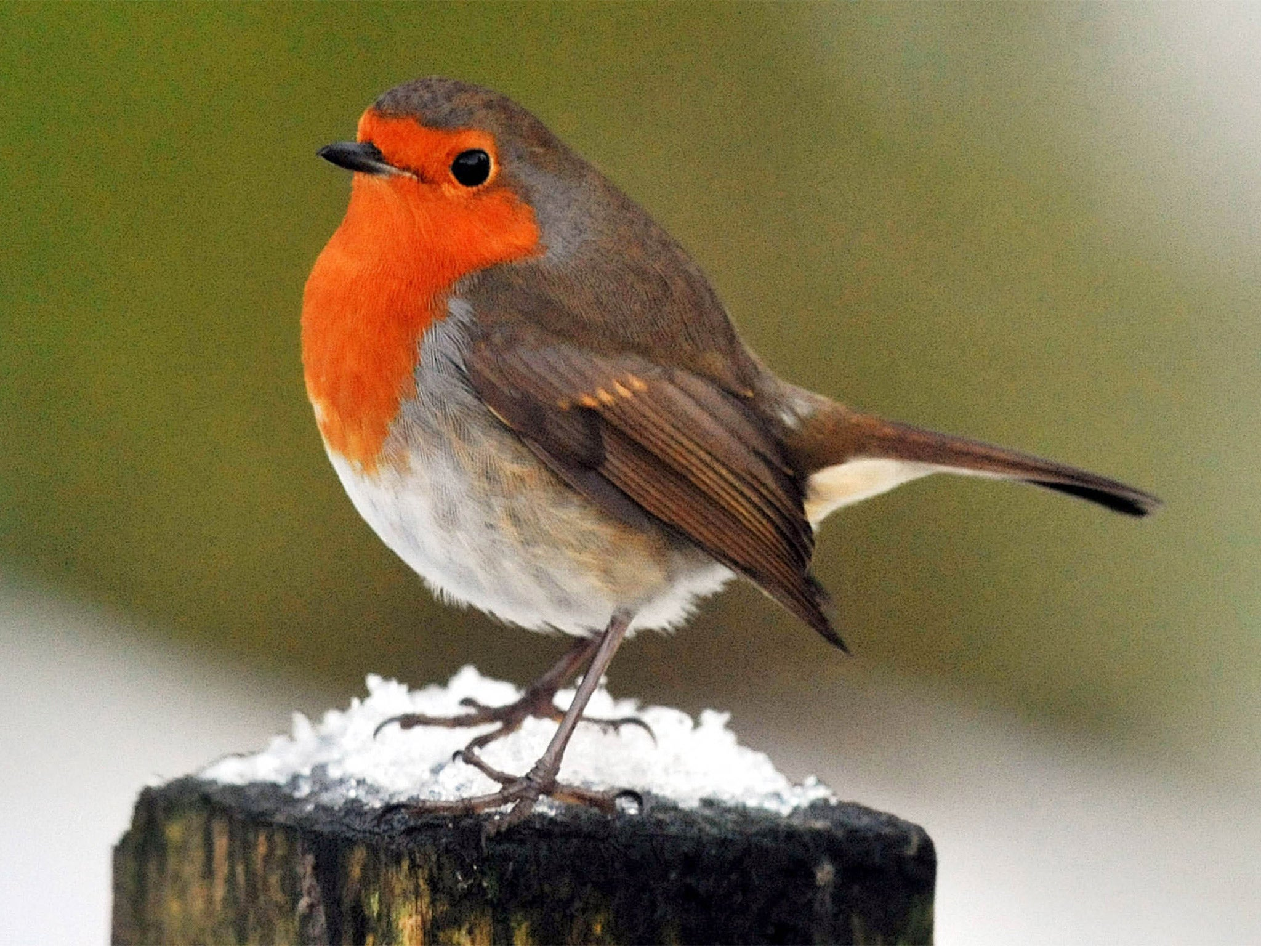
Penguin Chicken Seagull Robin
Mammals
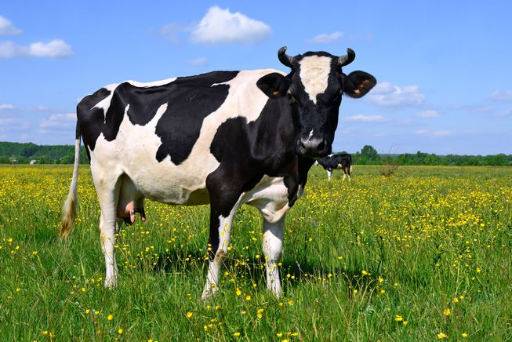
Human Mouse Dog Cow

