To Hear: Related Scripture and Texts

Key Vocabulary
Key Knowledge

- Moses is curious about a burning bush that does not burn up, and God calls him from it to lead the Israelites out of Egypt.
- God gives the Ten Commandments to the Israelites as part of His covenant, teaching them how to live as His holy people.
- The commandments show the Israelites how to love God and treat other people with respect and fairness.
- Jesus’ Great Commandment explains the purpose of all Ten Commandments: they guide us to live in love for God and for others
- A covenant is a binding agreement between God and human beings, which makes them His people.
- Obeying the Commandments helps grow virtues such as honesty, respect, and compassion, which contribute to personal and communal happiness
- Sin is a deliberate choice to disobey God and spoil our friendship with Him.
- Sin harms our relationships with other people by causing hurt, mistrust, or conflict
- A virtue is something you have to practise/exercise so it becomes a habit. Sometimes it is not easy
Exodus 3:1-15 Moses at the burning bush
Exodus 19:3-8 The Sinai Covenant with Moses
Exodus 20:1-17 The Ten Commandments
Matthew 22:36-40 Jesus' summary of the Law (aka 'The Great Commandment')
YouCat for Kids 110 Why is it important to God how I live?
Genesis 8:20-22 God's covenant with Noah
Genesis 15:1-6 God's covenant with Abraham
Exodus 19:3-8 God's covenant with Moses
- covenant a sacred agreement in which God forms a relationship with His people and invites them to respond with faith and obedience.
- prophet a person called by God to speak His truth, guide His people, and reveal His will
- revelation the way God makes Himself known, often through words, signs, or encounters such as the burning bush throughout their lives
- commandment a law or instruction given by God to guide people living rightly with Him and with others
- Sinai the mountain where Moses meets God and receives the Ten Commandments, marking a key moment in Israel's relationship with God
- divine law God-given instruction that helps people live in ways that reflect His holiness and love moral behaviour choosing actions that are good, fair and respectful, guided by God's teaching
- virtue a habit of acting in a consistently good way, such as honesty, justice, or compassion
- disposition a strong, steady tendency within a person to act or think in a certain way, developed over time
- habit a pattern of behaviour formed through repeated practice that becomes part of a person's character
- virtue a positive moral habit that helps a person freely choose what is good and become more like Christ

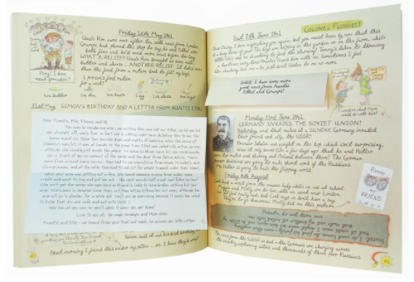
Discern :
How does breaking a rule or hurting someone affect the relationship between people, and why might it be hard for humans to forgive each other even if God forgives?
How do the Ten Commandments help people keep the promises God made in His covenants?

