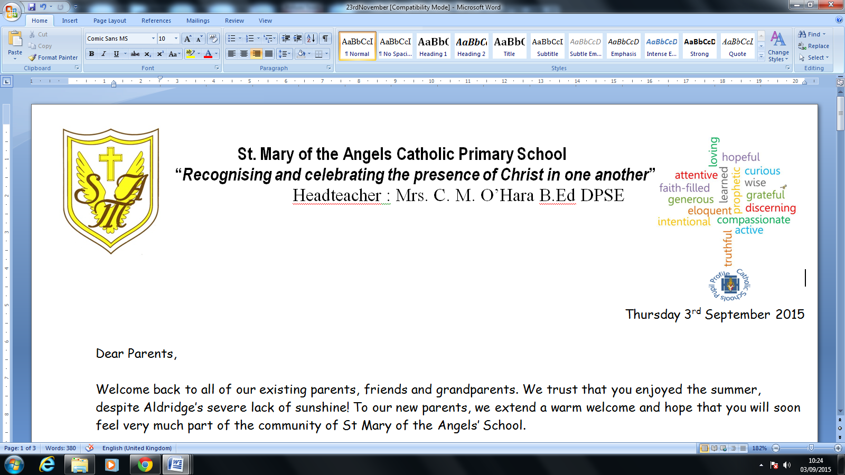
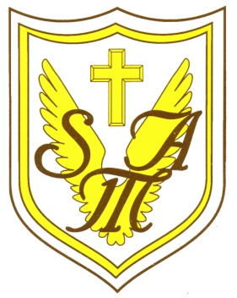

Head teacher: Mrs. C.M. O’Hara B.Ed DPSE

Thursday 9th July 2020
Dear Parents/Carers,
Next week is sports week in school and we are keen to give children the opportunity to take part in physical activity. Therefore, following the success of our recent virtual active challenges, St Mary of the Angels are inviting pupils to take part in our ‘Virtual Sports Day.’
In partnership with Streetly Academy, children are encouraged to take part in their class competition. Please see below for your class competition. Each challenge has a thirty second time limit.
Y6 - push ups (on knees is fine)
Y5 - 10m sprints (shuttle runs)
Y4 - skipping (with a rope)
Y3 - relay (set out objects e.g. cones for children to run to and count how many they successfully pass)
Y2 - bat and ball coordination (balance ball on bat - how many laps around a particular area can you do without the ball falling?)
Y1 - throw and catch (to themselves)
EYFS - star jumps
You can submit your results on the virtual scoreboard by clicking the link on our website. Results should be submitted by Wednesday 15th July.
It is not about achieving the best score; we are trying to promote physical activity and enjoy a different version of Sports Day this year, with a view to celebrating pupils’ participation and success.
Thank you for your support.

Yours sincerely,

Miss Wood Mrs Smith Mrs O’Hara

