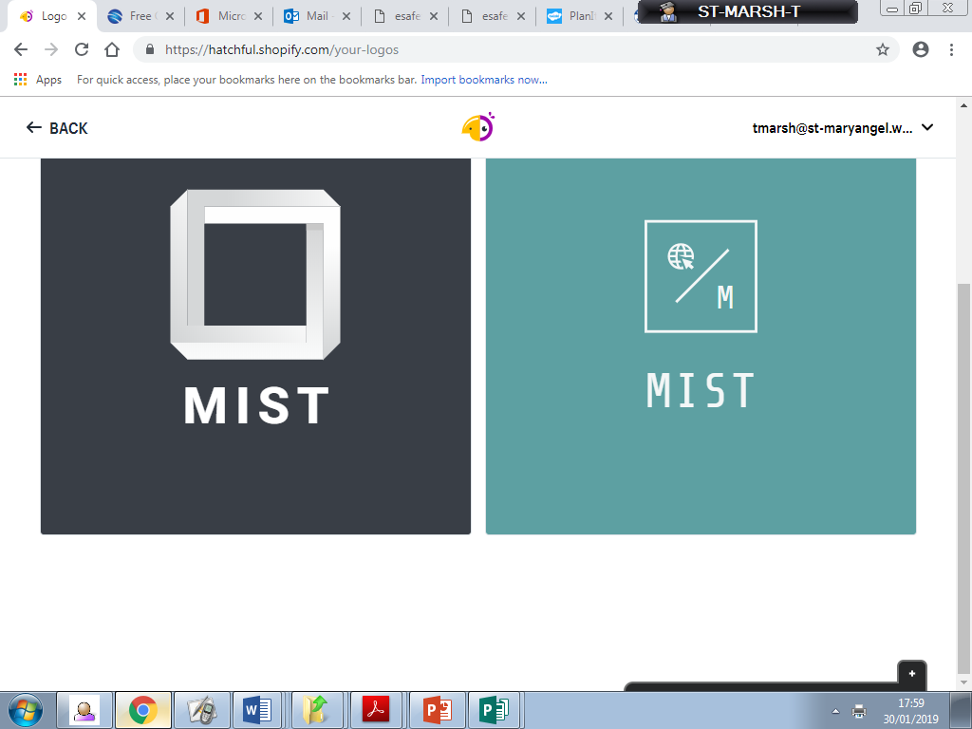

**Mary’s**

**Internet**

**Safety**

**Team**

**Conversation Starters for Parents and Carers**

Parental controls and privacy settings can be very effective tools to help minimise the risks your children may face, but they are not 100% effective. It’s really important to teach your child skills such as critical thinking and resilience, so they can be aware of online risk and know what do and where to go for help when needed. Always encourage them to talk to you if anything happens online that worries them or doesn’t feel right. Don’t miss opportunities to have a conversation with children about using the internet safely, responsibly and positively. Have a look at the conversation starters on the Safer Internet website for ideas: bit.ly/SaferInternetConversation

How does the internet make you feel?

Do different apps/games make you feel differently?

**Year 6 E-Safety Talk**

Yr6 parents recently attended an E-safety evening in school and it was well attended. John Owen led the session with very positive feedback from parents.

‘Very helpful’

‘It was very informative and interesting’

‘The E-safety information was up-to-date’

‘Very useful’

Thank you to everyone who attended. Informed parents = safer children!

Picture Books with an E-Safety Message

Welcome!

It gives me great pleasure to introduce the second newsletter from the MIST team. Over the past few weeks, we have been working to raise awareness of the need for more responsible gaming and general social media use outside of school.

**Spring E-Safety Newsletter 2019**

Story books can be a great way of helping younger children to understand the positives of online technology but can also help them think about what can sometimes go wrong and skills we need to navigate the online world safely.

‘Chicken Clicking’, explores online safety messages in a very funny and age appropriate way for younger children. Chicken has hours of fun online until everything goes wrong when she arranges to meet a friend she’s made online and she finds they were not who they said they were!

Watch out for the latest very funny cautionary tale, ‘#Goldilocks’, released in February 2019. Everyone loves Goldilocks’ amusing online videos, but in her quest to get more likes, more laughs and more hits, she tries something a little more daring: stealing porridge (#pipinghot), breaking chairs (#fun), and using someone else’s bed (#sleep). What will Daddy Bear do when he sees that online?