# What is school readiness?

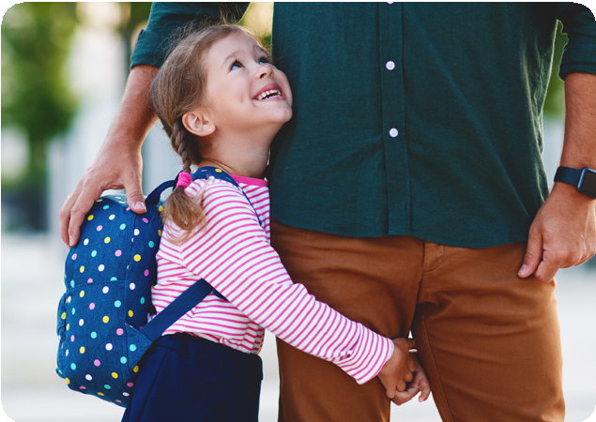

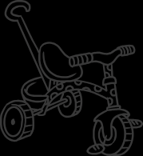School readiness is the term you’ll likely hear a lot when talking about your child’s upcoming transition into reception, how ready they are for it and the support they might benefit from ahead of it. It covers a really broad range of skills, characteristics and areas of development which lay the foundations for later learning.



**Physical Readiness**

# Core Strength

When your child starts reception, they’ll participate in more formal sessions, such as whole-class phonics or one-to-one reading sessions. Core strength enables your little one to comfortably hold their position and maintain their posture, which is really important for their concentration. Developing core strength is also essential for developing agility, coordination and spatial awareness, as well as controlling large and small movements such as climbing, running, writing and threading or weaving. To support your little one in developing core strength at home, you can:

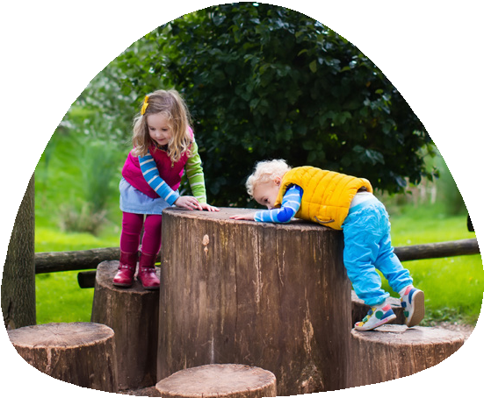

Provide plenty of opportunities to run, climb and explore outside

Create obstacle courses using

cushions, crates, planks, cones or any other resources around the home.

Ride bikes, trikes or scooters

Garden together, using wheelbarrows,

watering cans and any other gardening tools you have

Kick, throw and catch



A Parent Guide to

From developing independence to promoting a love of reading, there are so many ways you can support your little one in becoming ready for school. Let’s take a look at some simple things you can work on at home to help your child prepare for the transition into reception.

   

Fine Motor Development

Strengthening smaller muscles supports your child in being able to effectively manipulate writing implements, scissors, buttons, zips – the list is endless! There are so many ways you can support this area of development at home:

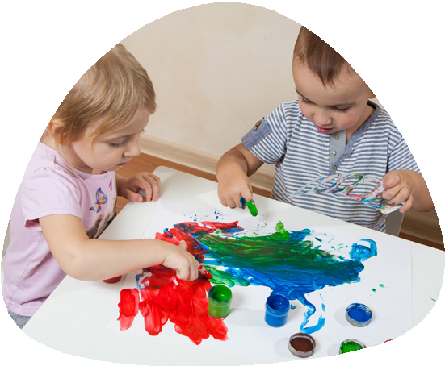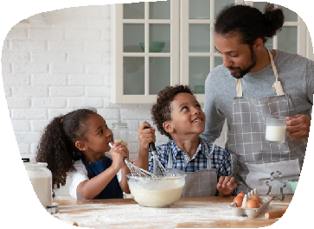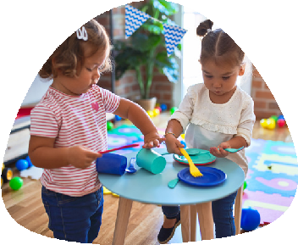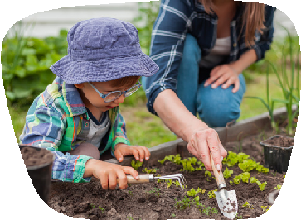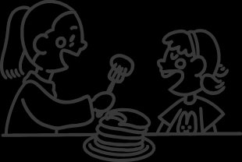

Draw lines or patterns on paper to practise cutting

Construct with building blocks

Practise fastening zips or buttons

Provide opportunities to make marks

with pens, pencils, paintbrushes, chalk or finger paints

Practise using cutlery

Bake and garden together





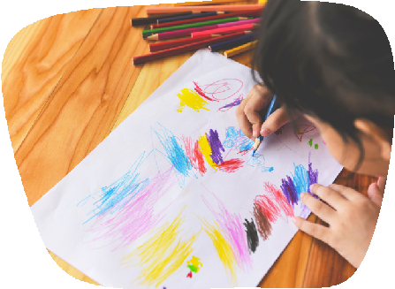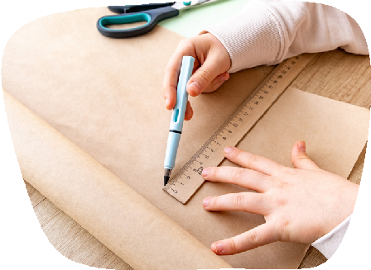

 

Personal, Social and Emotional Readiness

# Eating, Dressing and Hygiene

As your child will be spending more time away from you when they start school, it’s a really good idea to support them in becoming as independent as possible when it comes to managing their personal needs.

Mealtimes can often be challenging, particularly if your little one struggles with wrappers or cutlery. Provide plenty of opportunities for your child to peel, chop and unwrap food together at home – all skills take practice and patience. It’s also a good idea to practise unscrewing the cap on their water bottle or zipping up their lunch box if they’ll be taking one. It’s also a good idea to encourage your little one to explore new foods as their start date approaches, particularly if they’re a fussy eater.

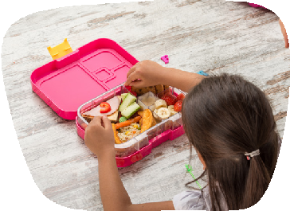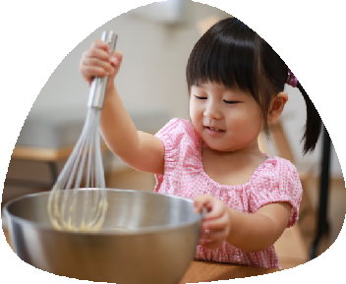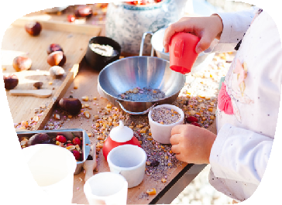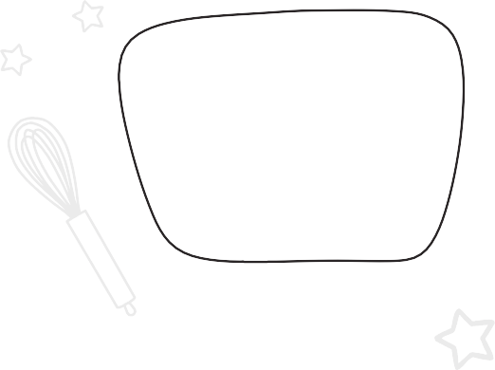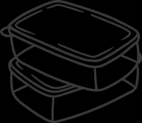

Being able to fasten and unfasten their coat, pull their trousers up or down when they’ve been to the toilet, take their jumper on or off and change for PE is also really advantageous. Although their teacher and support staff will be on hand to help with dressing, it can be difficult to navigate with a class of 30. Let your child dress themselves at home as much as possible over the summer, focusing on the basics and areas they find particularly difficult first.

Managing hygiene and toileting needs is another really important skill to master ahead of the transition into reception. Establish and embed a really consistent routine at home, including washing and drying their hands. You can use visual prompts or reward charts to remind and reward so that, hopefully, your little one is able to confidently navigate using the toilet independently by the time they start school.

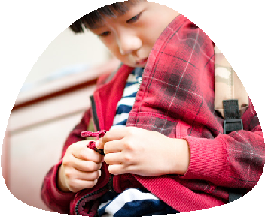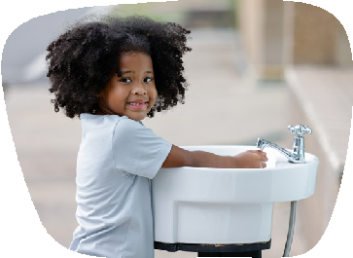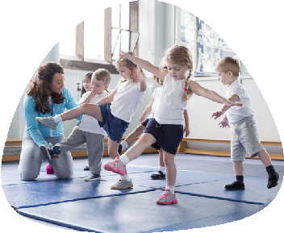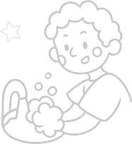

 

# Relationships and Emotions

Spend some time discussing the emotions your child might experience when they start reception. With new friends, teachers and environments to navigate, feelings of anxiety or nervousness aren’t uncommon. It’s also a good idea to talk about what they can do or who they can speak to if they do have any big or uncomfortable emotions to contend with.

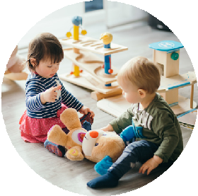



  

**Reading, Writing and Maths Readiness**

When they start reception, your child will learn how to read, write, count and work with shape, space and measure. To give them a head start, you could work on:

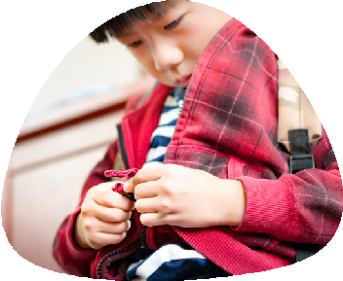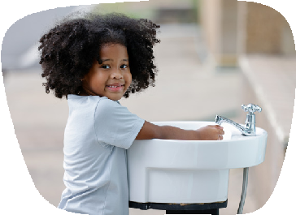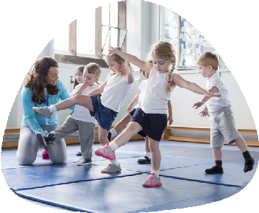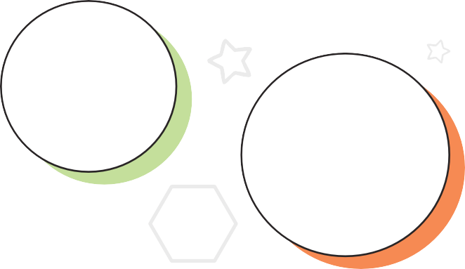

Reading stories (including stories about starting school)

Recognising numbers to 5

or 10

Forming the letters of their name

Looking for print in the environment

Singing number songs

Using language

like ‘more’, ‘less’,

‘bigger’, ‘smaller’, ‘heavier’ and ‘lighter’

Writing their name



Counting in sequence to 20

Completing jigsaws and puzzles

Identifying shapes

Counting using 1:1

correspondence