Key Knowledge

To Hear: Related Scripture and Texts

Key Vocabulary
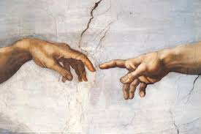
Genesis 1:1-31 The creation of the world (aka the six days of Creation)
Genesis 1:26-31 The creation of human beings (within the six days of Creation
Genesis 2:1-3 The seventh day, God rests
Laudato Si' 66 Humanity's call to responsible stewardship
Psalm 8 How Majestic Is Your Name

- The first Creation story in Genesis tells how God creates everything out of nothing through His Word and Spirit.
- The story is written with a pattern, like a poem, to help us remember and understand that all God made is good.
- God creates humans ‘in the image and likeness of God’.
- Made ‘in the image and likeness’ means that we are called to reflect God's love and goodness.
- God makes every person in His image, which means everyone has dignity and is important.
- Because we have dignity, we should treat every person with respect and kindness.
- Catholic social teaching tells us how the Catholic faith guides human actions.
- The Church teaches that all people are created with equal dignity.
- God created humans as the most important feature of His Creation and tasked them to be stewards.
- Pope Francis called caring for creation ‘ecological virtues,’ which help people live in ways that respect God’s world.
- In Laudato Si’, Pope Francis teaches that we should love God, each other, and God’s Creation.
- Psalm 8 is a hymn of praise that celebrates creation and the dignity of humankind.

Image and likeness



dignity
advocacy
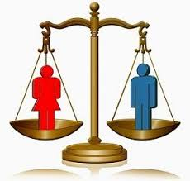
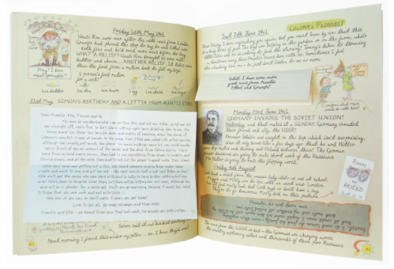
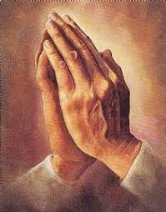
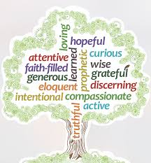
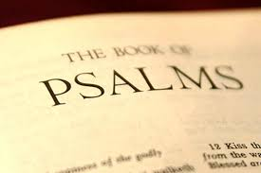
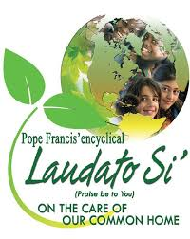
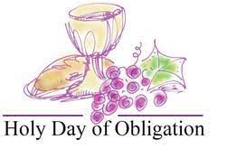
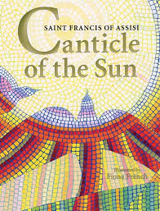
equality
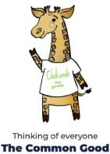
common good
Canticle psalm

virtue

Holy day Examen

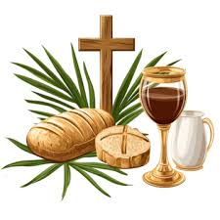
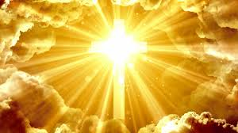
Ecological virtues Communion

Glory

