Key Vocabulary
Life processes | These are the things that all living things do. They move, breathe, sense, grow, make babies, get rid of waste and get their energy from food.
Living | Things that are living have all the life processes.
Dead | Things that are dead were once living. They did have all the life processes but don’t now.
Never living | Things made out of metal, plastic or rock were never living. They never had the life processes.
Food chain | A food chain shows how each animal gets its food. Food chains are one of the ways that living things depend on each other to stay alive.
Food sources | This is the place a living thing’s food comes from.

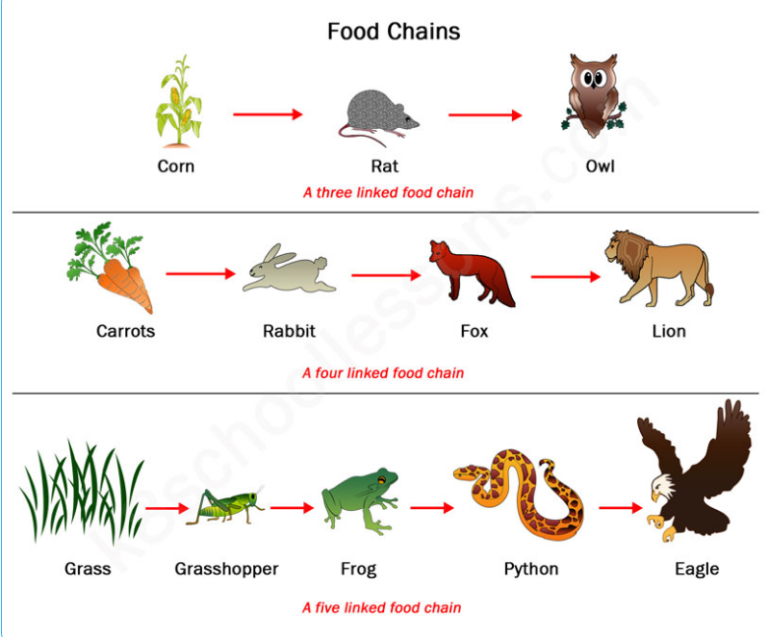
Food Chains: The arrows mean ‘is eaten by’

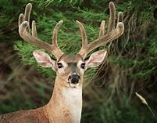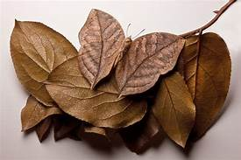
Living Dead Never Living

Key Vocabulary
Habitat | A habitat is the natural place something lives. A habitat provides living things with everything they need to survive such as food, shelter and water.
Microhabitat | A microhabitat is a very small habitat in places like under a rock, under leaves or on a branch. Minibeasts live in microhabitats. The microhabitats have everything they need to survive.
Depend | Many living things ina habitat depend on each other. This means they need each other for different things.
Survive | This means to stay alive.
Examples of Microhabitats:
Short Grass Flowers Inside Rotting Wood Under Leaves In and On Soil
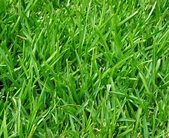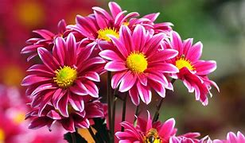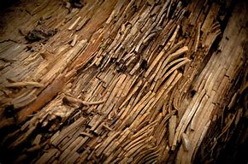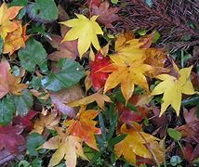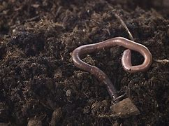
Examples of habitats:
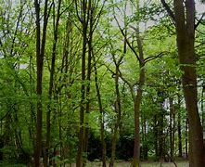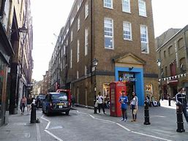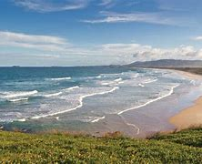
Woodland Urban Coastal
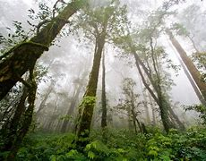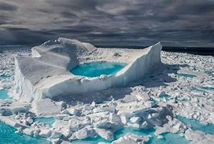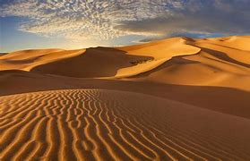
Rainforest Arctic Desert
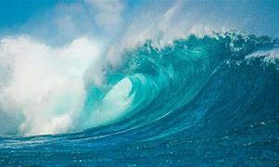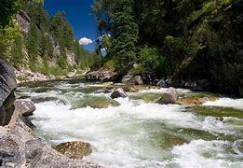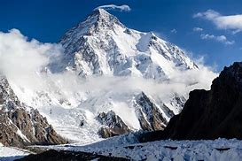
Ocean River Mountains

