Key Vocabulary
Electricity | The flow of an electric charge through a material e.g. from a power source through wires to an appliance.
Generate | To make or produce.
Renewable | A source of electricity that will not run out. These include solar, nuclear, geothermal, hydro and wind.
Non-renewable | This source of energy will eventually run out and so will no longer be able to be used to make electricity. These include fossil fuels – coal, oil and natural gas.
Appliances | A piece of equipment or device designed to perform a particular job, such as a washing machine or mobile phone.
Battery | A device that stores electrical energy as a chemical.
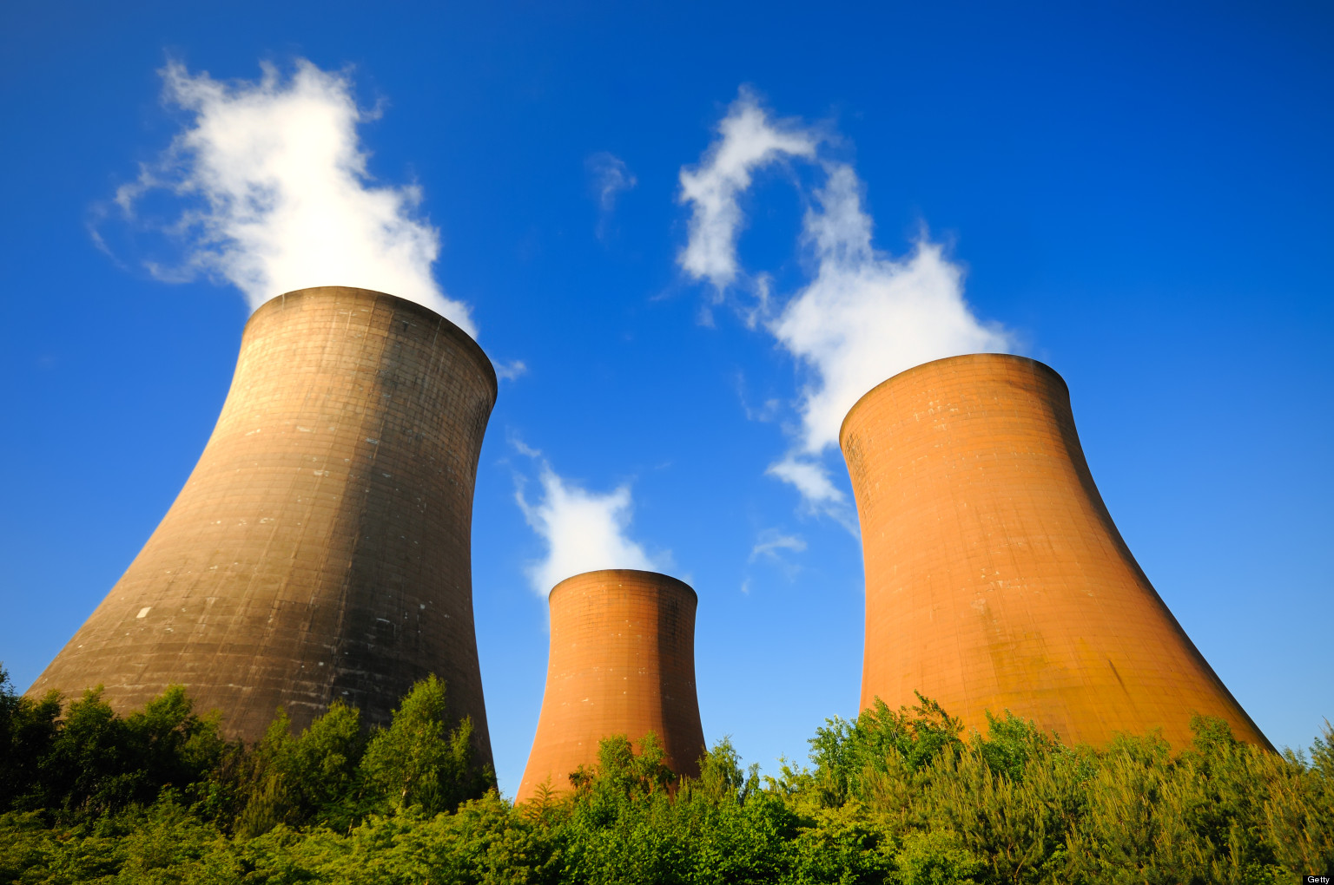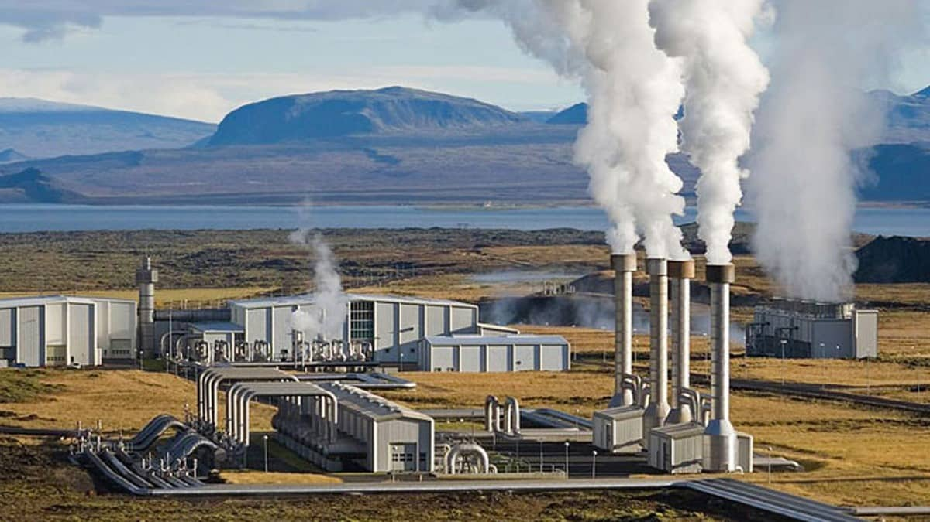
Nuclear energy is created when atoms are split. This creates heat which can be used to generate electricity. Geothermal energy is heat from the Earth that is converted into electricity.
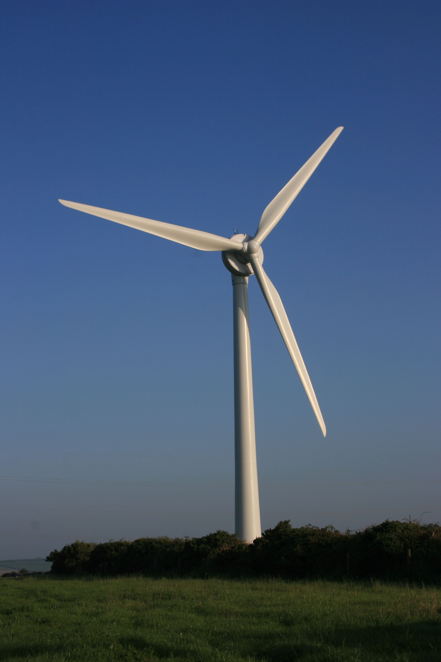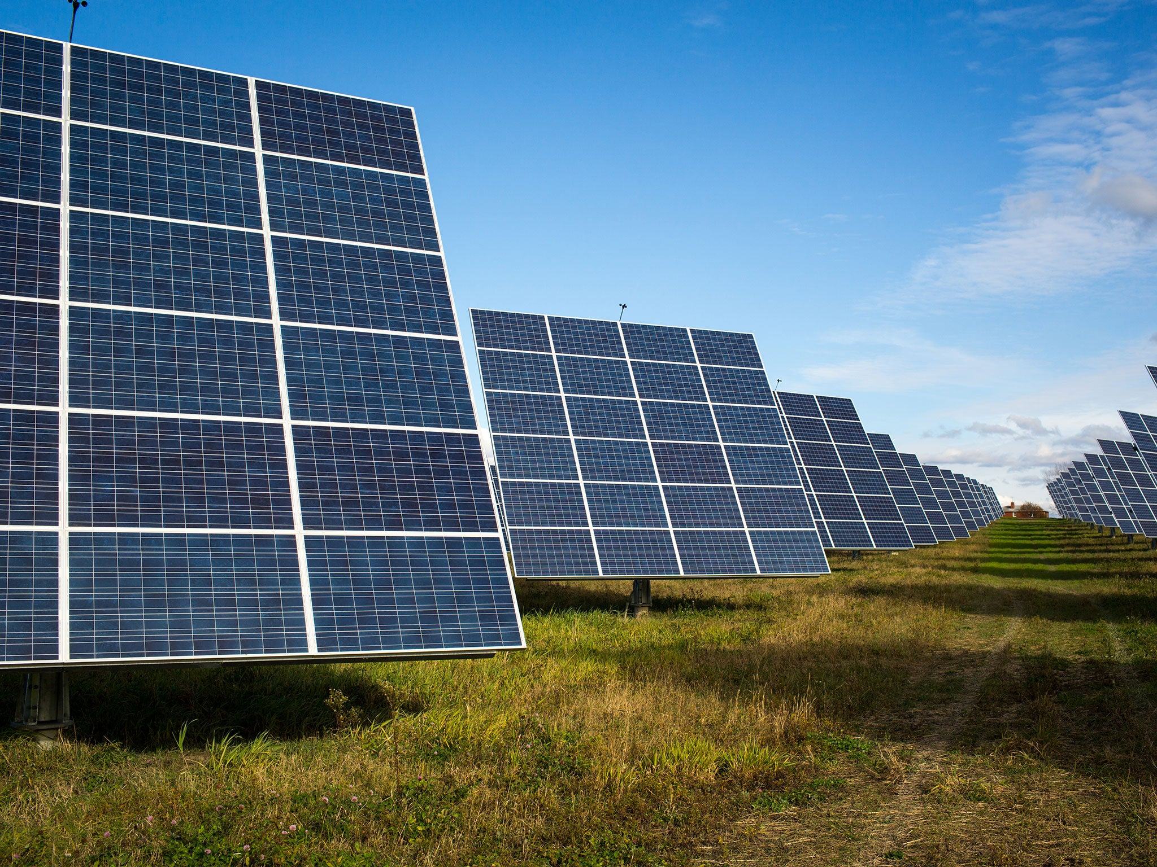
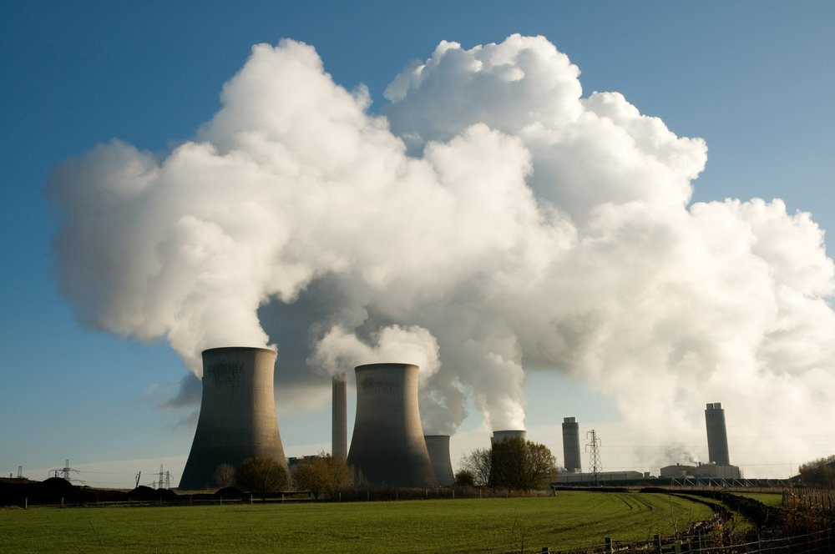
Coal, oil and natural gases are fossil fuels which, when burnt, produce heat which can be used to generate electricity.
Electricity can be generated from wind power used to turn windmills and hydroelectric power from water used in dams. The Sun’s rays can be converted into electricity by solar panels.
Many everyday appliances rely on electricity for them to work. Some appliances need to be plugged into a socket (mains electricity) and others have a battery to make them work. 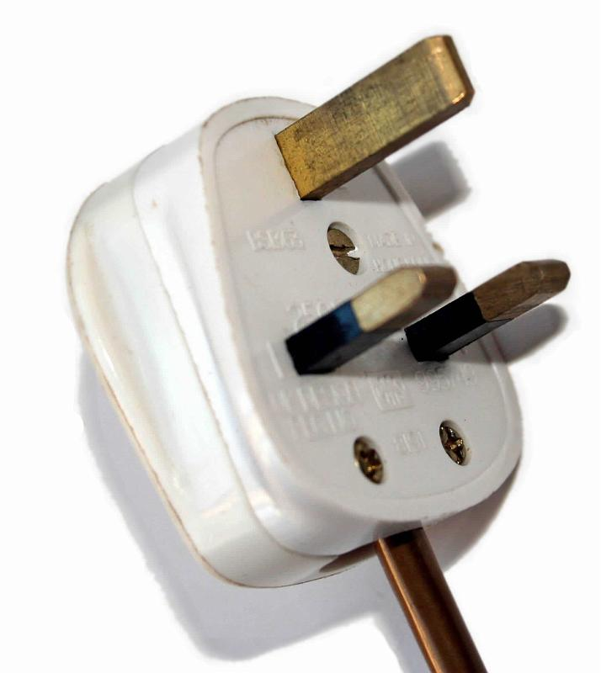 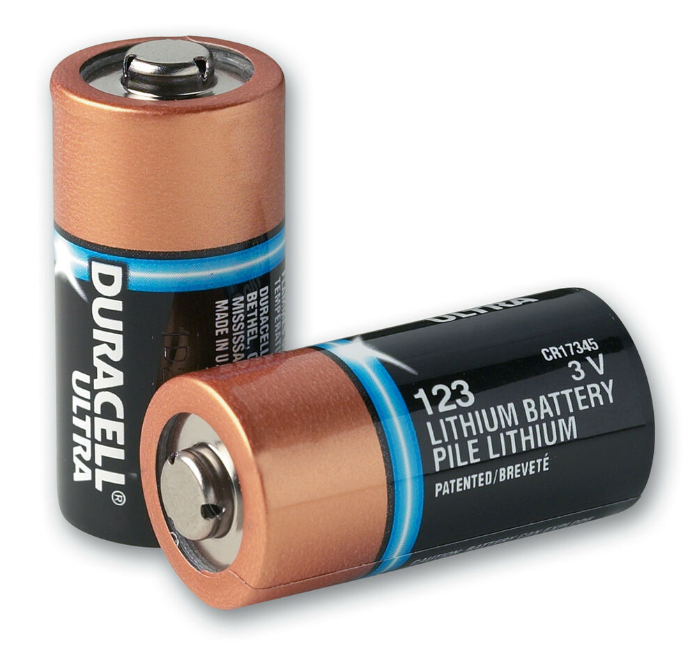
Key Knowledge
Lightning and static electricity are examples of electricity occuring naturally but for us to use electricity to power appliances, we need to make it.

Key Vocabulary
Circuit | A pathway that electricity can flow around. It includes wires and a power supply and may include bulbs, switches or buzzers.
Electrons | Small particles with an electric charge.
Switches can be used to open or close the circuit. When off, a switch ‘breaks’ the circuit to stop the flow of electrons. When the switch is on, the circuit is complete and the elctrons are able to flow around the circuit.
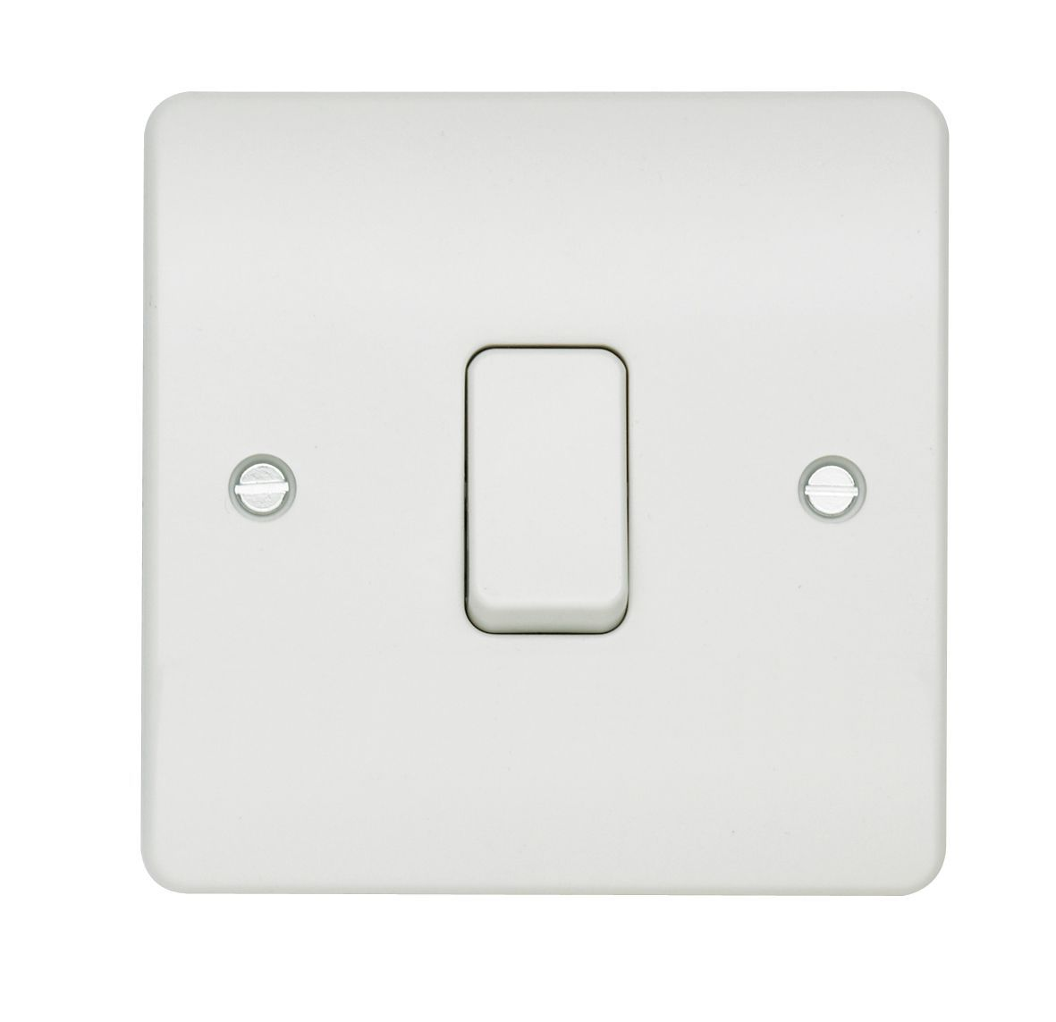
Electricity can only flow around a complete circuit that has no gaps. There must be wires connected to both the positive and negative end of the power supply/battery.
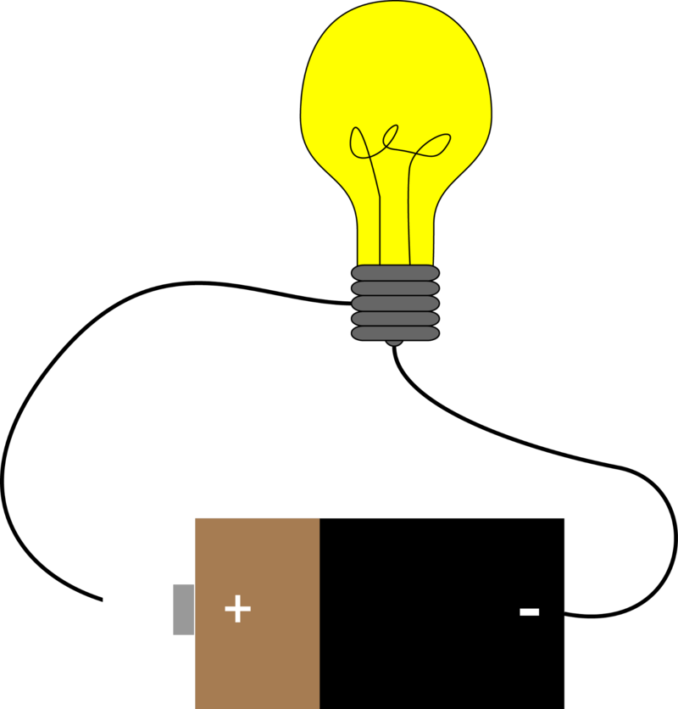
There are two types of electric current.
Mains electricity: Power stations send an electric charge through wires to transformers and pylons. Then, underground wires carry the electricity into our homes via wires in the walls and out through plug sockets.
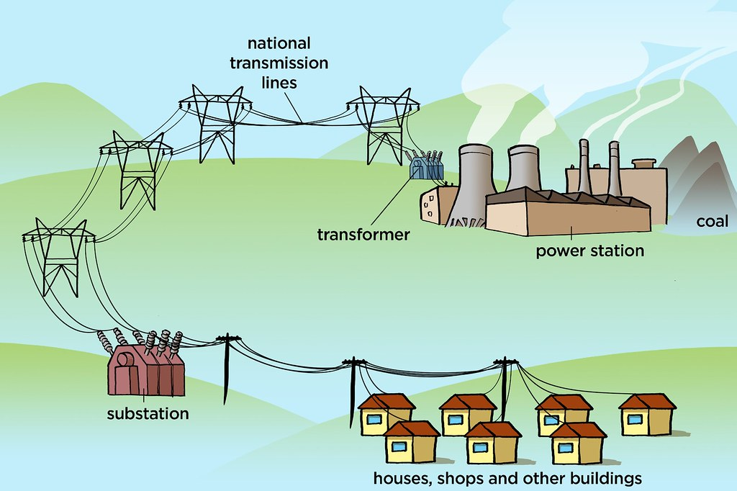
Battery electricity: Batteries store chemicals which produce an electric current. Eventually, even rechargeable batteries will stop producing an electric current.

A conductor of electricity is a material that is made up of free electrons which can be made to move in one direction, creating an electric current. Metals are good conductors. Electrical insulators have nofree electrons and so no electric current can be made. Wood, plastic and glass are good insulators.
