To Hear: Related Scripture and Texts

Key Knowledge

Key Vocabulary

An age-appropriate retelling of the Creation account in Genesis 1 (aka 'The Six Days of Creation')

- God made me.
- God loves me and everyone
- God made the world & everything in it.
- God made me too!
- We talk to God through prayer.
- The words of the Sign of the Cross prayer are ‘In the name of the Father, and of the Son and of the Holy Spirit. Amen’.
- We give thanks to God in prayer.
- I should look after myself because God made me.
- I should look after God’s world because it is amazing.

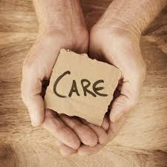
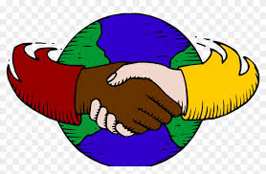
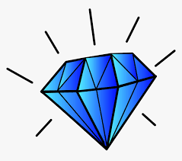
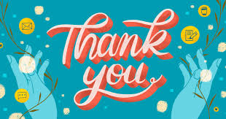
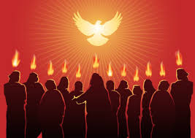

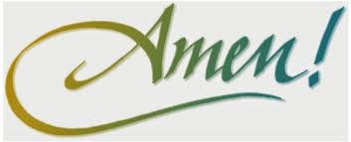
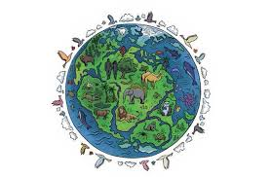
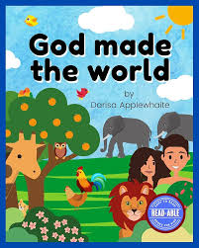
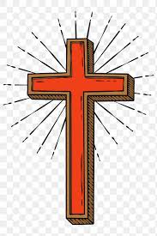
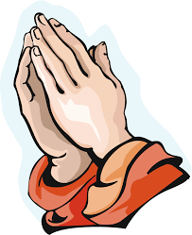
good
prayer

Amen
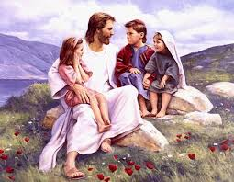
father
cross

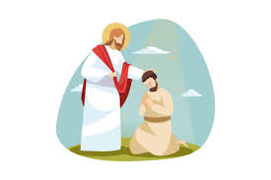
care
son

creation

Holy Spirit dignity
love

Thank you precious
world

