St Mary of the Angels
Early Years
Curriculum Offer/Procedures
2021/2022

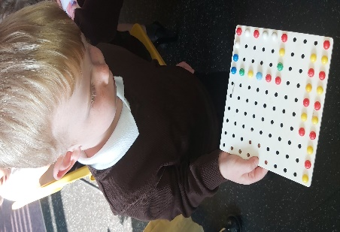

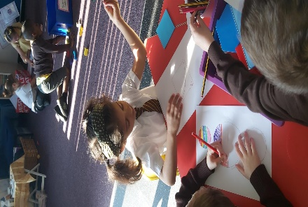

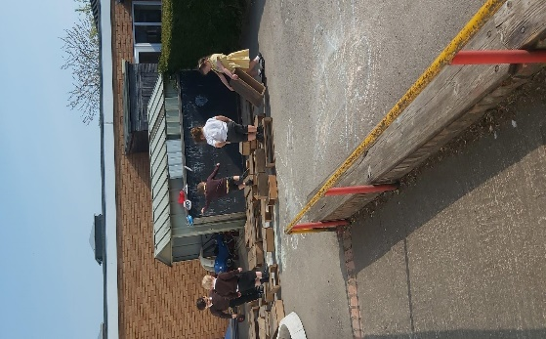

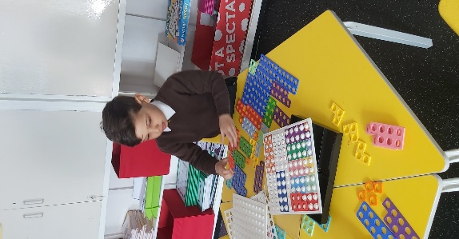

‘At St Mary of the Angels we recognise the importance of appropriate, engaging learning opportunities pertinent to our children n the Early Years environment. We see the early years as a critical time where foundations are laid for the future development of every child.
Through our delivery of the Early Years’ Curriculum we aim to make a positive contribution to children’s early development and learning. The opportunities provided will support future learning and will prepare the children for transition into Key Stage One.
Finally, we link with our whole school recognition of the type of children we serve, mirroring and fostering skills and beliefs which we will be further refined and developed through our whole school curriculum approach embodied in our SMA Teaching Threads.’

Intent
At St Mary of the Angels the EYFS department aim to ensure that:

- Our children feel happy, secure and actively involved in their own learning.
- Our children are encouraged to develop resilience and independence.
- Our children will be actively safeguarded.
- Our children feel valued, respected and included and that classroom, resources and activities reflect the culture and language of their homes.
- Our children are encouraged to enable choice and decision-making, foster independence and develop self-confidence;
- Our children are encouraged to develop positive relationships with both peers and all adults in and around school from their varied starting points.
- Our children are taught in a safe and stimulating environment where they are able to enjoy learning and grow in confidence that helps them to place firm foundations for future learning and development.
- Our children receive a broad and balanced curriculum which will enable them to develop personally, socially, emotionally, spiritually, physically, creatively and intellectually to his/her full potential.
- Our children are encouraged to learn through planned, purposeful activities in all areas of learning and development in the indoor and outdoor environment
- Our children’s parents are well informed of how their child is progressing throughout the year.
- Our children’s parents are encouraged and coached to be partners in their child’s progress across the EYFS phase, from their starting points

Implementation
In order to deliver our ‘intent’ as described we will enable the following:

- All staff are familiar and engage with school practices regarding safeguarding and wellbeing of children in our care.
- Parents as first educators are provided with opportunities throughout the year to discuss their child’s development. This can be via the class pages, parents’ consultations, reports. Parents are also welcome to discuss concerns they have.
- Parents and staff have regular opportunities to discuss progress and next steps via informal communication, home learning, phone calls and emails.
- Staff receive regular training opportunities
- Training opportunities are shared and good practice identified is embedded into the SMA curriculum.
- Senior staff monitor and evidence good practice in safe guarding learning environments, learning opportunities and breadth and range of provision.
- Children’s progress is tracked and those who are at the risk of falling behind are given different, additional environments and opportunities to begin to reduce gaps in their experiences.
- Children’s behavior is challenged from the starting points, to develop resilience and independence by all staff and their progress is evidenced over time.

SMA Curriculum cycle

Teaching & Learning – see core documents

Next steps Build on prior
Identified by staff knowledge

Relevant recording
to evidence progression

Engaging books, both fiction and non-fiction rhymes and songs

Timetable to ensure variety of support for Characteristics of Learning
Positive and engaging experiences
Planned/unplanned

Planning as part of our implementation

Learning at St Mary of the Angels Catholic School
Learning is a combination of independent play-based activities as well as adult directed planned/spontaneous activities. These can be indoors and outside. They involve high interaction from adults where they can be seen to be modelling, supporting, guiding and moving children on in their learning. There is a balance between adult-initiated experiences (guided learning) and child-initiated experiences.
The EYFS is based upon four principles:
• A Unique Child
• Positive Relationships
• Enabling Environments
• Learning and Development

We designed our curriculum with the particular strengths, interests and needs of the children of St Mary of the Angels in mind.

In the first half term, staff in our Nursery and Reception settings spend quality time getting to know the direct entry children and their families, whilst building on established relationships with children already known to staff. This trusting relationship helps children to settle into Nursery/Reception and grow in confidence in their new environment.

In Nursery, the majority of our planning is focused on the three prime areas. These are PSED, Communication and Physical, Health and wellbeing. Wellcomm is a national language audit and intervention resource which has evidence of good success at SMA. It therefore plays a large part in ensuring children reach their expected age in CLL.
Whilst these prime areas in EYFS continue to be the dominate the focus of planning the deliberate planned introduction of the specific areas become more regular throughout the year for the Nursery and running alongside and compliment the prime areas.
Reception children are assessed using statutory baseline assessments in the first two weeks of the Autumn Term.

SLT continue to monitor the attainment and progress throughout the year in both cohorts. Adaptions to planning and the environment are consistently reviewed and link with the outcomes of the termly assessment grids noting progress from starting points. Intervention groups are planned for, as children not on target can be identified easily. Monitoring the impact of these interventions is rigorous and adaptable. Evidence from the last year also demonstrates them to be effective, using the new curriculum now in place.

Wider Learning

SMATT Colour Code
SMATT 1 – How we communicate in differing ways for differing purposes
SMATT 2 – How other people’s lives affect the way we live
SMATT 3- About the world we live in and why changes happen to it over time
SMATT 4- How well we know our local area and the changing dynamics (human,
physical, social, economic)
SMATT -5 RE/ British Values/ Ethics/Culture
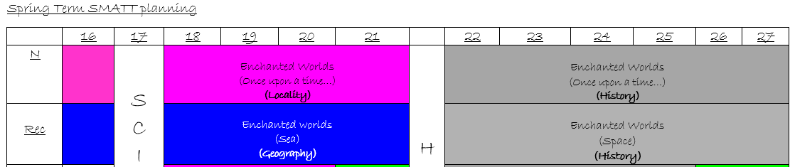
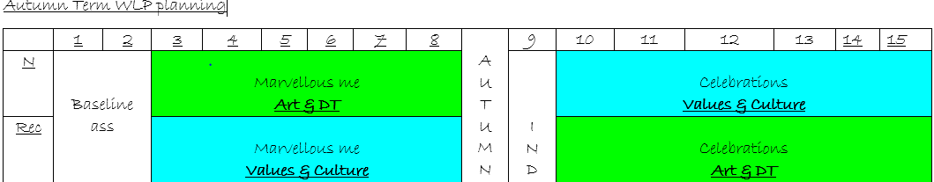
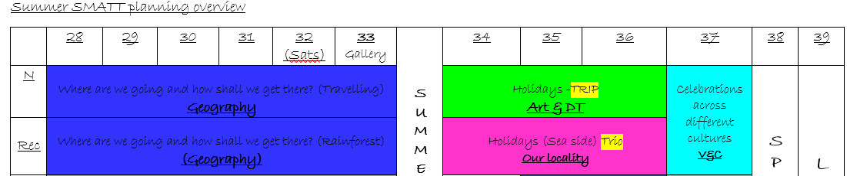
The Termly curriculum overviews are shared with parents through Key Knowledge Organisors (KKO’s) linked with the Wider Learning Project (WLP) each term. Their clarity helps parents to get involved and support their children’s learning at home. These are available via class pages regularly.

Assessment
See below for the expectations in each year group of the EYFS
Curriculum area | Goals
PSED  Nursery Goals  Reception Goals | Self-Regulation  Begin to follow rules without being prompted. Develop appropriate ways of being assertive.  Manage Self  Select and use activities and resources with help when needed. Show more confidence in new social situations. Understanding why rules are important.  Building Relationships  Discuss differences, such as skin colour, types of hair, gender, special needs and disabilities. Help to find solutions to conflicts. Begin to understand how others might be feeling.
Self-Regulation

Show an understanding of their own feelings and those of others, and begin to regulate their behaviour accordingly; - Set and work towards simple goals, being able to wait for what they want and control their immediate impulses when appropriate; - Give focused attention to what the teacher says, responding appropriately even when engaged in activity, and show an ability to follow instructions involving several ideas or actions.

Manage Self
Be confident to try new activities and show independence, resilience and perseverance in the face of challenge; - Explain the reasons for rules, know right from wrong and try to behave accordingly; - Manage their own basic hygiene and personal needs, including dressing, going to the toilet and understanding the importance of healthy food choices.

Building Relationships
Work and play cooperatively and take turns with others; - Form positive attachments to adults and friendships with peers; - Show sensitivity to their own and to others’ needs.

CL  Nursery Goals  Reception Goals | Listening, Attention and Understanding  Enjoy listening to longer stories and remember much of what happens. Follow a two - part instruction. Answer why questions.  Speaking  Use a wide range of vocabulary. Begin to use correct tenses and plurals. Begin to discuss and explain their ideas. Use talk to organise themselves and their play. Talk about stories.
Listening, Attention and Understanding
Listen attentively and respond to what they hear with relevant questions, comments and actions when being read to and during whole class discussions and small group interactions; - Make comments about what they have heard and ask questions to clarify their understanding; - Hold conversation when engaged in back-and-forth exchanges with their teacher and peers.
Speaking
Participate in small group, class and one-to-one discussions, offering their own ideas, using recently introduced vocabulary; - Offer explanations for why things might happen, making use of recently introduced vocabulary from stories, non-fiction, rhymes and poems when appropriate; Express their ideas and feelings about their experiences using full sentences, including use of past, present and future tenses and making use of conjunctions, with modelling and support from their teacher.
Physical  Nursery Goals  Reception Goals | Gross Motor Skills  Develop skills in performing movements such as running, balancing, climbing and use simple techniques when playing games; stopping, changing direction, moving into a space. Use and remember sequences and patterns of movements which are related to music and rhythm. Start taking part in some group activities. Be increasingly independent in meeting their own care needs. Begin to recognise healthy choices.  Fine Motor Skills  Use one-handed tools and equipment, for example, making snips in paper with scissors. Use a comfortable grip with good control when holding pens and pencils. Begin to be more independent in dressing and undressing themselves.
 | Negotiate space and obstacles safely, with consideration for themselves and others; - Demonstrate strength, balance and coordination when playing; Move energetically, such as running, jumping, dancing, hopping, skipping and climbing. ELG) - Hold a pencil effectively in preparation for fluent writing – using the tripod grip in almost all cases; - Use a range of small tools, including scissors, paint brushes and cutlery; - Begin to show accuracy and care when drawing.
Literacy  Nursery Goals  Reception Goals | Comprehension  Develop play around favourite stories using props. Repeat words and phrases from familiar stories and rhymes.  Word Reading  Understand the five key concepts about print: Listen for the sounds that can be heard in words and orally blend. Recognise some initial sounds and their corresponding grapheme.  Writing  Use some print and letter knowledge in early writing. Begin to write for a purpose; letter, list, label. Write name with some letters being correctly formed.
Comprehension
Demonstrate understanding of what has been read to them by retelling stories and narratives using their own words and recently introduced vocabulary; Anticipate – where appropriate, Recall key events in stories, Use and understand recently introduced vocabulary during discussions about stories, non-fiction, rhymes and poems and during role-play.
Word Reading
Say a sound for each letter in the alphabet and at least 10 digraphs; - Read words consistent with their phonic knowledge by sound-blending; - Read aloud simple sentences and books that are consistent with their phonic knowledge, including some common exception words.
Writing
Write recognisable letters, most of which are correctly formed; - Spell words by identifying sounds in them and representing the sounds with a letter or letters. Write simple phrases and sentences that can be read by others.

Maths  Nursery Goals  Reception Goals | Number  Working with numbers up to 5 and then 10, children will: recite numbers, count and Understand the value objects/amounts accurately. Begin to solve problems and understand some vocabulary including comparing amounts.  Numerical patterns  Explore 2D and 3D shapes; discuss and describe position & location. Talk about, create & correct patterns; compare objects (size, length, weight, capacity)
Number
Have a deep understanding of number to 10, including the composition of each number; - Subitise (recognise quantities without counting) up to 5; - Automatically recall (without reference to rhymes, counting or other aids) number bonds up to 5 (including subtraction facts) and some number bonds to 10, including double facts.
Numerical patterns
Verbally count beyond 20, recognising the pattern of the counting system; - Compare quantities up to 10 in different contexts, recognising when one quantity is greater than, less than or the same as the other quantity; - Explore and represent patterns within numbers up to 10, including evens and odds, double facts and how quantities can be distributed equally.

UTW  Nursery Goals  Reception Goals | Past & Present  Understand their own history (personal/family)  People, cultures & communities  Develop a positive attitude towards differences between people (occupation, gender, ethnicity, culture.) & places (countries).  Natural world  Explore materials and their properties; make observations and give explanations; show an interest in caring for the environment and living things.
Past & present
Talk about the lives of the people around them and their roles in society; - Know some similarities and differences between things in the past and now, drawing on their experiences and what has been read in class; - Understand the past through settings, characters and events encountered in books read in class and storytelling.
People & Culture
Describe their immediate environment using knowledge from observation, discussion, stories, non-fiction texts and maps. Know some similarities and differences between different religious and cultural communities in this country, drawing on their experiences and what has been read in class; - Explain some similarities and differences between life in this country and life in other countries, drawing on knowledge from stories, non-fiction texts and – when appropriate – maps.
Natural World
Describe their immediate environment using knowledge from observation, discussion, stories, non-fiction texts and maps. Know some similarities and differences between different religious and cultural communities in this country, drawing on their experiences and what has been read in class; - Explain some similarities and differences between life in this country and life in other countries, drawing on knowledge from stories, non-fiction texts and – when appropriate – maps.
EAD  Nursery Goals  Reception Goals | Creating with materials -  Explore and create using different materials. Draw and create with increasing detail. Explore the use of colours and what happens when colours are mixed together.  Being imaginative -  Develop and extend play around small world activities. Sing songs & use instruments with increasing control to create sounds.
Safely use and explore a variety of materials, tools and techniques, experimenting with colour, design, texture, form and function; - Share their creations, explaining the process they have used; - Make use of props and materials when role playing characters in narratives and stories
Invent, adapt and recount narratives and stories with peers and their teacher; - Sing a range of well-known nursery rhymes and songs; Perform songs, rhymes, poems and stories with others, and – when appropriate – try to move in time with music.

Impact

The EYFS is an important stage in our children’s development and our dedicated staff work tirelessly to deliver the best possible outcomes effectively for our children, incorporating a starting point for the 5 key outcomes from every Child matters document. The following proposed impact are evidenced across the year.
- Effective teaching and learning in this key stage helps children to learn and develop in all seven curriculum areas of learning as evidenced.
- The impact of learning is measured constantly and purposefully with the regard to it being manageable and not unyielding through ongoing observations and assessments, against the EYFS curriculum and summative ELG’s alongside our school’s monitoring timetable.
- Adults support children during learning and ensure they are challenged through careful use of questioning, modelling and scaffolding.
- Staff offer valuable opportunities to extend pupil’s learning and encourage curiosity.
- Half termly assessments evidence next steps for groups as well as individual children.
- Interventions are carefully planned for and make a difference to those involved.
- Teachers reflect and report on each child’s characteristics of learning and how this it supports their progress from starting points.
- Children are equipped with the skills, knowledge and understanding they need today. In readiness for the transition to Reception or Year 1, as evidenced through good planning/assessment opportunities described in our implementation section of this document.

Transition from EYFS to Year 1

At St. Mary of the Angels, we believe that a smooth, well planned transition from Reception to Year 1 is integral to the continued wellbeing of young children. We see transition as a process rather than an event.
Staff and Governors at SMA agree that a smooth transition from the Foundation Stage to Year 1 facilities young children to begin to link together what they have learnt and how to apply new learning. It enables them to manage the shift from largely exploratory learning to a greater degree of directed learning over time. We aim to find a balance that is not too quick, doesn’t loses the momentum and continues to challenge. We recognise that a gradual change in teaching styles from more informal to more adult-led teaching is beneficial to our pupils. By knowing the styles of learning of our groups, children will continue to feel confident, secure and successful. We therefore focus on the ways different children learn – recognising that some children may prefer to work in different ways and manage those starting points through our teaching styles.
Reception and Year 1 staff understand what happens in each other’s classrooms. We share all information so that children’s abilities and needs are understood, particularly those vulnerable children or those with additional needs.
Through EYFS, children are entitled to a curriculum that is based on what interests them and what they already know, can do and understand. Year 1 teachers build on these starting points and continue to nurture children’s natural desire for learning, whilst engaging in Year 1 expectations, as the Autumn Term plays out.
Through these adaptations, our aim is to continue to ensure children are motivated and challenged. That they continue to make the very best progress possible, with the continuation of high engagement and a desire to learn.

Thank you for your time in reading our Curriculum offer. Wide reference (see bibliography below) combined with deep rooted good and better practice here at SMA drive our passion to ensure that the little people we receive today are excellently equipped for the tomorrows.

Bibliography

- SMA Teaching Threads – philosophy & Development
- EYFS New Curriculum 2021
- Walsall Leaders Network (2020/2021)
- Julian Grenier; National Leader; led on the revision of Development Matters for the Department for Education.

Mission Statement

Recognising and celebrating the presence of Christ in one another.

At St. Mary of the Angels:

- we aim to follow Jesus through the teaching of the Gospels and inspire each other to be Christ-like;
- we all work as a big team to encourage everyone to be the best that they can be, at work and at play;
- we create a safe, positive, fair environment where all feel respected and valued.

