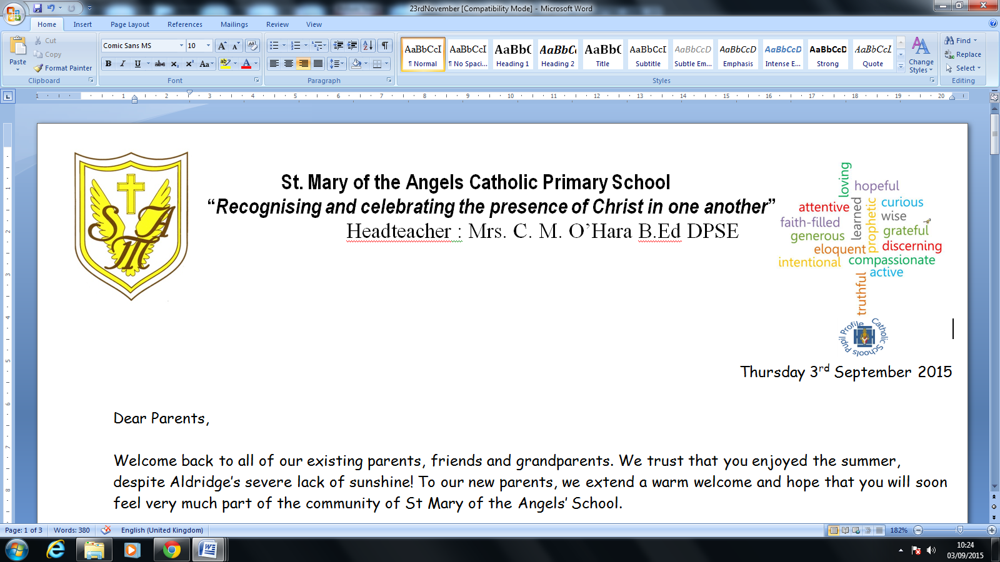


Head teacher: Mrs. C.M. O’Hara B.Ed DPSE

Friday 28th February 2020

Dear Parents,

On Friday 6th March, to further support and promote emotional wellbeing, we will be hosting a Wellbeing Day. To encourage connecting with others and to help the children be aware of their positive emotions, we would like to invite all children to wear one item of their favourite colour with their uniform.
Throughout the day all classes will be taking part in a variety of activities to promote
wellbeing. The five key principles of wellbeing will be explored as detailed below:

 | Intention | Activities
Connect | I will connect with others and share ideas and interests. | - Children to wear an item of their favourite colour and talk about what that means to them. What does it remind you of, why does it make you positive? Connect with someone you don’t often talk to who has the same favourite colour as you.
Be active | I will spend time being active and feeling full of energy. I will notice how this makes me feel – am I laughing, am I smiling? | - All classes to take part in an aerobic dance session.
Take notice | I will spend time relaxing and noticing my breathing.  I will notice my surroundings and listen to what I can hear around me. | - Nursery – Yr 4 will be encouraged to take part in a Yoga and meditation session  - Nursery – Yr6 to spend time in Wellbeing Garden weeding, tidying, talking.  - All classes will have an opportunity to take part in mindful art
Keep learning | I will learn something new. | - Learn a new song / poem  - Find some/ write some inspiring quotes for wellbeing in your class.  - Challenge class to find out a new fact about their work  - Find out about the charities CAFOD and Mind that we are supporting.
Giving | I will join in with the sponsored dance activities, to the best of my ability, as part of helping others in their Wellbeing also | - All children will be encouraged to take part in a sponsored dance to raise money for charities CAFOD and Mind at differing levels.

We hope the children will enjoy the day and learn some strategies that they can use to help them to look after their own well-being. Please take the time to talk to your child about what they have learned and maybe try to incorporate their tips to help your own wellbeing.

Many thanks for your continued support.

Yours sincerely

E. J. Hayes
Assistant Head and Pastoral Leader

