Key Vocabulary
Seasons | There are four seasons each year, autumn, winter, spring and summer.
Autumn | In autumn, the weather begins to get colder. The leaves start to fall from the trees. The amount of daylight becomes less. This means the daytimes are shorter and the night times are longer.
Winter | In winter, the weather is much colder. Sometimes it is cold enough to freeze, leaving frost and ice on the ground. It sometimes snows. Many trees have bare branches as all their leaves have fallen off. The daytimes are the shortest in the year and the night times are the longest.
Weather | The weather includes the temperature outside, the wind direction and strength, as well as rain, cloud, snow and sun.
Daylight | Daylight is when it is light outside. The amount of daylight changes with each season.
Daylight hours each month:
Month | Sept | Oct | Nov | Dec | Jan | Feb | Mar | Apr | May | June | July | Aug
Hours of Daylight | 13 | 11 | 9 | 8 | 8 | 10 | 12 | 14 | 15 | 16 | 16 | 14

The Four Seasons
Autumn:  September  October  November | Winter:  December  January  February
Spring:  March  April  May | Summer:  June  July  August

Autumn | Winter
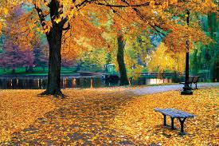 | 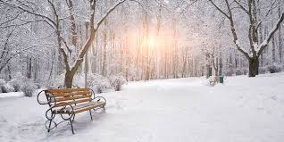

Key Vocabulary
Seasons | There are four seasons each year, autumn, winter, spring and summer.
Spring | In spring, the weather starts to get warmer. The leaves begin to grow on the trees and some trees may blossom (have flowers). Plants begin to grow and you may see baby animals like lambs around. The daytimes start to get longer.
Summer | In summer, the weather gets hotter. The daytime is long and the nights are short. Summer has the longest days. The trees are full of leaves and there are lots of flowers, bees, butterflies and other insects.
Weather | The weather includs the temperature outside, the wind direction and strength, as well as rain, cloud, snow and sun.
Daylight | Daylight is when it is light outside. The amount of daylight changes with each season.
Daylight hours each month:
Month | Sept | Oct | Nov | Dec | Jan | Feb | Mar | Apr | May | June | July | Aug
Hours of Daylight | 13 | 11 | 9 | 8 | 8 | 10 | 12 | 14 | 15 | 16 | 16 | 14

The Four Seasons
Autumn:  September  October  November | Winter:  December  January  February
Spring:  March  April  May | Summer:  June  July  August

Spring | Summer
