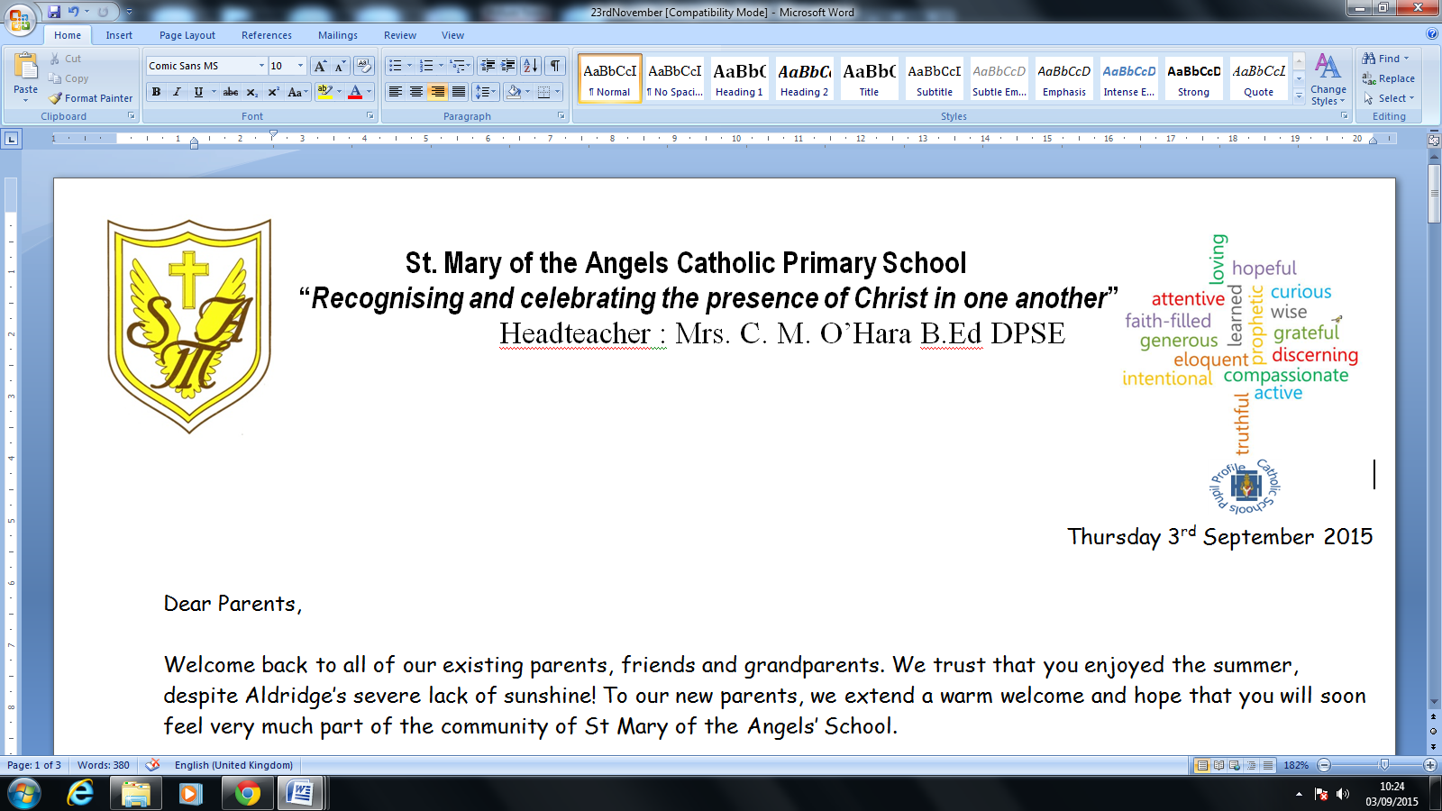


Head teacher: Mrs. C.M. O’Hara B.Ed DPSE

Friday 7th February 2020
“When I was hungry you gave me to eat” Matt 25:35
Dear Parent/Guardian,
On Friday 6th March pupils, staff and the PTA will be dancing through the day as they embark upon a sponsored “Danceathon”, in order to raise money for charity, as our 2020 Lenten charity fundraising event. The aim is to dance a collective total of 350 miles, which is approximately equivalent to the distance between Birmingham and Brussels.
The day coincides with a Wellbeing Day, which will encourage children to connect with their friends by being active through dance and yoga.
In line with the focus on wellbeing, money raised will support the School Council's local charity of choice, Mind (. This charity provides advice and support to empower anyone experiencing a mental health problem, by campaigning to improve services, raise awareness and promote understanding.
Monies raised will also be used to support CAFOD- who provide significant support for countries and regions overseas, who are desperate for basic food, shelter etc.
Attached is a sponsorship form for your child to use in order to help raise money for the event. Please ensure that sponsorship forms and any funds raised are returned to the school office by Friday 6th March. It does not matter how big or small your contribution is; every little helps. We would be so grateful if you could show your support by donating to these very worthy causes.
Finally, please also make sure that your child has their P.E kit in school on the event day. Children should come to school in their uniform and then change into their P.E kits.
Thank you in anticipation of creating a memorable event.
Yours sincerely,

Miss Wood Mrs Hayes
PE Lead Pastoral lead/Asst Headteacher

