Key Vocabulary
Circuit | A path that an electrical current can flow around.
Symbol | A visual picture that stands for something else.
Cell/battery | A device that stores energy as a chemical until it is needed. A cell is a asingle unit. A battery is a collection of cells.
Current | The flow of electrons, measured in amps.
Amps | How electric current is measured.
Voltage | The force that makes the electric current move through the wires. The greater the voltage, the more current will flow.
Resistance | The difficulty that the electric current has when flowing around a circuit.
Electrons | Very small particles that travel around an electrical circuit.
Components of a Circuit and their Symbols
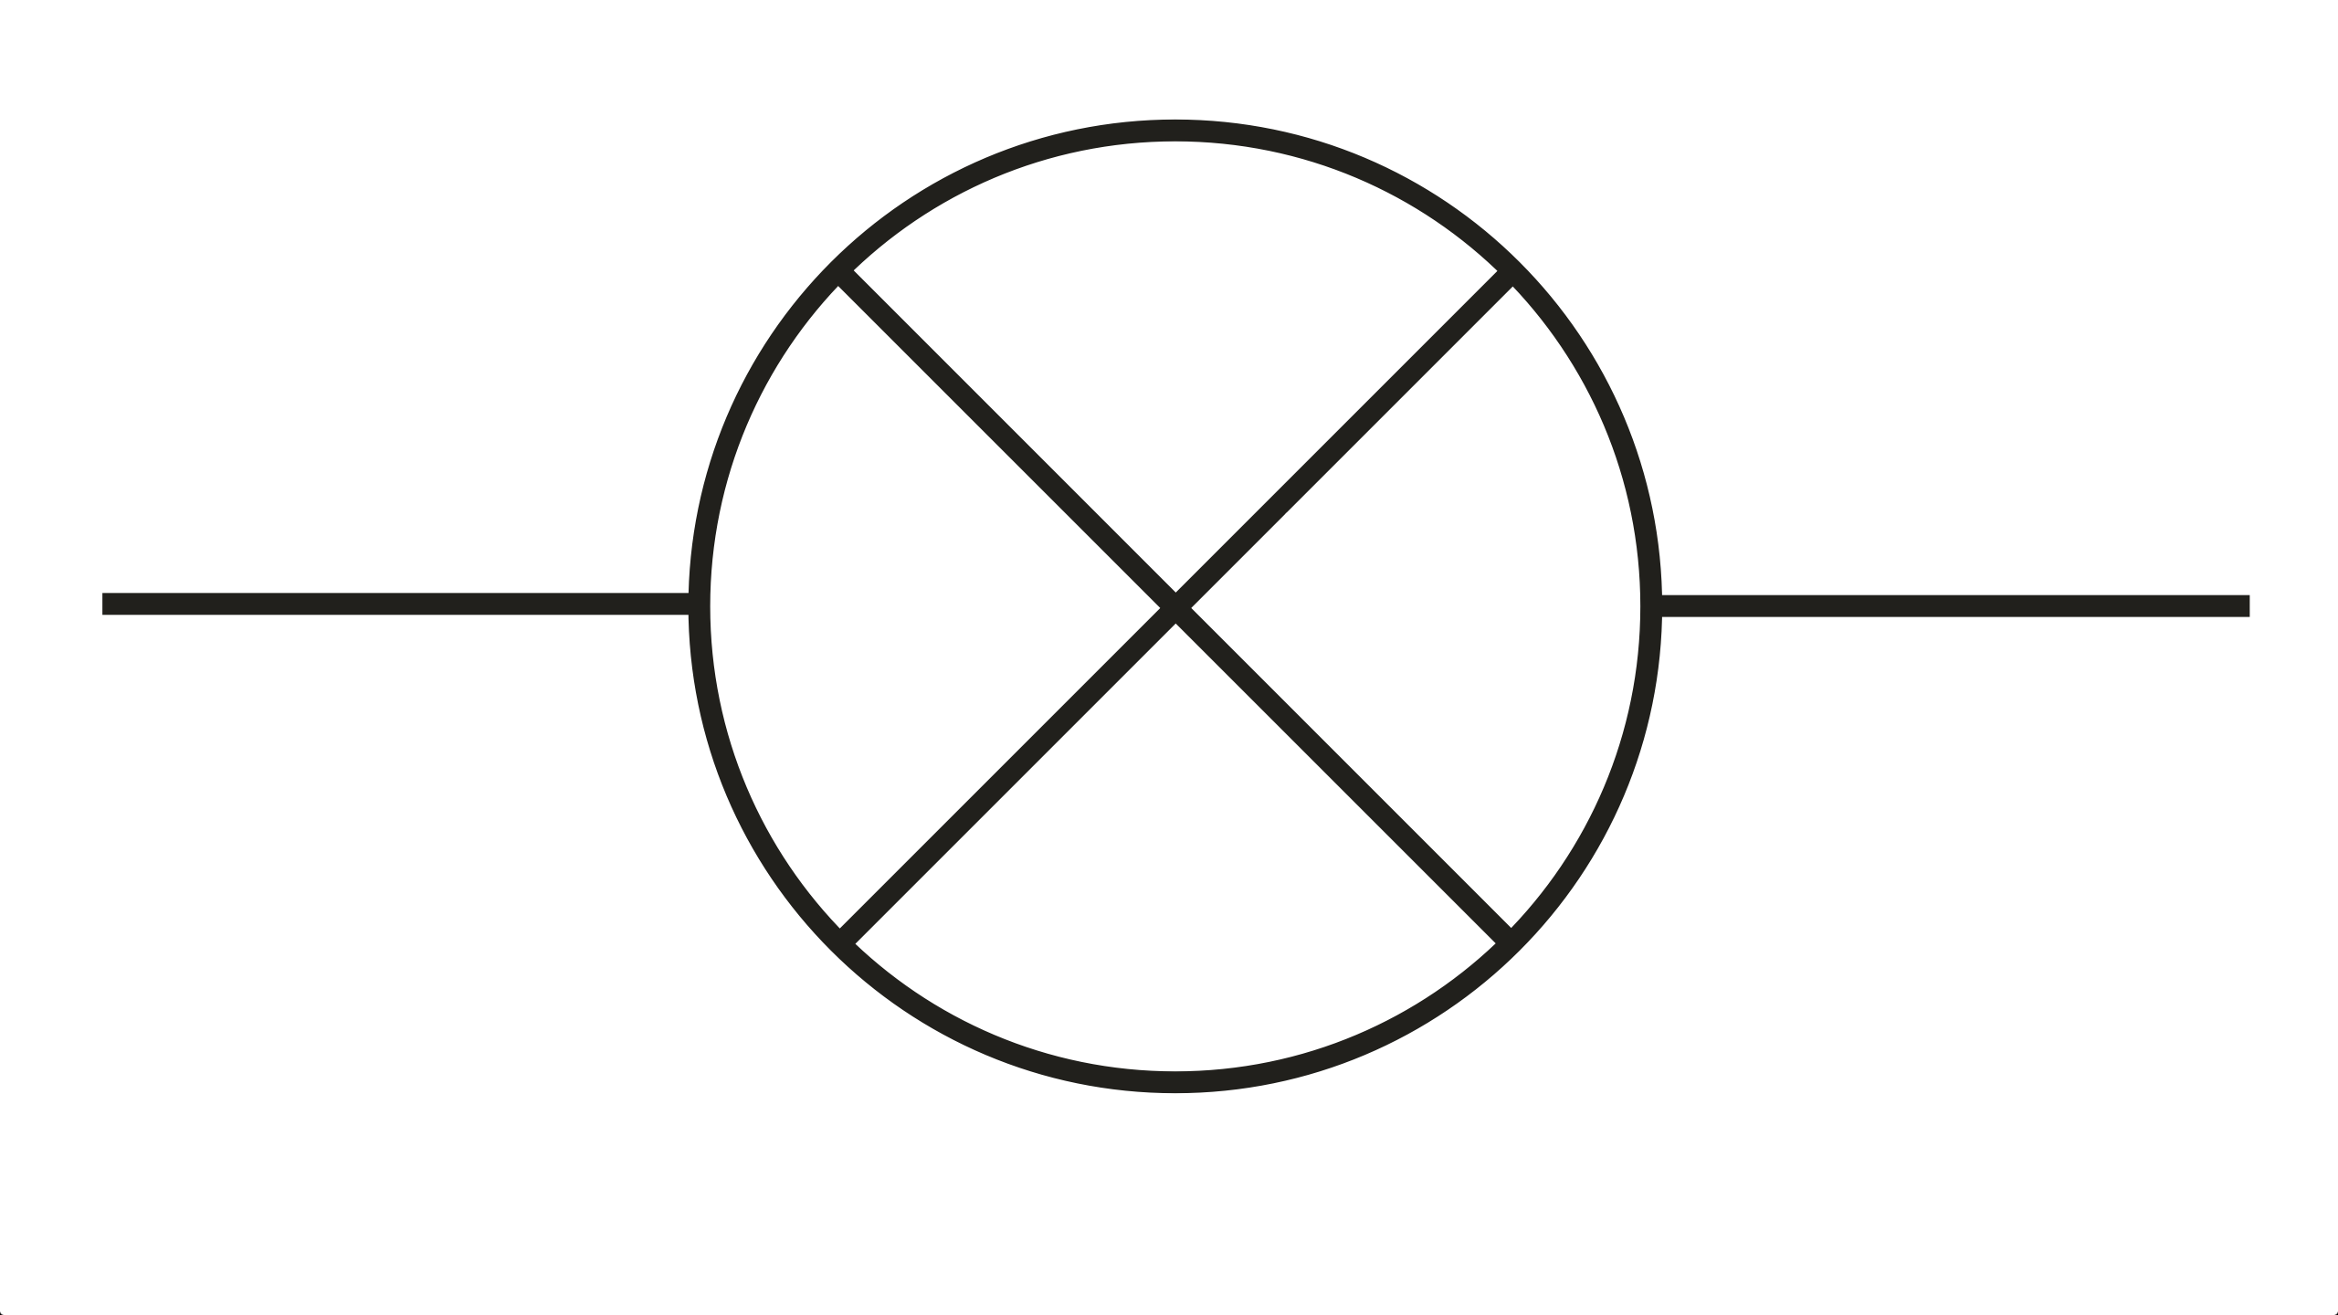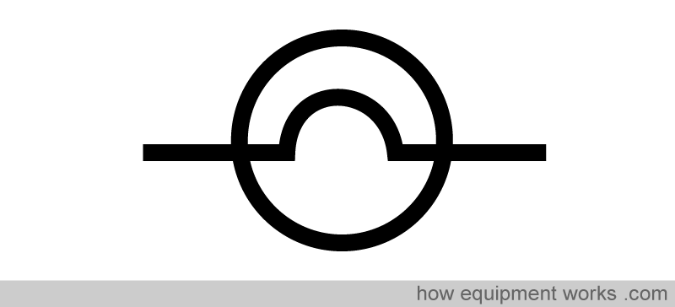
Lamp/bulb (indicator) Lamp/bulb (lighting) Wire

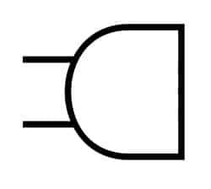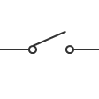
Motor Buzzer Switch (open)

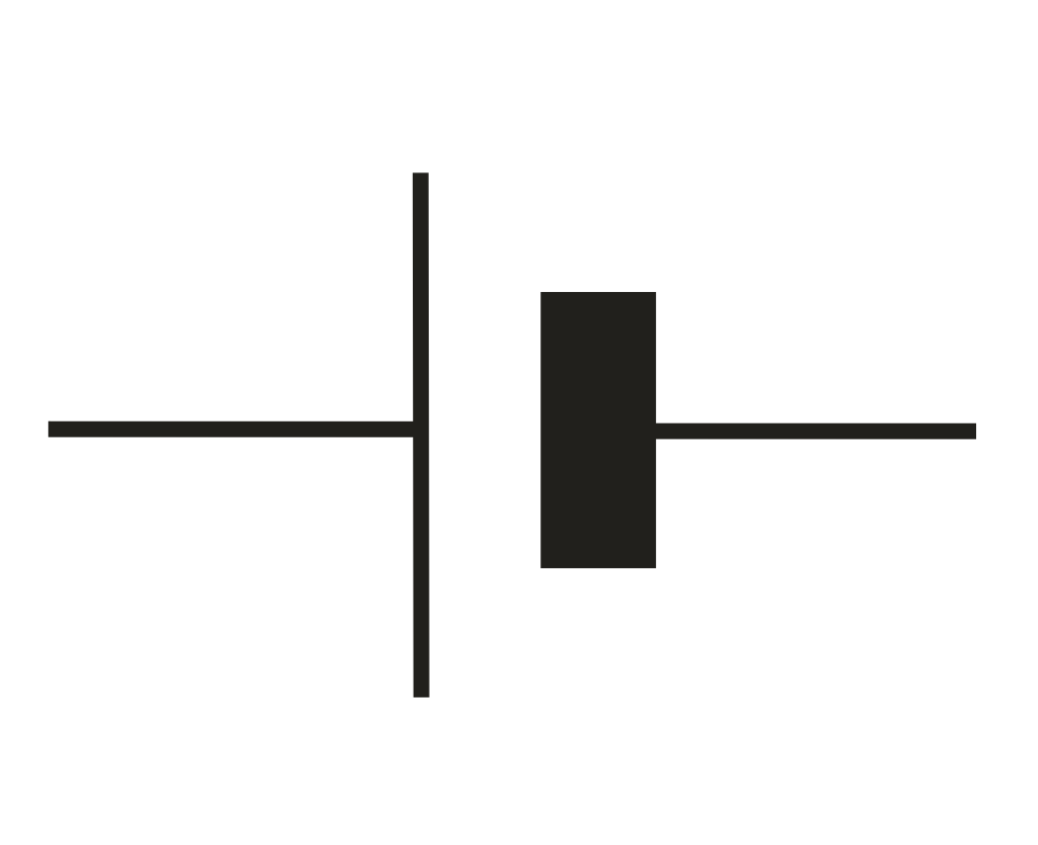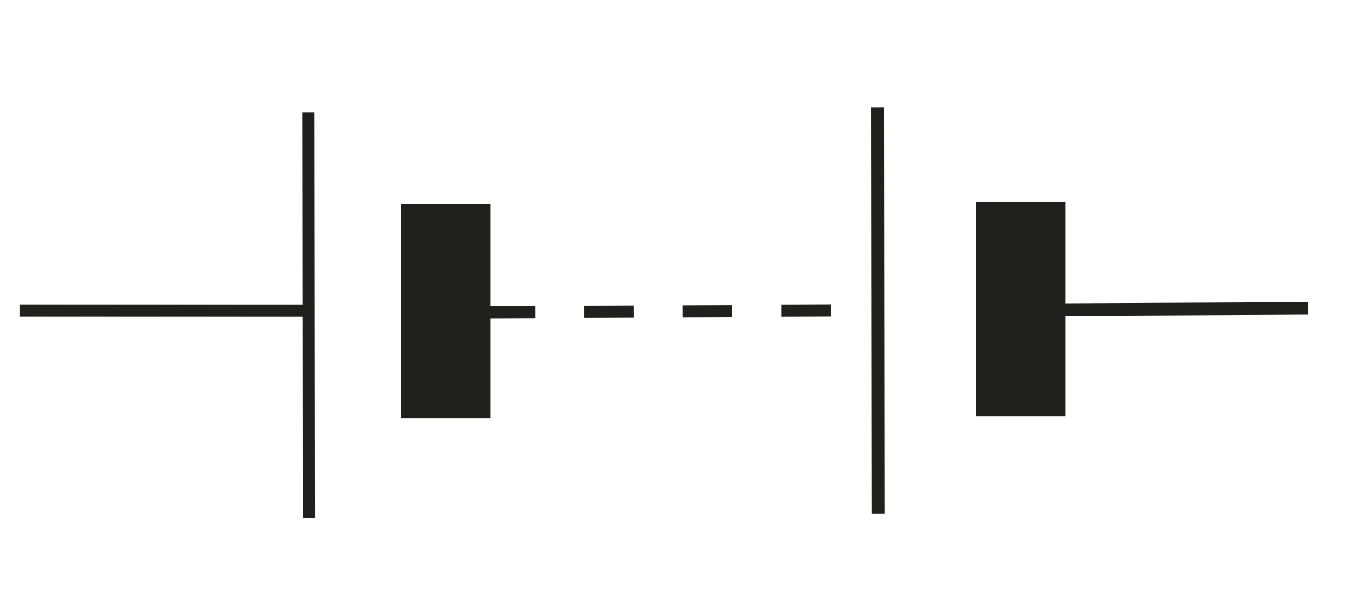
Cell Switch (closed) Battery
These symbols can be used to create electrical circuit diagrams.
Series Circuit
A circuit that has only one route for the current to take. If more bulbs or buzzers are added, the powerhas to be shared and so they will be dimmer or quieter. If just one part of this series circuit breaks, the circuit is broken and flow of current stops.
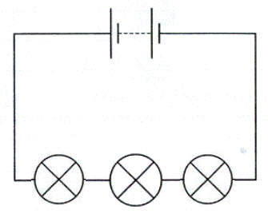
More components sharing less power.
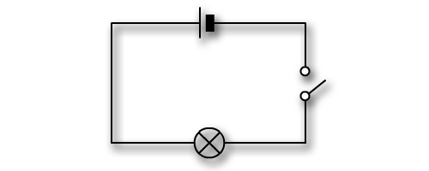
A broken circuit with no electrical current.
What will make a bulb brighter or a buzzer louder?
More batteries or a higher voltage create more power to flow through the circuit.
Shortening the wires means the electrons have less resistance to flow through.

What will make a bulb dimmer or a buzzer quieter?
Fewer batteries or a lower voltage give less power to the circuit.
More buzzers or bulbs mean the power is shared by more components.
Lengthening the wires means the electrons have to travel through more resistance.

