Key Vocabulary
Healthy | In a good physical and mental condition.
Nutrients | Substances that animals need to stay alive and healthy.
Energy | Strength to be able to move and grow.
Saturated Fats | Types of fats, considered to be less healthy, that should only be eaten in small amounts.
Unsaturated Fats | Fats that give you energy, vitamins and minerals.
- Living things need food to grow and to be strong and healthy.
- Plants can make their own food, but animals cannot.
- To stay healthy, humans need to exercise, eat a healthy diet and be hygienic.
- Animals, including humans, need food, water and air to stay alive.
Nutrient | Found in… (examples) | What it does/they do
Carbohydrates | 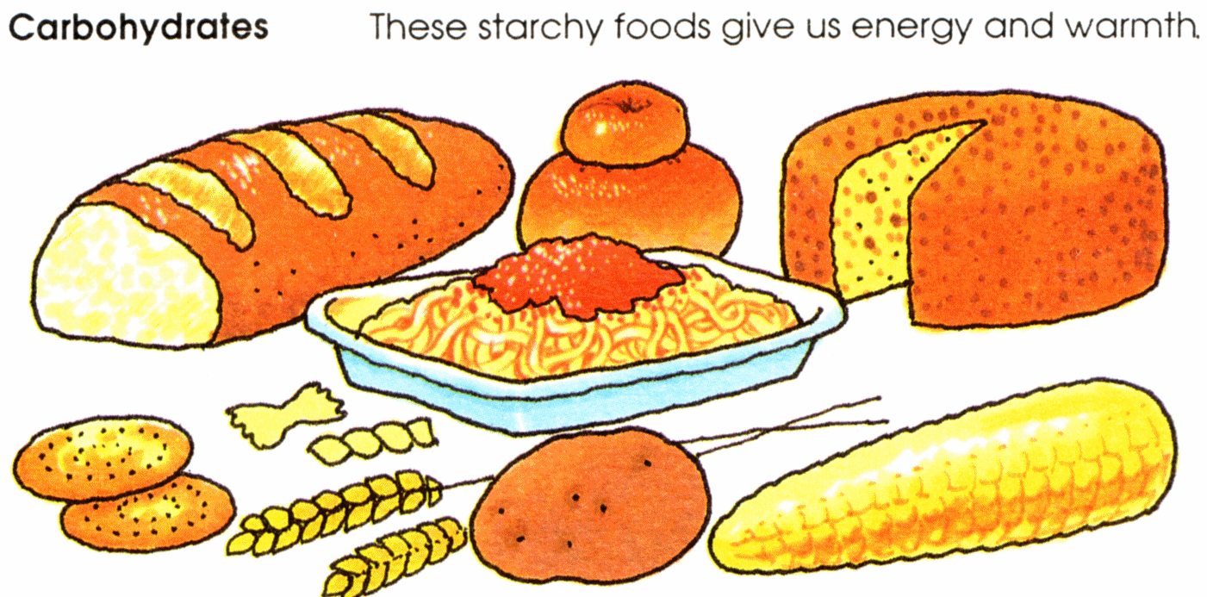 | Provide energy
Protein | 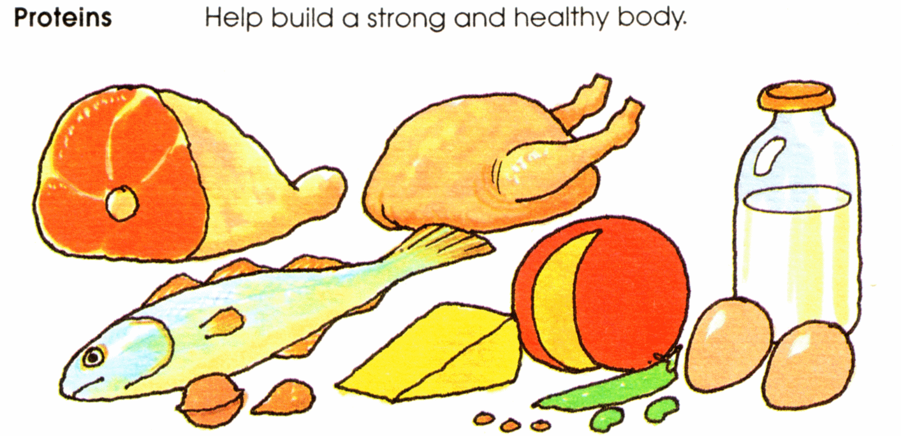 | Helps growth and repair
Fibre | 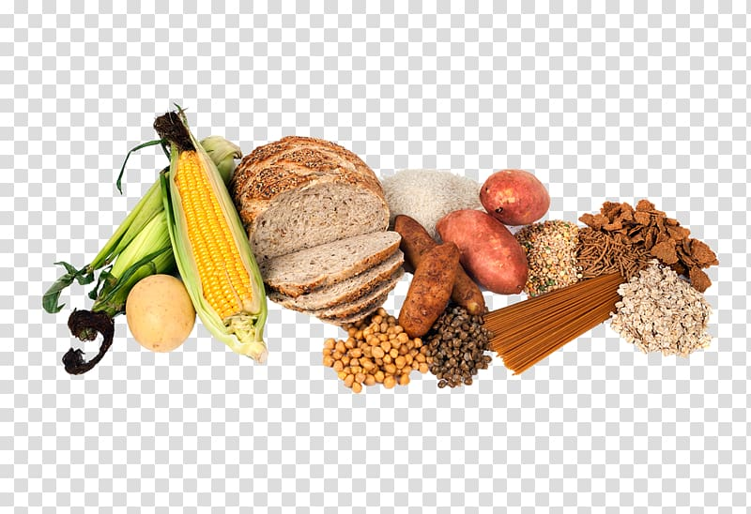 | Helps you to digest the food that you have eaten
Fats | 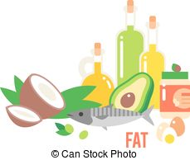 | Provide energy
Vitamins | 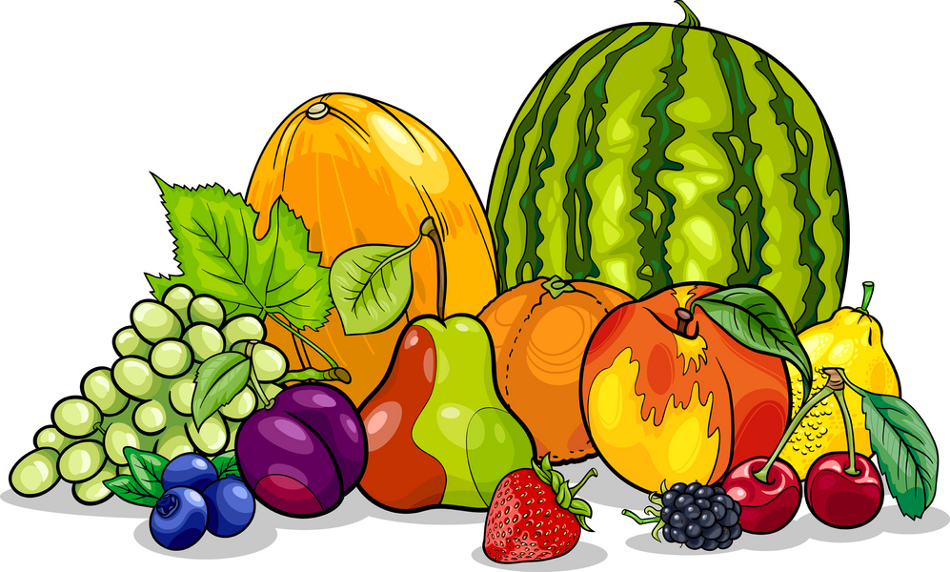 | Keep you healthy
Minerals | 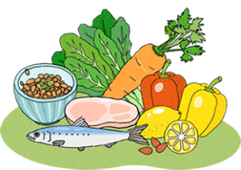 | Keep you healthy
Water | 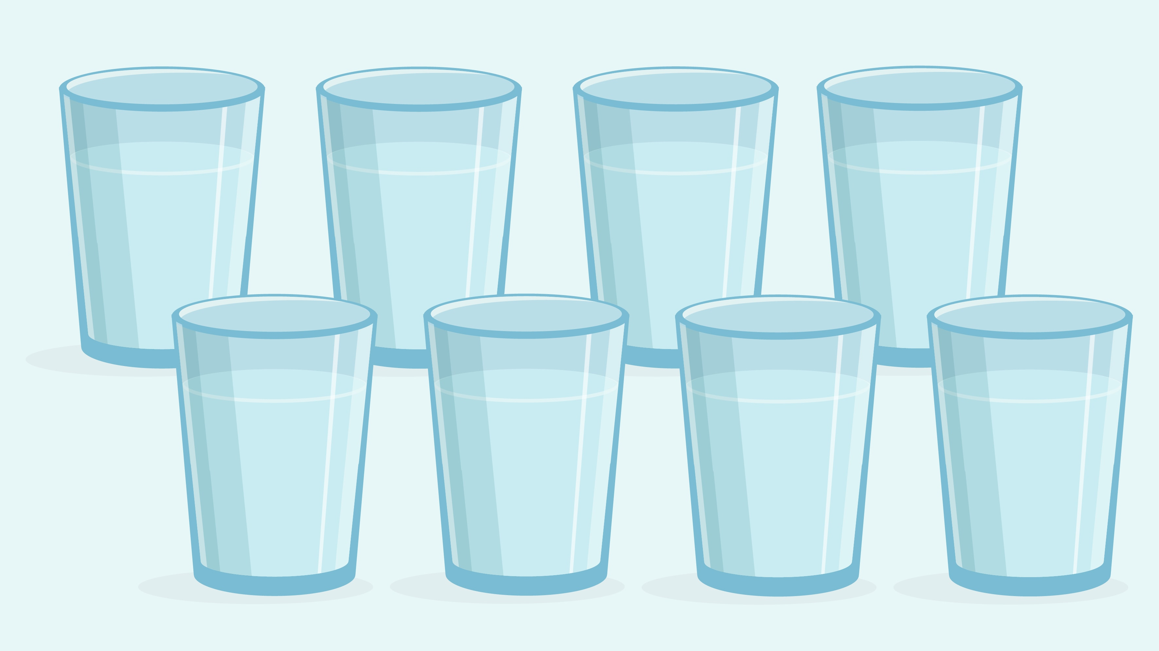 | Moves nutrients around your body and helps to get rid of waste.

Key Vocabulary
Vertebrate | Animals with backbones
Invertebrate | Animals without backbones
Muscles | Soft tissues in the body that contract and relax to cause movement
Tendons | Cords that join muscles to bones
Joints | Areas where two or more bones are fitted together
Vertebrate

Endoskeleton
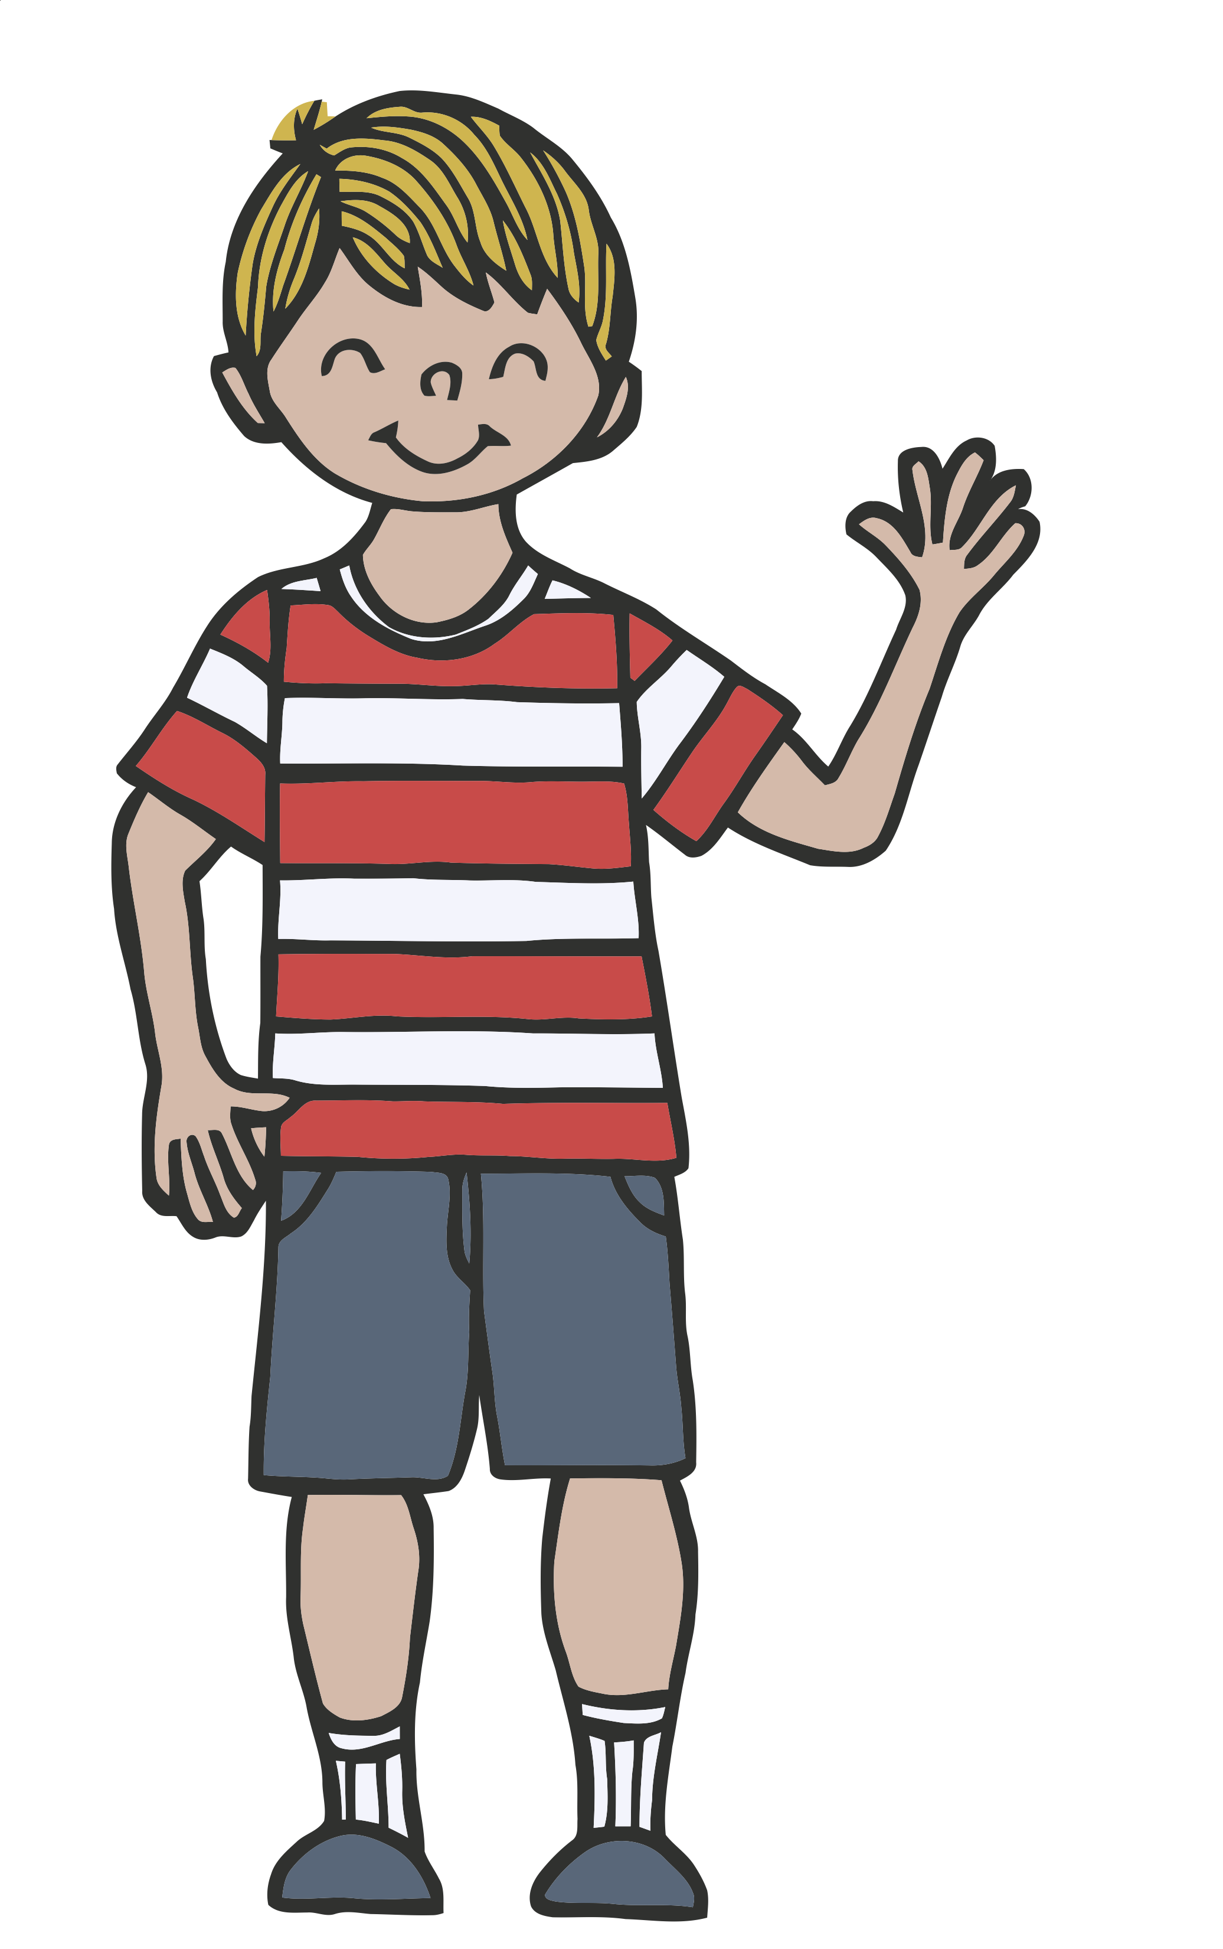
Skeletal muscles work in pairs to move the bones they are attached to by taking turns to contract (get shorter) and relax (get longer).
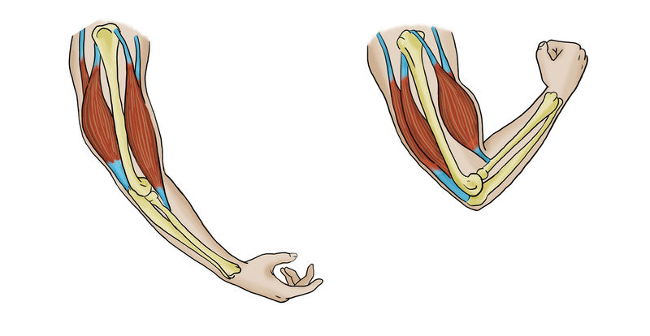
Relax Contract
Invertebrate

Exoskeleton Hydrostatic skeleton
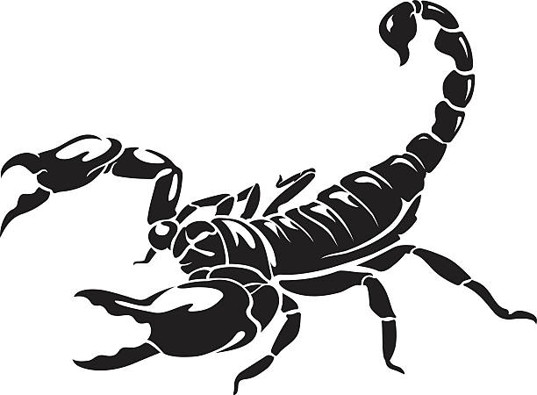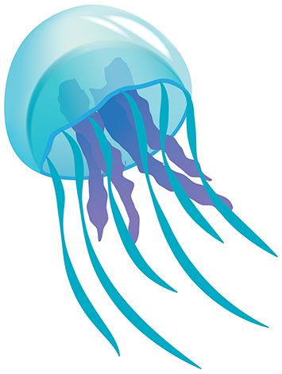

Skeletons do three important jobs:
- Protect organs inside the body
- Allow movement
- Support the body and stop it from falling on the floor

