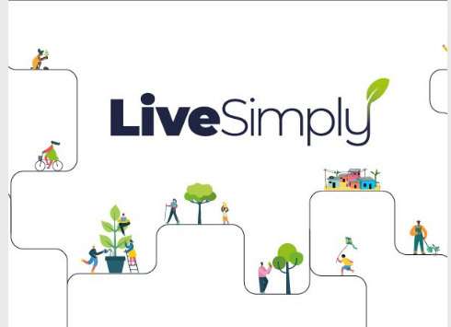
Pupil Voice
Give examples of how we can live simply?
- We prayed the Rosary each day for our class continent and then wore clothes to represent the colour of the continent (Mission Together)
- We had a school retreat, praying, thinking about God’s creation and singing.
- On Family Fast days we chose soup for lunch to remember those children who have no choice but to have the food they are given. We just had what we need and gave money to CAFOD
- We say a prayer as a school each morning on the playground before school.
Give examples of how we have shown solidarity with others over the last year.
- We donated tins to the food bank and took them to the food bank to learn about what happens. (We wrote letter to parents, talked to class about why we were doing this)
- We walked a mile for charity to remember those who were hungry and gave money to CAFOD.

Why is God’s creation so special? How can we look after it?
- We have to be stewards for God’s world and look after it – St Francis and Pope Francis teaches us this. Pope Francis wrote the letter called Laudato Si to tell us what we need to do.
- We made a bee friendly flower garden to encourage bees to populate.
- We need to be sustainable – We have to save energy by turning off the lights, the whiteboards.
- We have to save water – turn off the taps when finish and when brush teeth, we have a water butt to collect rain water to use to water plants. We planted plants that don’t need so much water.
- We use paper straws not plastic, we try to use reusable water bottles to reduce plastic.
- We encouraged children to walk to school especially on Walk to School Week.
- We made pledges to look after God’s world – mine was to pick up litter and walk to the shops.
What have you enjoyed doing over the year of Live Simply?
- Taking part in Masses and reading bidding prayers and singing Laudato Si.
- Creating the Mighty River and writing pledges on fish to remind us we are all part of God’s global family.
- Learning about Season of Creation and taking part in the school retreat called
- Raising money and choosing how to spend the money on World Gifts.
- Bringing tins for the harvest festival, setting up the display and then collecting tins into bags to take to the Thomas Project.
- Being part of the School Council and suggesting we buy recycling bins.
- Litter picking
- Being an Eco Warrior and helping to look after the gardens, planting, watering and making a bee garden.
- Not sending Christmas cards and just making one for my class to save trees by not wasting card and making lots of waste paper.
- Walking the mile for hunger
- The art gallery , when all work was on recycled materials.

