**Reception Literacy KKO**

**specific areas- Literacy & Maths**

**Celebrations!**

* Use print and letter knowledge in writing; and write

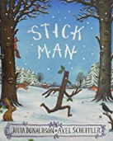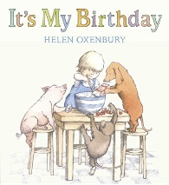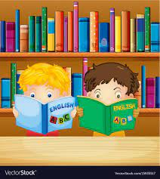

**Literacy Curriculum references**

Use print and letter knowledge in writing; and write names. Write some letters accurately and write for a purpose. Continue to develop correct letter formation. Develop skills in rhyming and begin to add more rhyming words to the string. Identify words with the same initial sound - alliteration. Read the sounds in simple and longer words to blend. Introduce digraphs. Encourage engagement in extended conversations about stories, using new vocabulary. Encourage children to hold conversations with adults and peers; asking questions.

What could be better than sharing a birthday cake with the friends who helped to bake it? In this whimsical, cumulative birthday tale, a host of generous friends helps a small child assemble the ingredients for a delicious cake. Full of fun and good cheer.

 Aim – To continue to explore different types of writing; a recipe, a birthday card. Continue to be able to identify differences between fiction and non-fiction writing.

**Stick man – Julia Donaldson**

**“S**tick Man lives in the family tree  
With his Stick Lady Love and their stick children three.”

Aim- Develop sequencing skills, recall and orally change parts of the story. Write the repeated refrain changing key words. Identify with the time of year – Christmas. Write for different purposes; a Christmas list to Santa, a Christmas card to my family, a thank you letter.