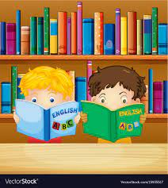

**Reception Literacy KKO**

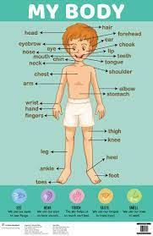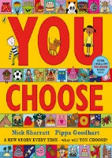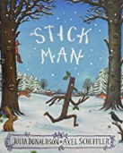

**Stick man – Julia Donaldson**

“Stick Man lives in the family tree  
With his Stick Lady Love and their stick children three.”

But it's dangerous being a Stick Man. A dog wants to play with him, a swan builds her nest with him. He even ends up on a fire! Will he ever get back to the family tree?

Aim- Develop sequencing skills, recall and orally change parts of the story. Write the repeated refrain changing key words.

**My Body – nonfiction; First explorers**

Find out some first facts about the human body! Use the chunky push, pull and slide mechanisms to see what's inside your body, how you think and what happens when you eat and drink? Bright, clear illustrations makes the human body amazing!

Aim – Recognise differences between fiction & Non-fiction. Begin to write a fact using word mats.

**You choose – by Nick Sharratt**

Imagine you could go anywhere, with anyone and do anything. Where would you live? Where would you sleep? Who would be your friends? What games would you play? Go on -you choose!

Aim – Extends vocabulary while encouraging children to make up their own stories recognising settings, and characters.

Begin to write single words with sounds they can hear in order.

**Marvellous me!**