Key Vocabulary
Fertilisation | The process of the male and female sex cells fusing together.
Prenatal | The stage of development from the time of fertilisation to the time of birth.
Gestation | The process or time when prenatal development takes place before birth.
Reproduce | To produce young.
Asexual Reproduction | A process where one parent produces new life.
Sexual Reproduction | A process where two parents – one male and one female – are required to produce new life.
Life Cycle | The changes a living thing goes through, including reproduction.
Fertilisation: The male and female sex cells fuse together.
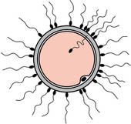
Late adulthood: Leading a healthy lifestyle can help to slow down the decline in fitness and health which occurs during this stage.
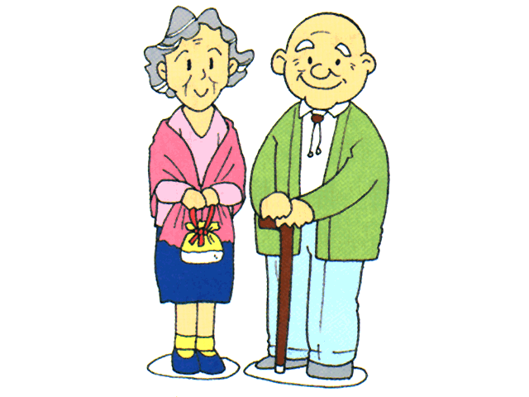
Adolescence: The body starts to change over a few years. The changes occur to enable reproduction during adulthood. Much more independent.
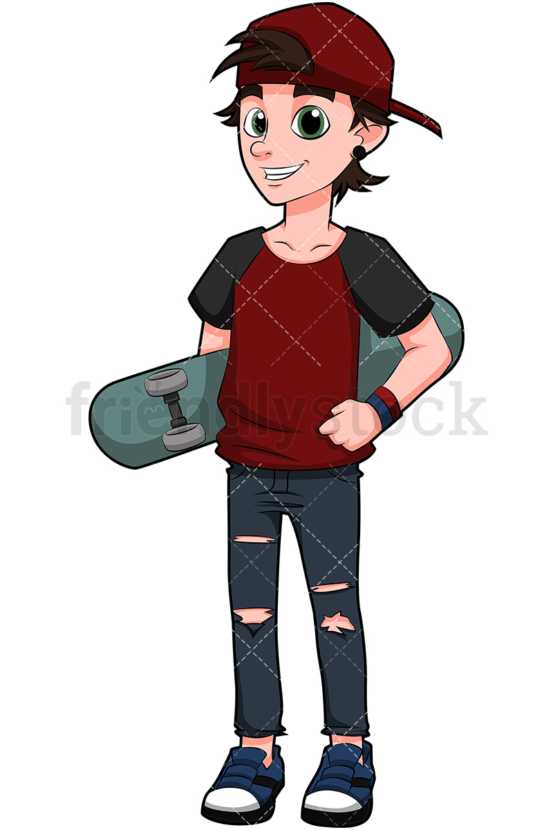
Childhood: Children learn new skills and become more independent.

Prenatal: The cells develop and grow into a foetus inside the mother’s uterus. After around nine months, the baby is born.
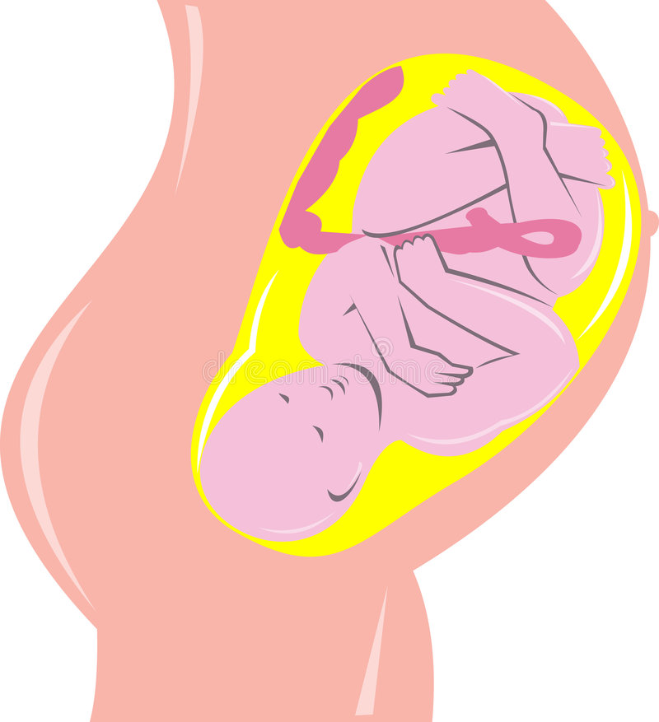

Middle adulthood: Ability to reproduce decreases. There may be hair loss or hair may turn grey.
Early adulthood: The human body is at its peak of fitness and strength.
Infancy: Rapid growth and development. Children learn to to and walk.
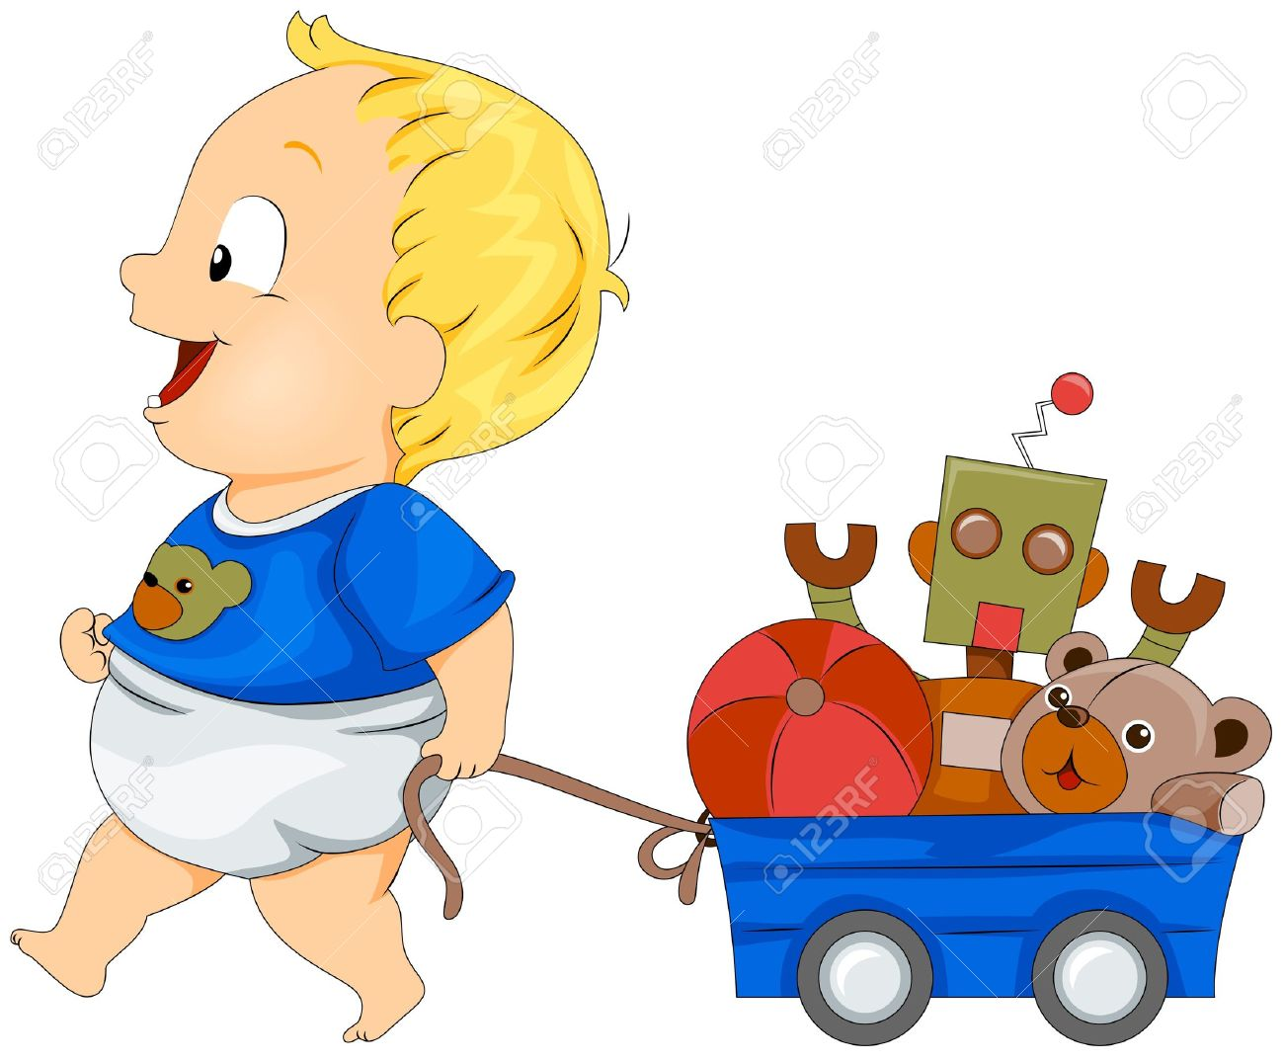
Key Vocabulary
Adolescence | The social and emotional stage of development between childhood and adulthood.
Puberty | The physical stage of development between childhood and adulthood.
Menstruation | When the female body discharges the lining of the uterus. This happens approximately once a month.
Adulthood | The stage of development when a human is fully grown and mature.
Life Expectancy | The length of time, on average, that a particular animal is expected to live.
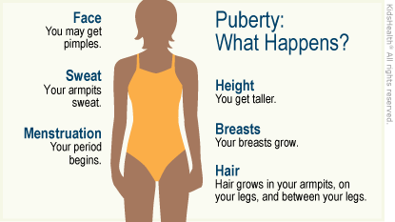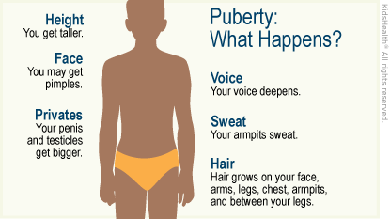

Both males and females grow in all parts of the body, and their sweat glands produce more sweat.

