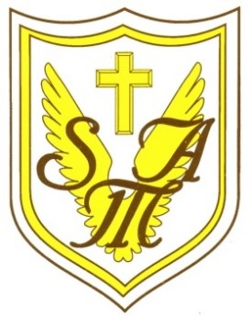

Recognising and celebrating the presence of Christ in one another.

**St Mary of the Angels Catholic Primary School**

Weston Crescent, Aldridge, WS9 0HA

E: postbox@st-maryangel.walsall.sch.uk

T: 01922 743 411

W: www.st-maryangel.walsall.sch.uk

@SMAAldridge

Headteacher: Mrs N. Hill



Friday 13th September 2023

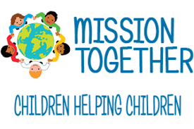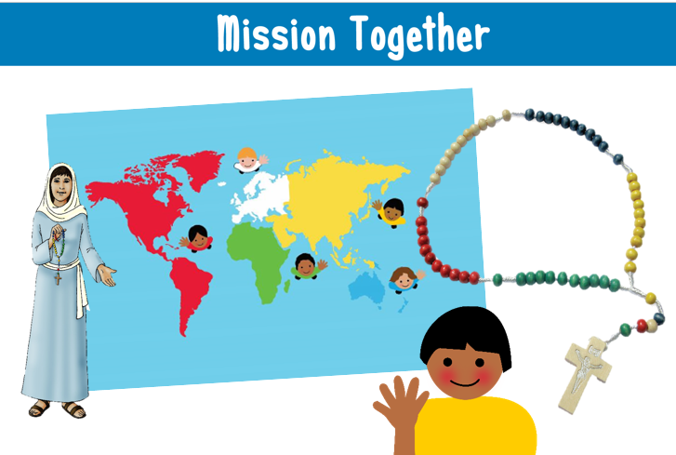

Dear Parents,

We are the Mini Vinnies and our role is to help lead the school to live simply and in solidarity with others.

Therefore, as Mini Vinnies, we have agreed, since the Harvest Mass is next Friday, that we would like to raise money for Mission Together and collect food for the local food bank at the Thomas Project. But none of this will be able to happen without the children of St Mary of the Angels working together in solidarity for their global family.

So, on **Friday 20th October**, the day of the Harvest Mass, we would appreciate it if all children could bring in a tin or packet ( not fresh food) which some of the Mini Vinnies will take to our local food bank, The Thomas Project. Just by everyone bringing one tin we could provide over seventy meals. As St Teresa of Calcutta reminds us: *“It's not how much we give but how much love we put into giving.”*

To help our global family, we would also love to raise money for Mission Together, a charity that helps children around the world to have the simple things we always have, for example, food, books and a warm bed. We think it would be great if everyone wore the colour of the continent that they have been praying the Hail Mary for, during the month of October, and make a donation on the School Gateway.

The colours for classes to wear are:

**EYFS** – Africa - **Green**

**Year 1 and 2**– Europe -White

**Year 3 and 4**- North and South America - **Red**

**Year 5** Australia - **Blue**

**Year 6** – Asia – **Yellow**

In dressing in bright colours, we will not only brighten up our day but also the day of our global family when they receive the money we raised to help them.

Many thanks for your continued support as we work together in solidarity for the common good.

Yours Sincerely

The Mini Vinnies and E. J. Hayes (Assistant Head and RE Lead)