Key Vocabulary
Wild plants | A wild plant seed grows where it falls. It doesn’t need to be planted or cared for as it grows.
Garden plants | Garden plants are plants that people choose to grow in their gardens.
Weed | Weeds are wild plants that grow in places where people don’t want them.
Deciduous | A deciduous tree loses its leaves each year.
Evergreen | An evergreen tree keeps its green leaves all year round, even in the winter.
Types of Tree
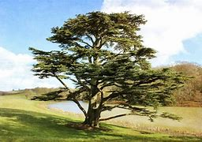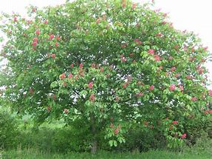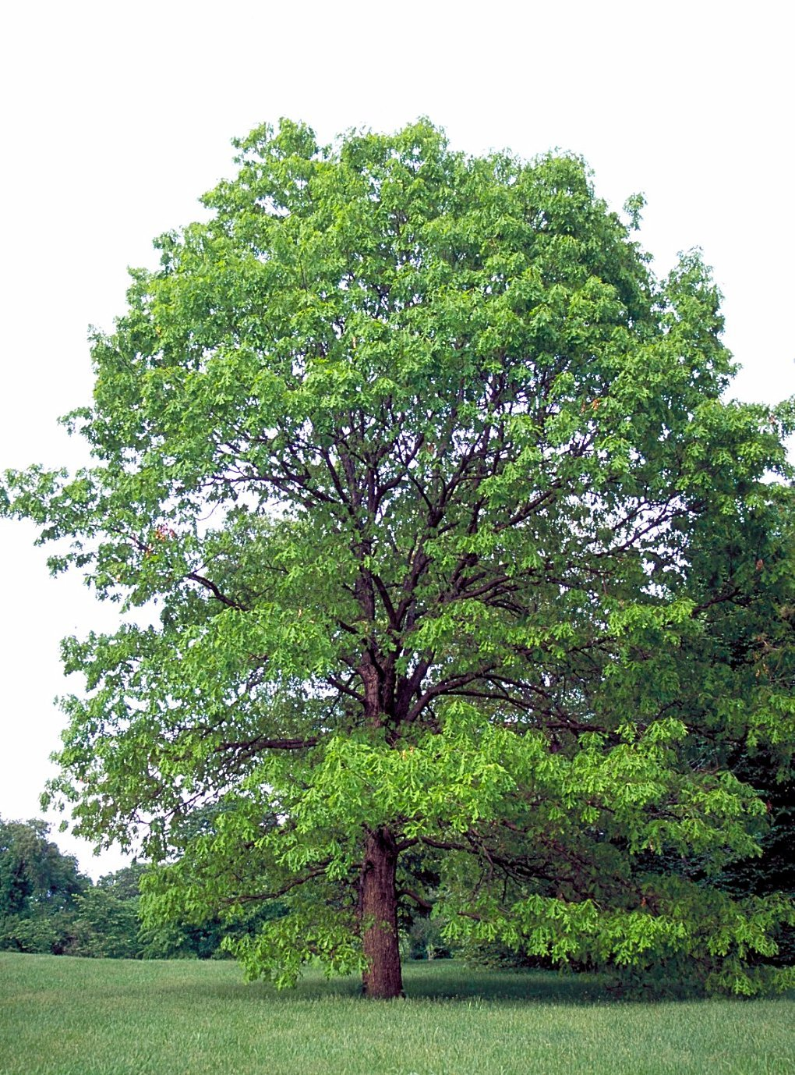
Cedar Horse chestnut Oak
Garden Plants
Fuchsia Pansy Sweet Pea Sunflower
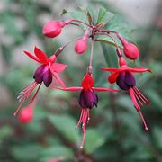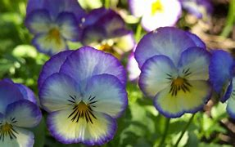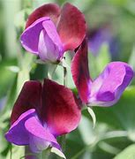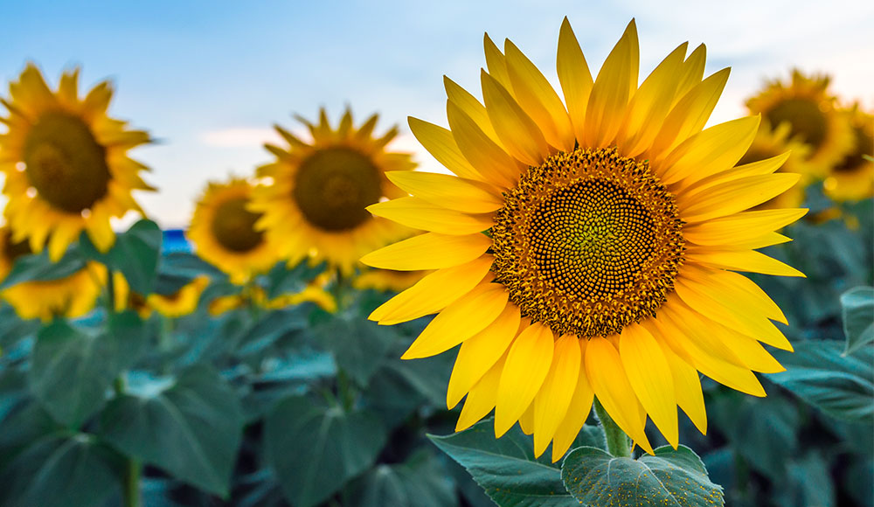
Rose Lavender Iris
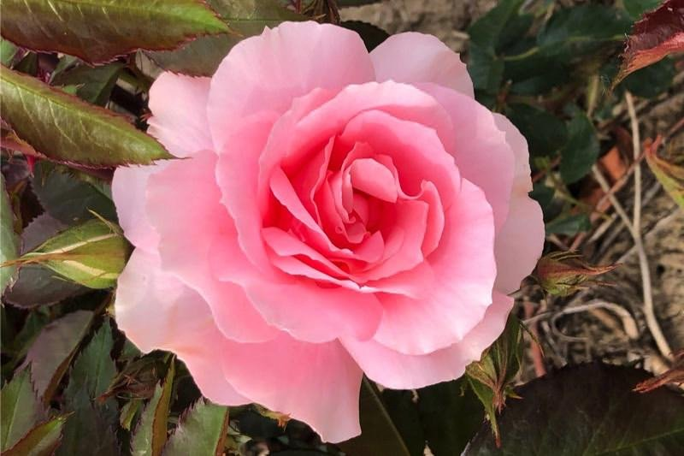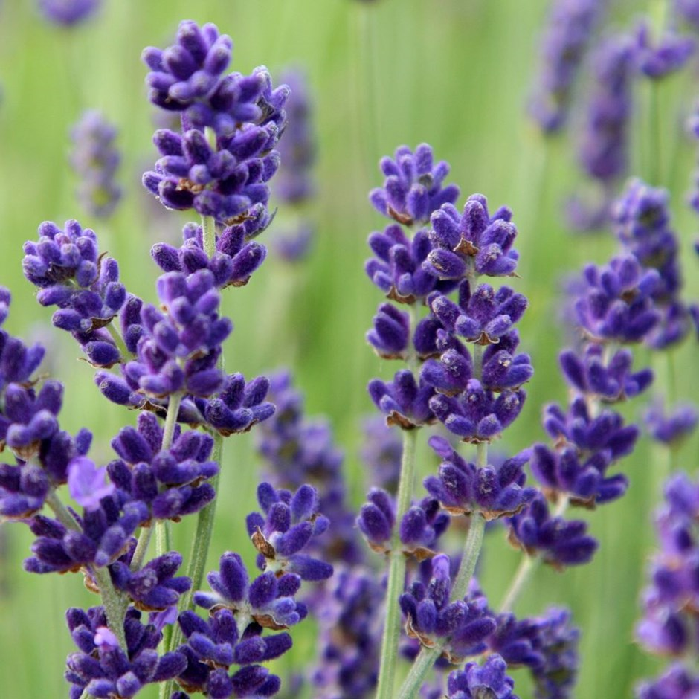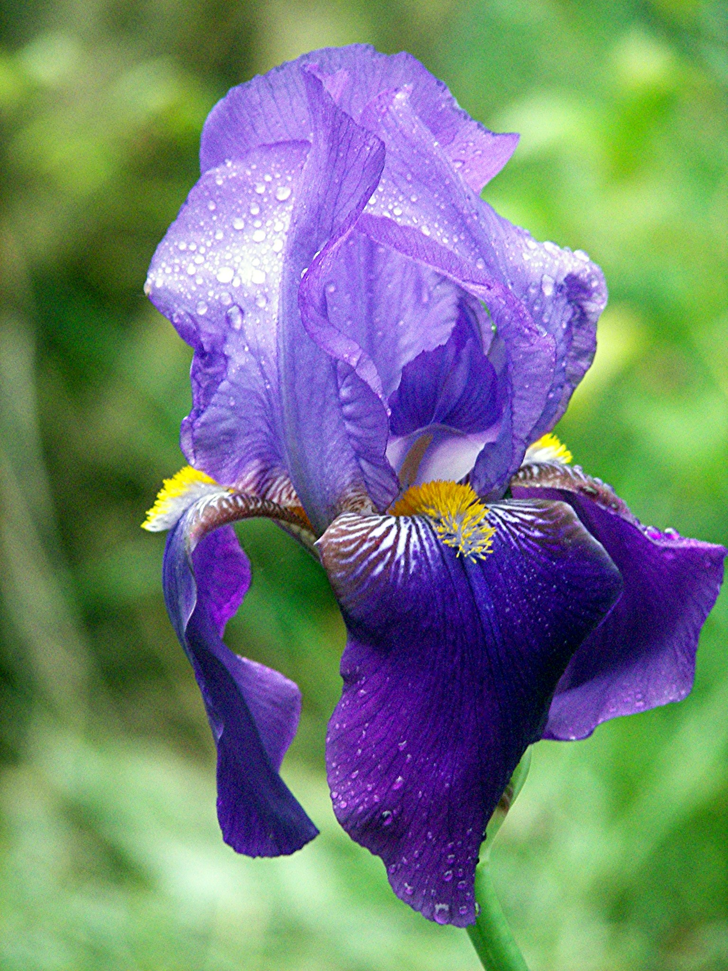
Wild Plants
Dandelion Daisy Buttercup Nettles
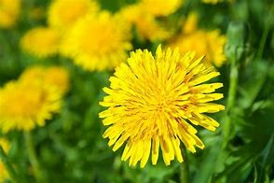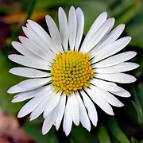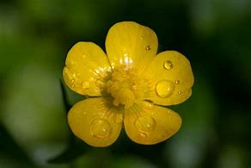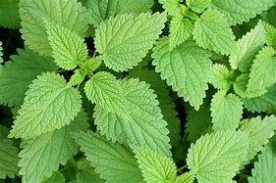
Ivy Dog rose Clover Brambles
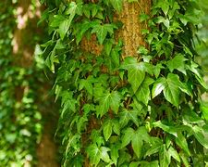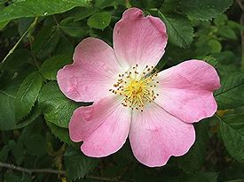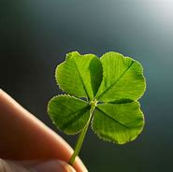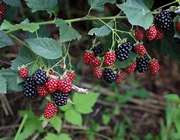
Key Vocabulary
Roots | Roots take in water and nutrients from the soil.
Stem | The stem holds the plant up and carries the water and nutrients from the roots to the leaves and flowers.
Leaves | Leaves catch sunlight to make energy.
Flowers | Flowers attract insects and birds
Petals | Petals are the colourful part of the flower.
Fruit | Fruit contains the plant’s seeds. Sometimes humans try to grow fruit without seeds because it’s easier to eat.
Seed | Seeds grow into new plants.
Bulb | Bulbs grow into new plants.

