

**Celebrations !**

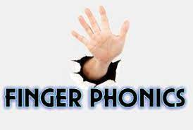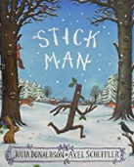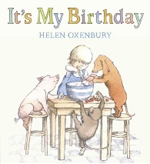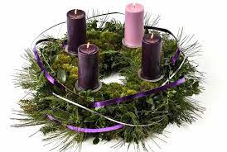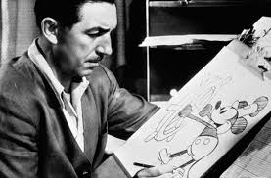

Children will be encouraged to sound out words using phonic fingers to count the sounds. This will help with segmenting when reading and writing.

**T**

**E**

**X**

**T**

**S**

**Advent**

**Sites & home learning**

* [**https://www.youtube.com/watch?v=UWLIgjB9gGw**](https://www.youtube.com/watch?v=UWLIgjB9gGw)
* [**https://www.youtube.com/watch?v=fTbEpGZyseA**](https://www.youtube.com/watch?v=fTbEpGZyseA)
* [**https://www.youtube.com/watch?v=D0Ajq682yrA**](https://www.youtube.com/watch?v=D0Ajq682yrA)
* [**https://learnenglishkids.britishcouncil.org/category/topics/festivals-and-**](https://learnenglishkids.britishcouncil.org/category/topics/festivals-and-)
* **https://www.youtube.com/watch?v=uT3CdfWpZyM**

**Prior learning- linked to SMATT**

**Who will you dress up as?**

**Links to specific areas- Literacy & Maths**

* Use print and letter knowledge in writing; and write names. Write some letters accurately and write for a purpose. Continue to develop correct letter formation. Develop skills in rhyming and begin to add more rhyming words to the string. Identify words with the same initial sound - alliteration. Read the sounds in simple and longer words to blend. Introduce digraphs. Encourage engagement in extended conversations about stories, using new vocabulary. Encourage children to hold conversations with adults and peers; asking questions
* Recognise up to 6 objects, without having to count them individually (‘subitising’). Make marks as well as numerals. Begin to solve real world mathematical problems with numbers up to 10. Talk about and explore 3D shapes using informal and mathematical language. Copy, continue and create patterns.

**Links to prime areas**

* Continue to listen to stories; developing comprehension, recognise setting and characters. Continue to extend vocabulary. Encourage use of longer sentences and begin to express a point of view, using words as well as actions.
* Develop a good posture when sitting at a table and encourage a correct pencil grip. Discuss healthy choices about food, drink, activity and tooth brushing.
* Develop the skills to manage personal hygiene. Make friends and develop the skills to play with one another and begin to find solutions to conflicts including negotiation. Extend language to express their feelings and consider the feelings of others. Learn how to identify and moderate their own feelings. Recognise the importance of following rues and understand why they are important.

**We will be having a Disney day… you need to dress up in your favourite Disney character….**