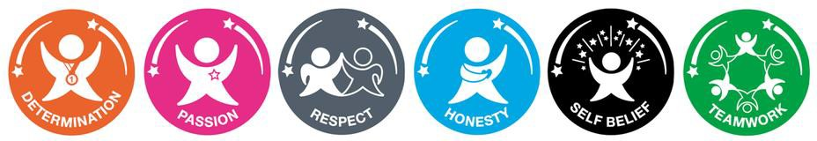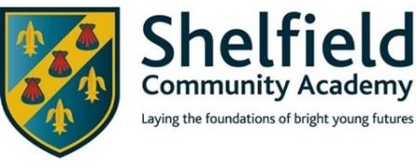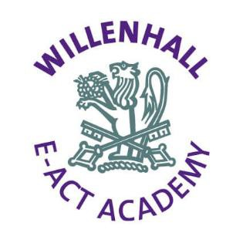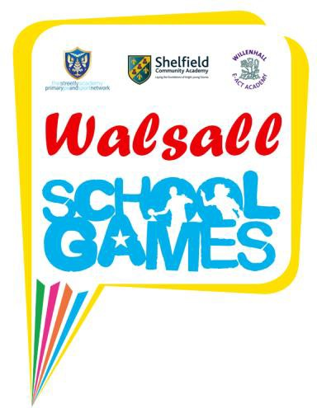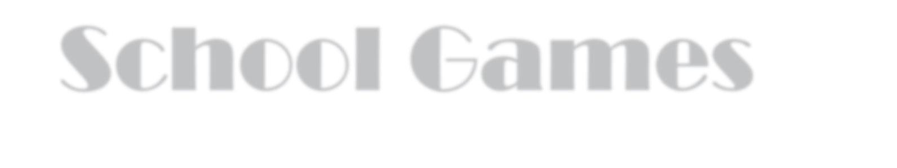

School Games
Recognition Award
St. Mary of the Angels Catholic Primary School
Thank you for all your hard work during a challenging year, your school has demonstrated its commitment to providing physical opportunities throughout the School Games Programme 2020/21

