Key Vocabulary
Roots | These anchor the plant into the ground and absorb water and nutrients from the soil.
Stem | This holds the plant up and carries water and nutrients from the soil to the leaves. A trunk is the stem of a tree.
Leaves | These make food for the plant using sunlight and carbon dioxide from the air.
Flowers | These make seeds to grow into new plants. Their petals attract pollinators to the plant.
Nutrients | These substances are needed by living things to grow and survive. Plants get nutrients from the soil and also make their own food in their leaves.
Evaporation | When a liquid turns into a gas.

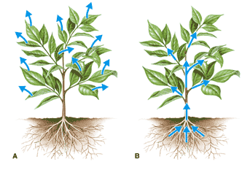
How water moves through a plant.
- The roots absorb water from the soil.
- The stem transports water to the leaves.
- Water evaporates from the leaves.
- This evapora on causes more water to be sucked up the stem.
The water is sucked up the stem like water being sucked up through a straw.
What does a plant need to grow?
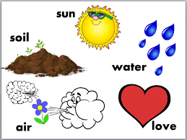
Different plants vary in how much of these things they need. For example, cacti can survive in areas with little water, whereas water lilies need to live in water.

Seed Dispersal | A method of moving the seeds away from the parent plant so that the seeds have the best chance of survival.
Fertilisation | When the male and female parts of the flower have mixed in order to make seeds for new plants.
Petal | The brightly coloured part of the flower that attracts insects to pollinate the plant.
Stamen | The male parts of the flower. The stamen is made up of the anther and the filament. The filament’s job is to hold up the anther. The job of the anther is to make the pollen.
Carpel (pistil) | The female parts of the flower. Made up of the stigma, style and ovary. The job of the style is to hold up the stigma. The stigma collects the pollen when a pollinator brushes by it. The ovary contains the ovules, which are the part of the flower that gets fertilised and eventually becomes the new seed.
Sepal | Leaf-like structures that protect the flower and petals before they open out.
Pollination | When pollen (a fine powdery substance produced by a flowering plant) is moved from the male anther of a flower to the female stigma.
Pollinator | Animals or insects which carry pollen between plants. Examples include birds, bees and bats.
Germination | When a seed starts to grow.
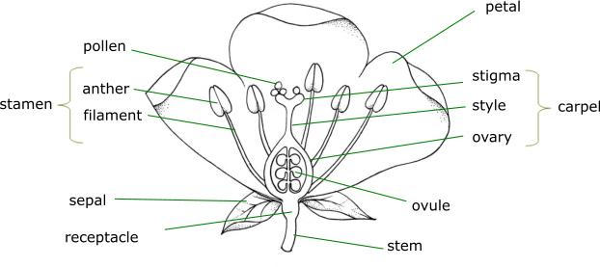
Seed Dispersal:
Seeds can be dispersed by:
Water Shaking
Dropping
Carrying
Eating
Bursting
