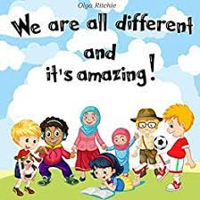

Children will be asked to send a photograph of their family.

**Texts**

**Marvellous me!**

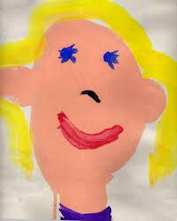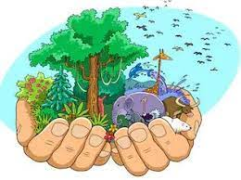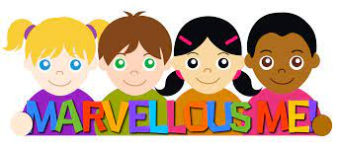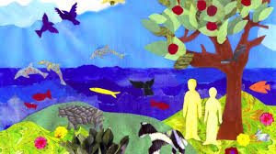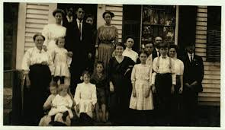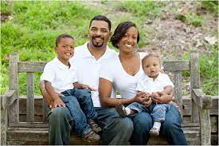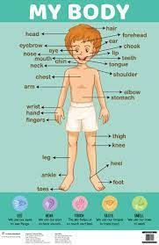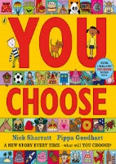

**Can you paint a portrait of yourself?**

Children in reception have class dojos for behaviour. We also have over the rainbow stickers… How many will you get?

**Creation**

**Links to specific areas- Literacy & Maths**

* Use print and letter knowledge in writing; and write names. Write some letters accurately; correct letter formation will be encouraged. Develop skills in rhyming. Continue to count or clap syllables in a word. Identify words with the same initial sound. Read the sounds in words to blend. Introduce digraphs Encourage engagement in extended conversations about stories, using new vocabulary.
* Recognise up to 6 objects, without having to count them individually (‘subitising’). Develop an understanding of the ‘cardinal principal’ – knowing that the amount counted represents the set. Show ‘finger numbers’ up to 10 and begin to make marks as well as numerals. Begin to solve real world mathematical problems with numbers up to 10. Compare quantities using language: ‘more than’, ‘fewer than’. Talk about and explore 2D shapes using informal and mathematical language. Continue to understand position.

**Sites & home learning**

* [**https://www.youtube.com/watch?v=D0Ajq682yrA**](https://www.youtube.com/watch?v=D0Ajq682yrA)
* [**https://www.youtube.com/watch?v=ZXgfO1jSljQ&t=70s**](https://www.youtube.com/watch?v=ZXgfO1jSljQ&t=70s)
* <https://www.youtube.com/watch?v=vXXiyIGqliE>
* [**https://www.youtube.com/watch?v=rsxhDJhZ8kk**](https://www.youtube.com/watch?v=rsxhDJhZ8kk)
* https://www.youtube.com/watch?v=txcVVbK2iEA

**Prior learning- linked to SMATT**

**Links to prime areas**

* Listen stories; developing comprehension. Listen and learn new rhymes and songs, looking to extend vocabulary. Encourage use of longer sentences and begin to express a point of view, using words as well as actions.
* Develop a good posture when sitting at a table or sitting on the floor. Discuss healthy choices about food, drink, activity and tooth brushing
* Develop the skills to manage the school day; lining up and queuing, mealtimes and personal hygiene. Use a chosen hand to hold their pencil. Make friends and develop the skills to play with one another and begin to find solutions to conflicts. Extend language to express their feelings and consider the feelings of others. Begin to understand how others might be feeling. Learn how to identify and moderate their own feelings. Show more confidence in new social situations. Recognise the importance of following rues and understand why they are important. Describe feelings.