Key Vocabulary
Organisms | This is another word that can be used to mean ‘living things’
Life processes | The things that living things do to stay alive.
Respiration | A process where plants and animals use oxygen gas from the air to help turn their food into energy.
Sensitivity | The way living things react to changes in their environment.
Excretion | The process by which living things get rid of waste products.
Nutrition | Food which provides living things with energy to live and stay healthy.
Habitat | The specific area or place in which particular animals or plants may live.
Environment | An environment contains many habitats and these include areas where there are both living and non-living things.
Endangered species | A plant or animal where there are not many of their species left and scientists are concerned that the species may become extinct.
Extinct | When a species has no more members alive on the planet, it is extinct.
Reproduction | The process through which young are produced.
Plants and animals rely on the environment to give them everything they need. Therefore, when habitats change, it can be very dangerous to the plants and animals that live there.
Human-made:
Deforestation
Pollution
Urbanisation
The introduction of new animal or plant species to an evironment
Creating new nature reserves
Natural:
Earthquakes
Storms
Floods
Droughts
Wildfires
The seasons
Changes to an environment can be natural or caused by humans. Changes to an evironment can have positive as well as negative effects. Here are some exmples of things that can change an environment.
Life Processes
To stay alive and healthy, all living things need certain conditions that let them carry out the seven life processes:
Characteristics | The distinguishing features or qualities that are specific to a species
Classification | This is where plants or animals are placed into groups according to their similarities.
Vertebrates | Animals with a backbone
Invertebrates | Animals without a backbone.
Specimen | A particular plant or animal that scientists study to find out about its species.
Plants can be sorted into many different groups e.g. flowering and non-flowering plants.
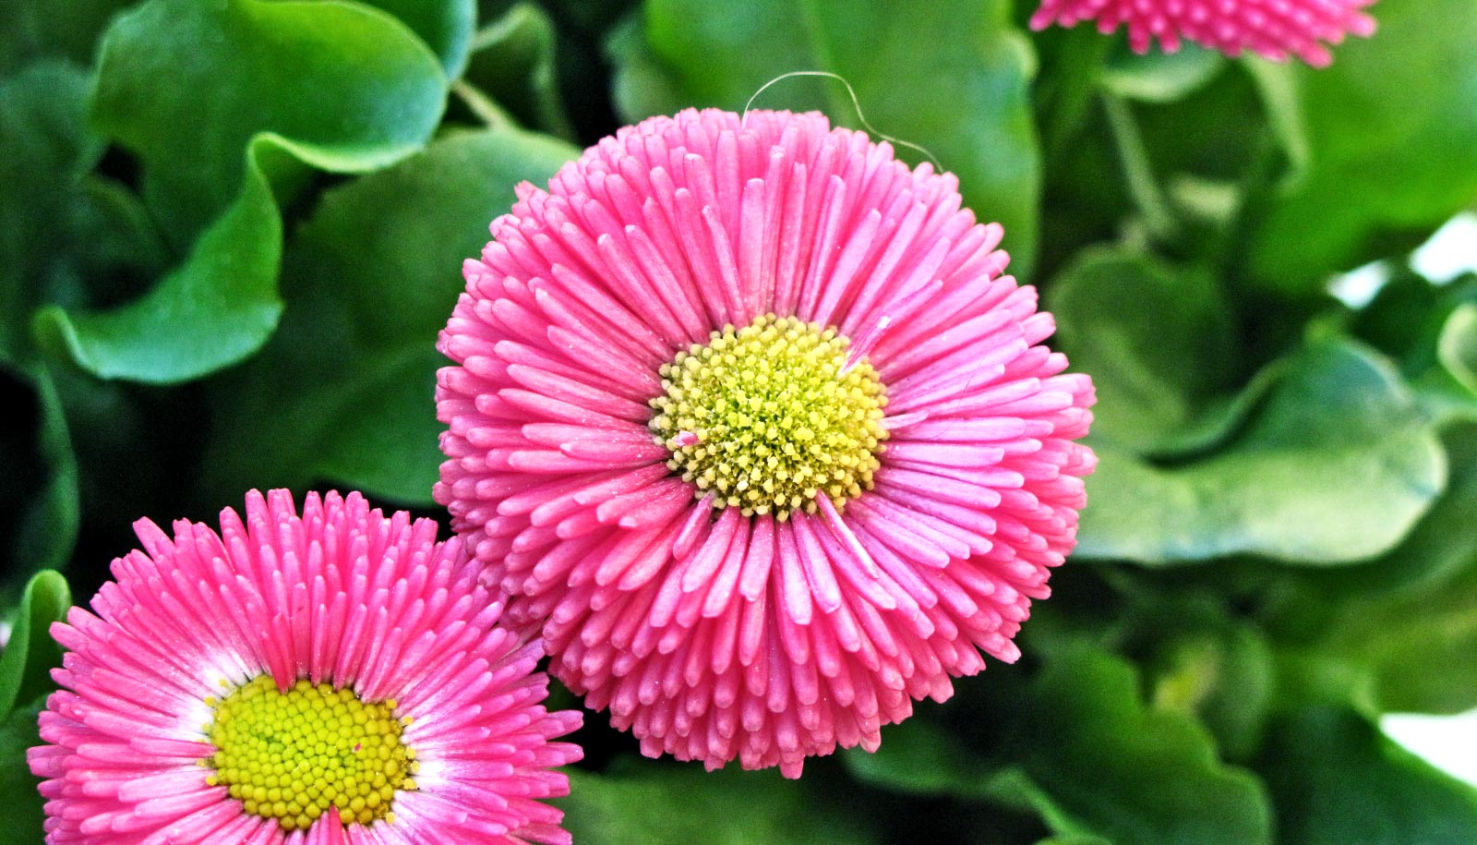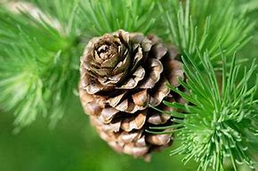

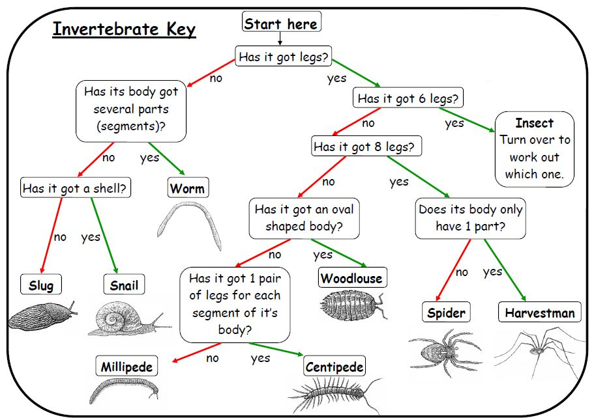
Invertebrates
You could sort invertebrates you might see around school indifferent ways, such as in this example. The vast majority of living things on the planet are invertebrates
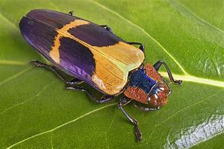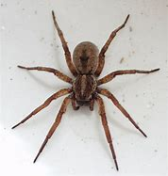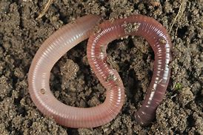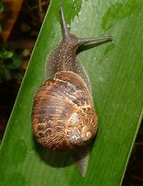
Insects Spiders Woms Slugs and Snails
Vertebrates
Vertebrates can be separated into five broad groups.
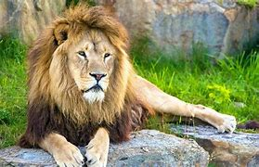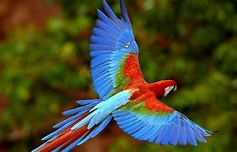
Mammals Fish Birds Reptiles Amphibians
You can use classification keys to help group, identify and name a variety of living things. Here is an example of a classification key:
Animals can be grouped in lots of different ways based upon their characteristics.

