**Reception Autumn Term Numeracy KKO**

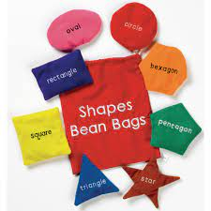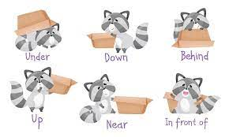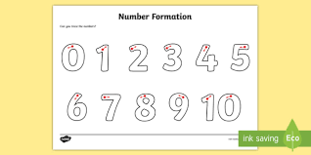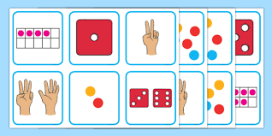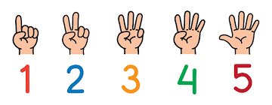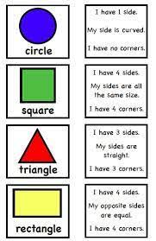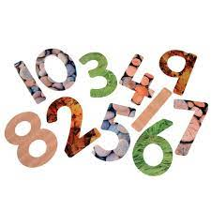

**Numerical Pattern**

* Talk about and

explore 2D shapes

using informal and

mathematical

language.

* Continue to understand position.

**Problem solving**

Guess the shape - Hiding games - feely bags with shapes. Discuss why it is that shape?

Doubling - Collect 4 sticks. If I collected 4 more – how many would I have altogether?

**Number**

* Recognise up to 6 objects, without having to count them individually (‘subitising’).
* Show ‘finger numbers’ up to 10 and begin to make marks as well as numerals
* Compare amounts

**Key Vocabulary**

* **Fewer than**
* **Lots**
* **More**
* **Equal**
* **Subitise**
* **Positional Language**
* **Double**
* **Half**
* **Shape names**
* **Round**
* **Straight**

**Look at these sites at home-**

* [**https://www.youtube.com/watch?v=idJYhjGyWTU**](https://www.youtube.com/watch?v=idJYhjGyWTU)
* [**https://www.youtube.com/watch?v=8jOzhiACB68**](https://www.youtube.com/watch?v=8jOzhiACB68)